# CHAPTER5 Linear Inequalities and Linear Programming

*Animation 5.1: Feasible Solution Set*

*Source and credit: eLearn.Punjab*

**1. Quadratic Equations eLearn.Punjab 1. Quadratic Equations eLearn.Punjab**

***5. Linear Inequalities and Linear Programming eLearn.Punjab 5. Linear Inequalities and Linear Programming eLearn.Punjab***

## 5.1 INTRODUCTION

Many real life problems involve linear inequalities. Here we shall consider those problems (relating to trade, industry and agriculture etc.) which involve systems of linear inequalities in two variables. Linear inequalities in such problems are used to prescribe limitations or restrictions on allocation of available resources (material, capital, machine capacities, labour hours, land etc.). In this chapter, our main goal will be to optimize (maximize or minimize) a quantity under consideration subject to certain restrictions.

3

2

3

2

<

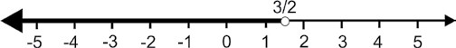

The method under our discussion is called the linear programming method and it involves solutions of certain linear inequalities.

## 5.2 LINEAR INEQUALITIES

Inequalities are expressed by the following four symbols;

> (greater than); < (less than); 8 (greater than or equal to); 7 (less than or equal to)

For example (i) *ax* < *b* (ii) *ax* + *b* 8 *c* (iii) *ax* + *by* > *c* (iv) *ax* + *by* 7 *c* are inequalities. Inequalities (i) and (ii) are in one variable while inequalities (iii) and (iv) are in two variables.

The following operations will not afect the order (or sense) of inequality while changing it to simpler equivalent form:

1. Adding or subtracting a constant to each side of it.
2. Multiplying or dividing each side of it by a positive constant.

Note that the order (or sense) of an inequality is changed by multiplying or dividing its each side by a negative constant.

Now for revision we consider inequality, *x* < (A) All real numbers are in the solution set of (A).

Thus the interval - , ∞ 32  or - ∞ < < *x* 32 is the solution set of the inequality (A) which is shown in the igure 5.21

Fig. 5.21

We conclude that the solution set of an inequality consists of all solutions of the inequality.

### **5.2.1 Graphing of A Linear Inequality in Two Variables**

Generally a linear inequality in two variables *x* and *y* can be one of the following forms:

*ax* + *by* < *c* ; *ax* + *by* > *c* ; *ax* + *by* 7 *c* ; *ax* + *by* 8 *c*  where *a*, *b*, *c* are constants and *a*, *b* are not both zero. We know that the graph of linear equation of the form *ax* + *by* = *c* is a line which divides the plane into two disjoint regions as stated below: (1) The set of ordered pairs (*x*, *y*) such that *ax* + *by* < *c*

(2) The set of ordered pairs (*x*, *y*) such that *ax* + *by* > *c*

The regions (1) and (2) are called **half planes** and the line *ax* + *by* = *c* is called the **boundary of each half plane**.

Note that a **vertical line** divides the plane into **left and right half planes** while a **nonvertical line** divides the plane into **upper and lower half planes**.

A solution of a linear inequality in *x* and *y* is an ordered pair of numbers which satisies the inequality.

For example, the ordered pair (1, 1) is a solution of the inequality *x* + 2*y* < 6 because 1 + 2(1) = 3 < 6 which is true.

There are ininitely many ordered pairs that satisfy the inequality *x* + 2*y* < 6, so its graph will be a half plane.

Note that the linear equation *ax* + *by* = *c* is called **“associated or corresponding equation”** of each of the above mentioned inequalities.

**Procedure for Graphing a linear Inequality in two Variables**

1. The corresponding equation of the inequality is irst graphed by using ‘dashes’ if the inequality involves the symbols > or < and a solid line is drawn if the inequality involves the symbols 8 or 7.
2. A test point (not on the graph of the corresponding equation) is chosen which determines that the half plane is on which side of the boundary line.

### 2 3

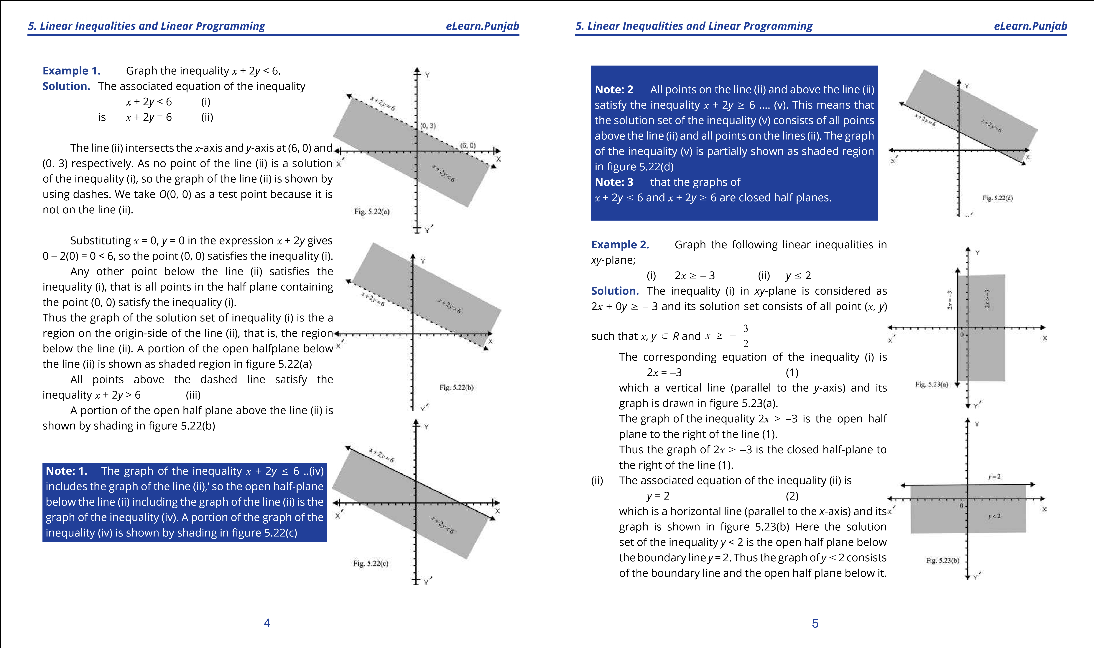

**1**

**. Quadratic Equations**

**eLearn.Punjab**

**1**

**. Quadratic Equations**

**eLearn.Punjab**

***5***

***. Linear Inequalities and Linear Programming***

***5***

***. Linear Inequalities and Linear Programming***

***eLearn.Punjab***

***eLearn.Punjab***

6

7

Note that the intersection of graphs of 2

*x*

8

-

and

3

*y*

7

).

is partially shown in the adjoining igure 5.23(c

2

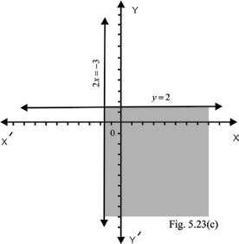

**REGION BOUNDED BY 2 OR 3**

**5.3**

**SIMULTANEOUS INEQUALITIES**

The graph of a system of inequalities consists of the set of all ordered pairs (

*x*

,

*y*

in the

)

*xy*

plane which simultaneously satisfy all the inequalities in the system. Find the graph of

-

such a system, we draw the graph of each inequality in the system on the same coordinate

axes and then take intersection of all the graphs. The common region so obtained is called

the solution region for the system of inequalities.

**Graph the system of inequalities**

**Example 1:**

***x***

-

**2**

***y***

7

**6**

**2**

***x***

**+**

***y***

8

**2**

**Solution.**

The graph of the line

*x*

-

2

*y*

= 6 is drawn by joining

the point (6, 0) and (0,

-

3)

. The point (0,0) satisfy the

inequality

*x*

-

2

*y*

< 6 because 0

-

2(0) = 0 < 6. Thus the

graph of

*x*

-

2

*y*

7

6 is the upper half-plane including

the graph of the line

*x*

-

2

*y*

= 6. The closed half-plane is

partially shown by shading in igure 5.31(a).

We draw the graph of the line 2

*x*

+

*y*

*=*

2 joining

the points (1, 0) and (0, 2). The point (0, 0) does not

satisfy the inequality 2

*x*

+

*y*

> 2 because 2(0) + 0 = 0

>

2. Thus the graph of the inequality 2

*x*

+

*y*

8

2 is the

closed half-plane not on the origin-side of the line

2

*x*

+

*y*

= 2.

Thus the closed half-plane is shown partially as a

shaded region in igure 5.31(b). The solution region of

the given system of inequalities is the intersection of

the graphs indicated in igures 5.31(a) and 5.31(b) and is

shown as shaded region in igure 5.31(c).

The intersection point (2,

-

2)

can be found by

solving the equations

*x*

-

2

*y*

= 6 and 2

*x*

+

*y*

= 2.

Note that the line

*x*

-

2

*y*

= 6 and 2

*x*

+

*y*

= 2 divide the

*xy*

plane into four region bounded by these lines. These

-

four (bounded) regions are displayed in the adjoining

igure.

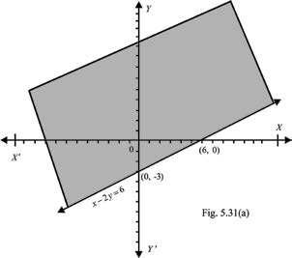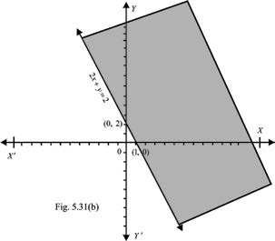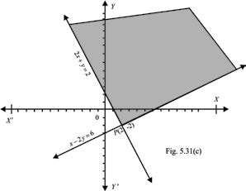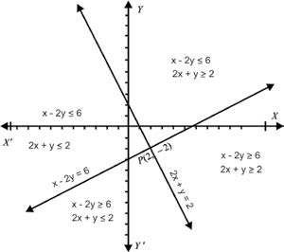

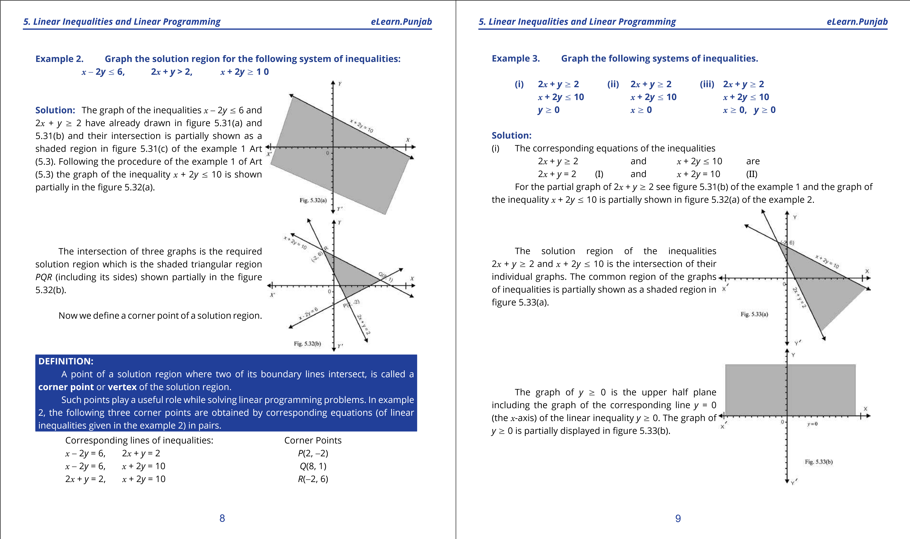

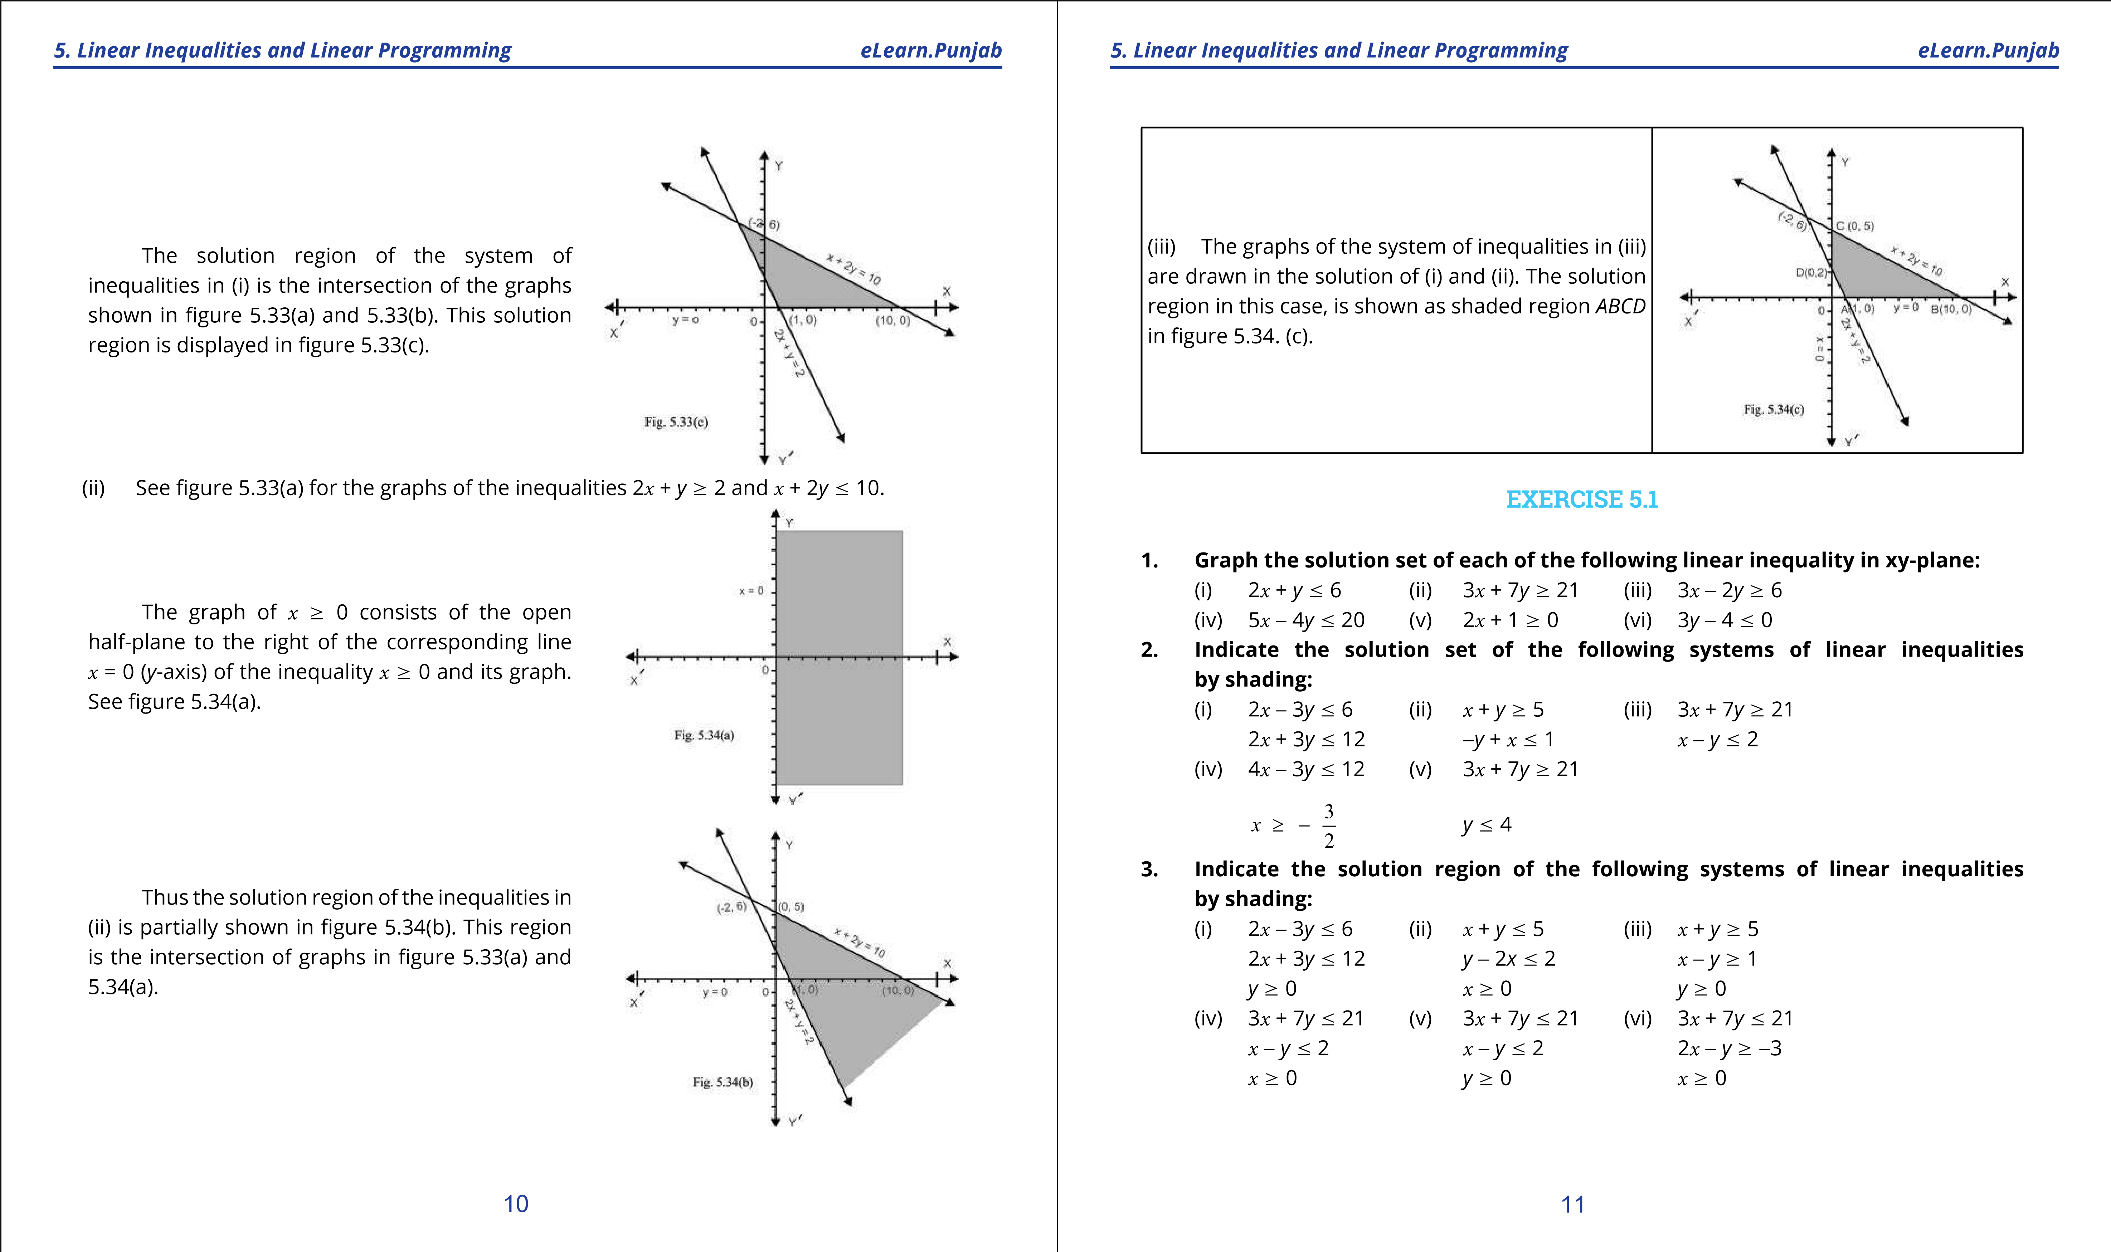

**1. Quadratic Equations eLearn.Punjab 1. Quadratic Equations eLearn.Punjab**

***5. Linear Inequalities and Linear Programming eLearn.Punjab 5. Linear Inequalities and Linear Programming eLearn.Punjab***

1. **Graph the solution region of the following system of linear inequalities and ind the corner points in each case.**
   1. 2*x* - 3*y* 7 6 (ii) *x* + *y* 7 5 (iii) 3*x* + 7*y* 7 21

2*x* + 3*y* 7 12 -2*x* + *y* 7 2 2*x* - *y* 7 -3 *x* 8 0 *y* 8 0 *y* 8 0

(iv) 3*x* + 2*y* 8 6 (v) 5*x* + 7*y* 7 35 (vi) 5*x* + 7*y* 7 35 *x* + 3*y* 7 6 -*x* + 3*y* 7 3 *x* - 2*y* 7 2 *y* 8 0 *x* 8 0 *x* 8 0

1. **Graph the solution region of the following system of linear inequalities by shading.**
   1. 3*x* - 4*y* 7 12 (ii) 3*x* - 4*y* 7 12 (iii) 2*x* + *y* 7 4

3*x* + 2*y* 8 3 *x* + 2*y* 7 6 2*x* - 3y 8 12 *x* + 2*y* 7 9 *x* + *y* 8 1 *x* + 2*y* 7 6

(iv) 2*x* + *y* 7 10 (v) 2*x* + 3*y* 7 18 (vi) 3*x* - 2*y* 8 3 *x* + *y* 7 7 2*x* + *y* 7 10 *x* + 4*y* 7 12

-2*x* + *y* 7 4 -2*x* + *y* 7 2 3*x* + *y* 7 12

## 5.4 PROBLEM CONSTRAINTS

In the beginning we described that linear inequalities prescribe limitations and restrictions on allocation of available sources. While tackling a certain problem from every day life each linear inequality concerning the problem is named as **problem constraint**. The system of linear inequalities involved in the problem concerned are called **problem constraints**. The variables used in the system of linear inequalities relating to the problems of every day life are non-negative and are called **non-negative constraints**. These nonnegative constraints play an important role for taking decision. So these variables are called **decision variables**.

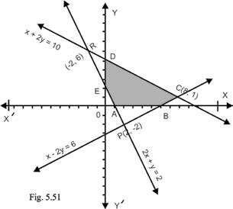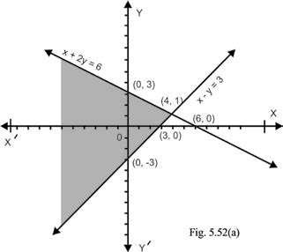

## 5.5 Feasible solution set

We see that solution region of the inequalities in example 2 of Art 5.3 is not within the irst quadrant. If the nonnegative constraints *x* 8 0 and *y* 8 0 are included with the system of inequalities given in the example 2, then the solution region is restricted to the irst quadrant.

It is the polygonal region *ABCDE* (including its sides) as shown in the igure 5.51.

Such a region (which is restricted to the irst quadrant) is referred to as a **feasible region** for the set of given constraints. Each point of the feasible region is called a **feasible solution** of the system of linear inequalities (or for the set of a given constraints). A set consisting of all the feasible solutions of the system of linear inequalities is called a **feasible solution set**.

**Example 1. Graph the feasible region and ind the corner points for the following system of inequalities (or subject to the following constraints).**

***x*** - ***y*** 7 **3**

***x* + 2*y*** 7 **6 , *x*** 8 **0, *y*** 8 **0**

**Solution:** The associated equations for the inequalities *x* - *y* 7 3 (i) and *x* + 2*y* 7 6 (ii) are *x* - *y* = 3 (1) and *x* + 2*y* = 6 (2)

As the point (3, 0) and (0, -3) are on the line (1), so the graph of *x* - *y* = 3 is drawn by joining the points (3, 0) and (0, -3) by solid line.

Similarly line (2) is graphed by joining the points (6, 0) and (0, 3) by solid line. For *x* = 0 and *y* = 0, we have;

0 - 0 = 073 and 0 + 2(0) = 076,

so both the ciosed half-planes are on the origin sides of the lines (1) and (2). The intersection of these closed half-planes is partially displayed as shaded region in igure 5.52(a).

### 12 13

**1**

**. Quadratic Equations**

**eLearn.Punjab**

**1**

**. Quadratic Equations**

**eLearn.Punjab**

***5***

***. Linear Inequalities and Linear Programming***

***5***

***. Linear Inequalities and Linear Programming***

***eLearn.Punjab***

***eLearn.Punjab***

14

15

For the graph of

*y*

8

0, see igure 5.33(b)

of the example 3 of art 5.3.

The intersection of graphs shown in

igures 5.52(a) and 5.33(b) is partially graphed

as shaded region in igure 5.52(b).

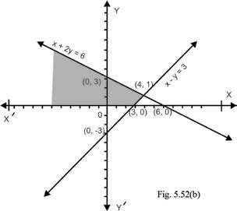

The graph of

*x*

8

0 is drawn in igure

. The intersection of the graphs shown

5.34(a)

in igures 5.52(a) and 5.34(a) is graphed in

igure 5.52(c).

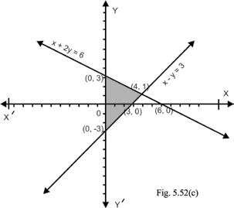

Finally the graph of the given system

of linear inequalities is displayed in igure

5.52(d)

which is the feasible region for the

given system of linear inequalities. The

points (0, 0), (3, 0), (4, 1) and (0, 3) are corner

points of the feasible region.

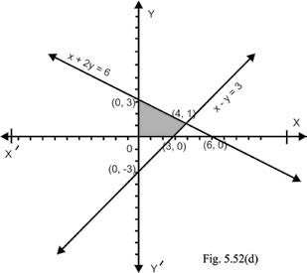

**Example 2.**

A manufacturer wants to make two types of concrete. Each bag of Agrade

concrete contains 8 kilograms of gravel (small pebbles with coarse sand) and 4 kilograms of

cement while each bag of B-grade concrete contains 12 kilograms of gravel and two kilograms

of cement. If there are 1920 kilograms of gravel and 480 kilograms of cement, then graph

the feasible region under the given restrictions and ind corner points of the feasible region.

**Solution:**

Let

*x*

be the number of bags of A-grade concrete produced and

*y*

denote the

number of bags of B-grade concrete produced, then 8

*x*

kilograms of gravel will be used

for A-grade concrete and 12

*y*

kilograms of gravel will be required for B-grade concretes so

8

*x*

+ 12

*y*

should not exceed 1920, that is,

8

*x*

+ 12

*y*

7

1920

Similarly, the linear constraint for cement will be

4

*x*

+ 2

*y*

7

480

Now we have to graph the feasible region for the

linear constraints

8

*x*

+ 12

*y*

7

1920

4

*x*

+ 2

*y*

7

480,

*x*

8

0,

*y*

8

0

Taking the one unit along

*x*

-

axis and

*y*

-

axis

equal to 40 we draw the graph of the feasible region

required.

The shaded region of igure 5.53(a) shows the

graph of 8

*x*

+ 12

*y*

7

1920 including the nonnegative

constraints

*x*

8

0 and

*y*

8

0

In the igure 5.53(b), the graph of 4

*x*

+ 2

*y*

7

480

including the non-negative constraints

*x*

8

0 and

*y*

8

0

is displayed as shaded region.

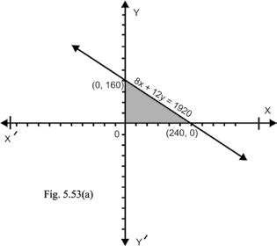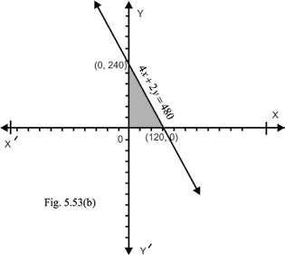

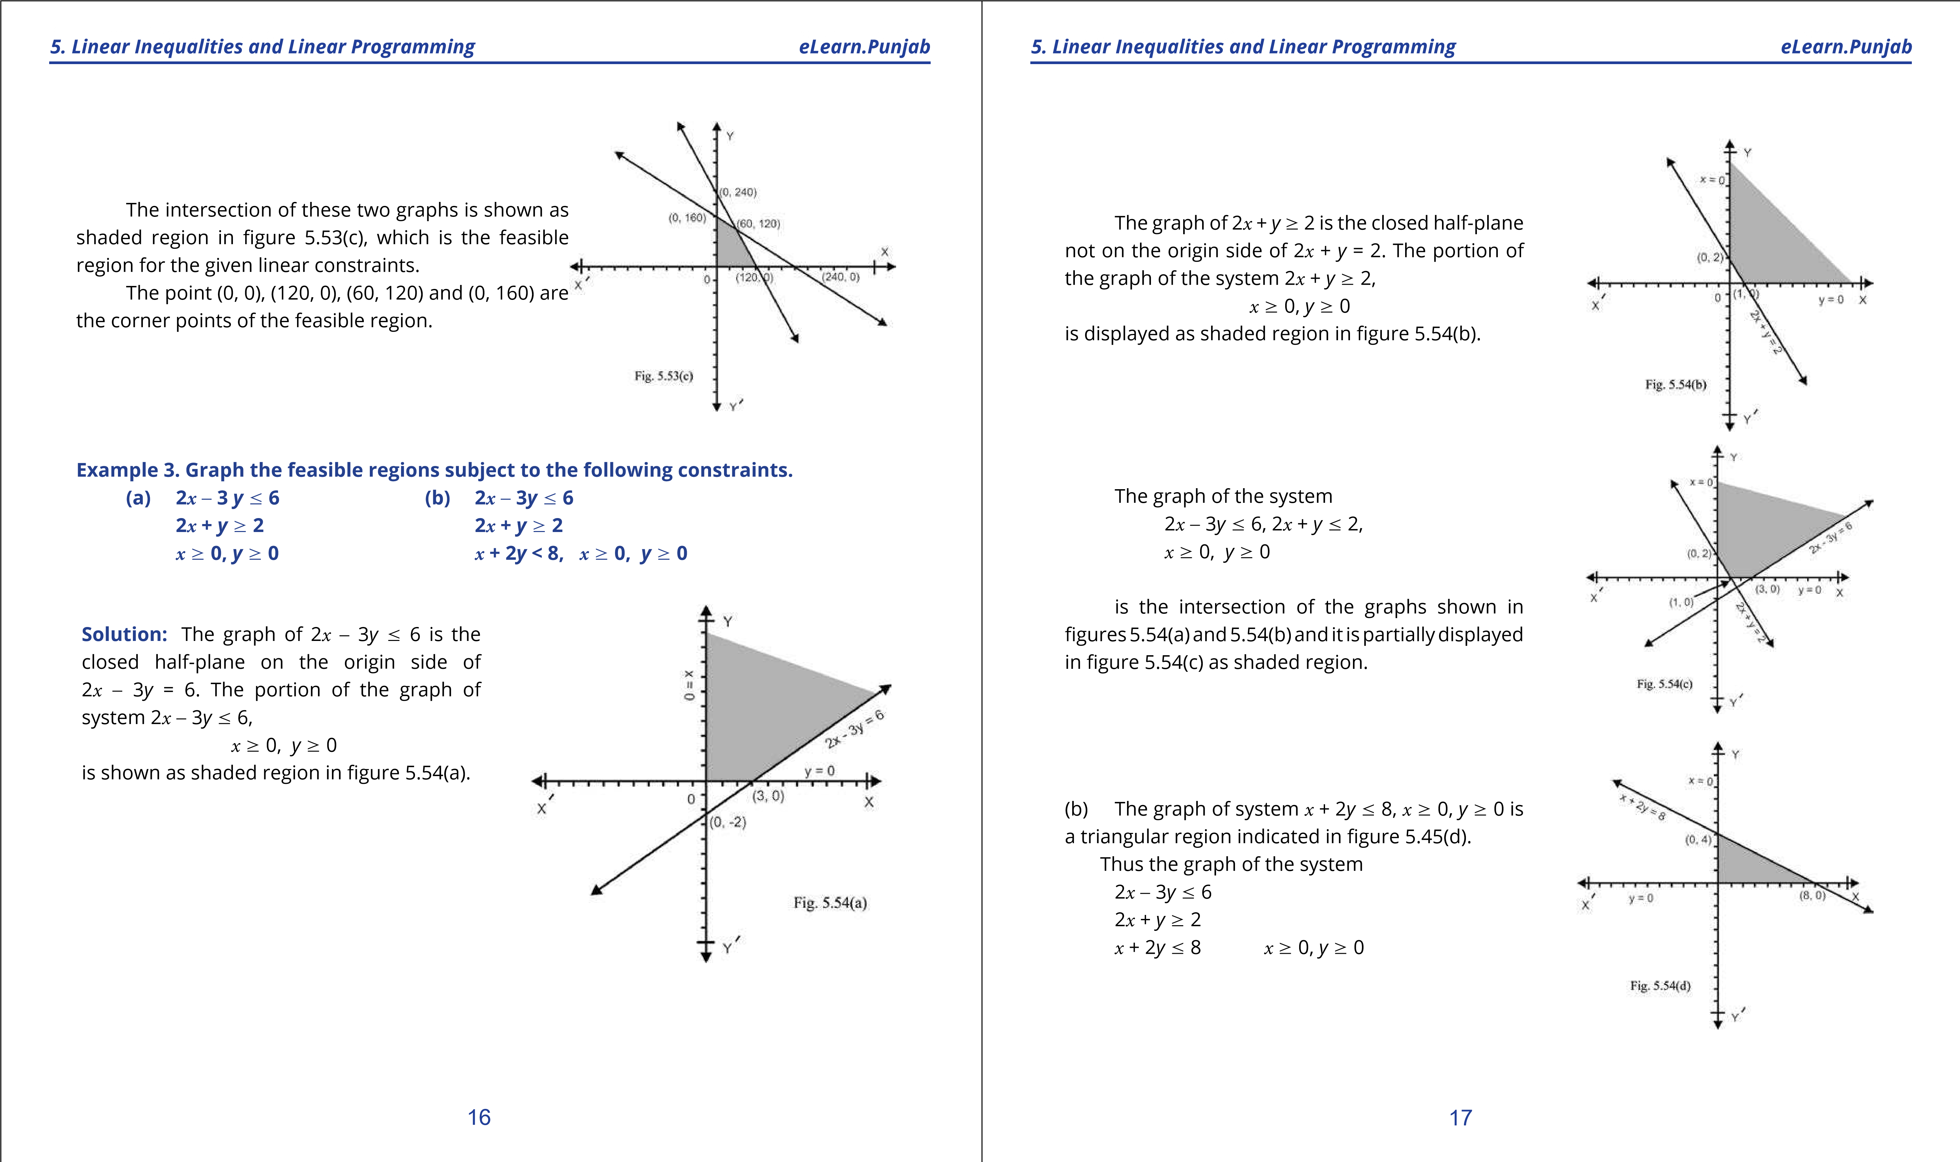

**1. Quadratic Equations eLearn.Punjab 1. Quadratic Equations eLearn.Punjab**

***5. Linear Inequalities and Linear Programming eLearn.Punjab 5. Linear Inequalities and Linear Programming eLearn.Punjab***

is the intersection of the graphs shown in igures 5.54(c) and 5.54(d). It is the shaded region indicated in the igure 5.54(e).

**Note:** The corner points of feasible region the set of constraints in (a) are (1, 0), (3, 0) and (0, 2) while the corner points of the feasible region for the set of constraints in (b) are (1, 0),

(3, 0),  36 *,* 10,(0, 4) and (0, 2)

 7 7 

We see that the feasible solution regions in example 3(a) and 3(b) are of diferent types. The feasible region in example 3(a) is unbounded as it cannot be enclosed in any circle how large it may be while the feasible region in example 3(b) can easily be enclosed within a circle, so it is bounded. If the line segment obtained by joining any two points of a region lies entirely within the region, then the region is called **convex**.

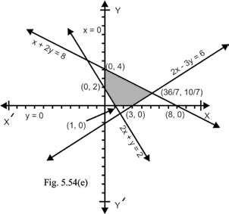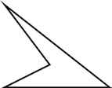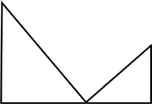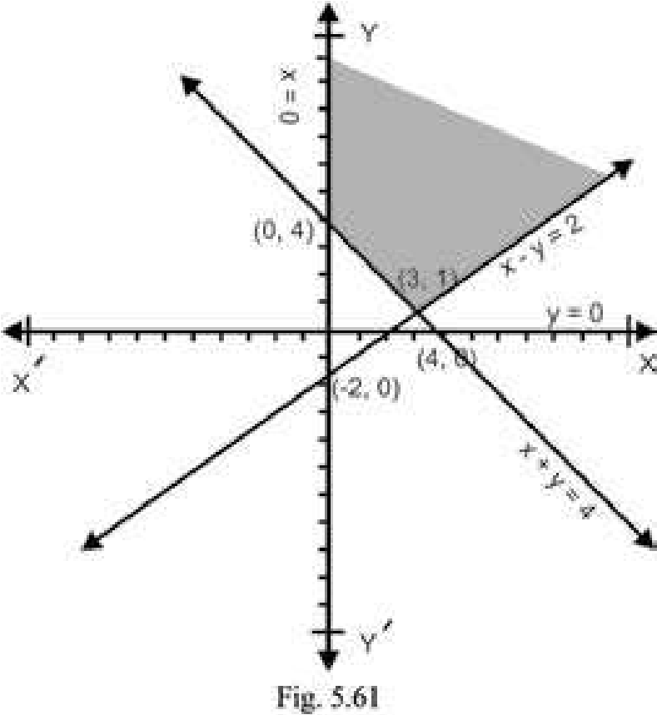

Both the feasible regions of example 3(a) and 3(b) are convex but the regions such as shown in the adjoining igures are not convex.

### **EXERCISE 5.2**

1. **Graph the feasible region of the following system of linear inequalities and ind the corner points in each case.**
   1. 2*x* - 3*y* 7 6 (ii) *x* + *y* 7 5 (iii) *x* + *y* 7 5 2*x* + 3*y* 7 12 -2*y* + *y* 7 2 -2*x* + *y* 8 2 *x* 8 0, *y* 8 0 *x* 8 0, *y* 8 0 *x* 8 0

(iv) 3*x* + 7*y* 7 21 (v) 3*x* + 2*y* > 6 (vi) 5*x* + 7*y* 7 35 *x* - *y* 7 3 *x* + *y* 7 4 *x* - 2*y* 7 4 *x* 8 0, *y* 8 0 *x* 8 0, *y* 8 0 *x* 8 0, *y* 8 0

1. **Graph the feasible region of the following system of linear inequalities and ind the corner points in each case.**
   1. 2*x* + *y* 7 10 (ii) 2*x* + 3*y* 7 18 (iii) 2*x* + 3*y* 7 18 *x* + 4*y* 7 12 2*x* + *y* 7 10 *x* + 4*y* 7 12 *x* + 2*y* 7 10 *x* + 4*y* 7 12 3*x* + *y* 7 12 *x* 8 0, y 8 0 *x* 8 0 , *y* 8 0 *x* 8 0, *y* 8 0 (iv) *x* + 2*y* 7 14 (v) *x* + 3*y* 7 15 (vi) 2*x* + *y* 7 20

3*x* + 4*y* 7 36 2*x* + *y* 7 12 8*x*+15*y* 7120 2*x* + *y* 7 10 4*x* + 3*y* 7 24 *x* + *y* 7 11 *x* 8 0, *y* 8 0 *x* 8 0, *y* 8 0 *x* 8 0, *y* 8 0

## 5.6 LINEAR PROGRAMMING

A function which is to be maximized or minimized is called an **objective function**. Note that there are ininitely many feasible solutions in the feasible region. The feasible solution which maximizes or minimizes the objective function is called the **optimal solution**. The theorem of linear programming states that the maximum and minimum values of the objective function occur at corner points of the feasible region.

**Procedure for determining optimal solution:**

1. Graph the solution set of linear inequality constraints to determine feasible region.
2. Find the corner points of the feasible region.
3. Evaluate the objective function at each corner point to ind the optimal solution.

**Example 1.** Find the maximum and minimum values of the function deined as:

*f*(*x*, *y*) = 2*x* + 3*y* subject to the constraints; *x* - *y* 7 2  *x* + *y* 7 4 2*x* - *y* 7 6, *x* 8 0

**Solution.** The graphs of *x* - *y* 7 2 is the closed half plane on the origin side of *x* - *y* = 2 and the graph of *x* + *y* 7 4 is the closed half-plane not on the origin side of *x* + *y* = 4. The graph

of the system *x* - *y* 7 2, *x* + *y* 8 4

### 18 19

**1. Quadratic Equations eLearn.Punjab 1. Quadratic Equations eLearn.Punjab**

***5. Linear Inequalities and Linear Programming eLearn.Punjab 5. Linear Inequalities and Linear Programming eLearn.Punjab***

including the non-negative constraints *x* 8 0 is partially displayed as shaded region in the igure 5.61. The graph of 2*x* - *y* 7 6 consists of the graph of the line 2*x* - *y* = 6 and the half plane on the origin side of the line 2*x* - *y*=6. A portion of the solution region of the given system of inequalities is shaded in the igure 5.62.

We see that feasible region is unbounded upwards and its corner points are *A*(0, 4), *B*(3, 1) and *C*(4, 2). Note that the point at which the lines *x* + *y* = 4 and 2*x* - *y* = 6 intersect is not a corner point of the feasible region.

It is obvious that the expression 2*x* + 3*y* does not posses a maximum value in the feasible region because its value can be made larger than any number by increasing *x* and *y*. We calculate the values of *f* at the corner points to ind its minimum value:

*f* (0, 4) = 2(0) + 3 x 4 = 12  *f* (3, 1) = 2 x 3 + 3 x 1 = 6 + 3 = 9  *f* (4, 2) = 2 x 4 + 3 x 2 = 8 + 6 = 14

Thus the minimum value of 2*x* + 3*y* is 9 at the corner point (3, 1).

**Note:** lf *f*(*x* , *y*) = 2*x* + 2*y*, then *f* (0 , 4) = 2 x 0 + 2 x 4 = 8, *f* (3, 1) = 2 x 3 + 2 x 1 = 6 + 2 = 8 and *f*(4, 2) = 2 x 4 + 2 x 2 = 8 + 4 =12. The minimum value of *2x* + *2y* is the same at two corner points (0, 4) and (3, 1).

We observe that the minimum value of 2*x* + 2*y* at each point of the line segment *AB* is

8 as:

*f*(*x*, *y*) = 2*x* + 2(4 - *x*) (*a*  *x* + *y* = 4 ⇒ *y* = 4 - *x*)

= 2*x* + 8 - 2x = 8

**Example 2.** Find the minimum and maximum values of *f* and f deined as: *f*(*x*, *y*) = 4*x* + 5*y*, f (*x*, *y*) = 4*x* + 6*y*

under the constraints

2*x* - 3*y* 7 6 2*x* + *y* 8 2 2*x* + 3*y* 7 12 *x* 8 0, *y* 8 0

**Solution.** The graphs of 2*x* - 3*y* 7 6, 2*x* + *y* 8 2, are displayed in the example 3 of

Art. 5.5. Joining the points (6. 0) and (0, 4), we obtain the graph of the line 2*x* + 3*y* = 12. As 2(0) + 3(0) = 0 < 12, so the graph of 2*x* + 3*y* < 12 is the half plane below the line 2*x* + 3*y* = 12. Thus the graph of 2*x* + 3*y* 7 12 consists of the graph of the line 2*x* + 3*y* = 12 and the half plane below the line 2*x* + 3*y* = 12. The solution region of 2*x* - 3*y* 7 6, 2*x* + *y* 8 2 and 2*x* + 3*y* 7 12 is the triangular region *PQR* shown in igure 5.63. The non-negative constraints *x* 8 0, *y* 80 indicated the irst quadrant. Thus the feasible region satisfying all the constrains is shaded in the igure 5.63 and its corner points are (1, 0) (0, 2), (0, 4),

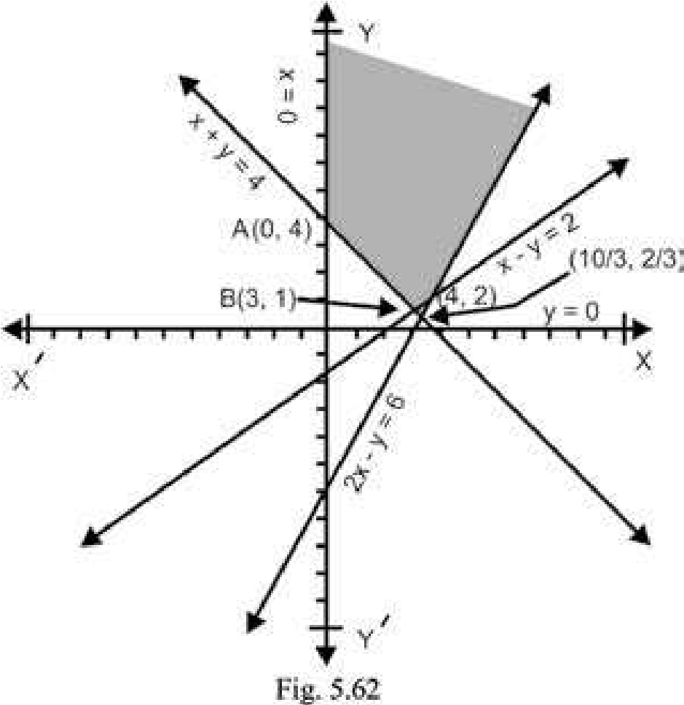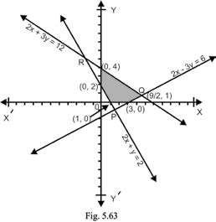

 92 , 1 and (3, 0).

We ind values of *f* at the corner points. **Corner**

***f*(*x*, *y*) = 4*x* + 5*y***

**point**

(1, 0) *f* (1, 0) = 4 x 1 + 5.0 = 4

(0, 2) *f* (0, 2) = 4 x 0 + 5.2 = 10

(0, 4) *f* (0, 4) = 4 x 0 + 5.4 = 20

(9/2, 1) *f* (9/2, 1) = 4 x 9/2 + 5.1 = 23

(3, 0) *f* (3, 0) = 4 x 3 + 50 x 0 = 12

From the above table, it follows that the minimum value of *f* is 4 at the corner point

(1points are given below in tabular form., 0) and maximum value of *f* is 23 at the corner point  92 , 1. The values of f at the corner

**Corner point** f**(*x*, *y*) = 4*x* + 5*y*** (1, 0) f (1, 0) = 4.1 + 6.0 = 4

(0, 2) f (0, 2) = 4.0 + 6.2 = 12

(0, 4) f (0, 4) = 4.0 + 6.4 = 24

(9/2, 1) f (9/2, 1) = 4 . 9/2 + 6.1 = 24

(3, 0) f (3, 0) = 4 x 3 + 6.0 = 12

The minimum value of f is 4 at the point (1, 0) and maximum value of f is 24 at the corner points (0, 4) and  92 , 1. As observed in the above example, it follows that the function f has maximum value at all the points of the line segment between the points

### 20 21

**1. Quadratic Equations eLearn.Punjab 1. Quadratic Equations eLearn.Punjab**

***5. Linear Inequalities and Linear Programming eLearn.Punjab 5. Linear Inequalities and Linear Programming eLearn.Punjab***

(0, 4) and  92 , 1.

**Note 1.** Some times it may happen that each point of constraint line gives the optimal value of the objective function.

**Note 2.** For diferent value of *k*, the equation 4*x* + 5*y* = *k* represents lines parallel to the line 4*x* + 5*y* = 0. For a certain admissible value of *k*, the intersection of 4*x* + 5*y* = *k* with the feasible region gives feasible solutions for which the proit is *k*.

## 5.7 LINEAR PROGRAMMING PROBLEMS

Convert a linear programming problem to a mathematical form by using variables, then follow the procedure given in Art 5.6.

**Example 1:** A farmer possesses 100 canals of land and wants to grow corn and wheat. Cultivation of corn requires 3 hours per canal while cultivation of wheat requires 2 hours per canal. Working hours cannot exceed 240. If he gets a proit of Rs. 20 per canal for corn and Rs. 15/- per canal for wheat, how many canals of each he should cultivate to maximize his proit?

**Solution:** Suppose that he cultivates *x* canals of corn and *y* canals of wheat. Then constraints can be written as:

*x* + *y* 7 100 3*x* + 2*y* 7 240

Non-negative constraints are *x* 8 0, *y* 8 0. Let *P*(*x*, *y*) be the proit function, then *P*(*x*, *y*) = 20*x* + 15*y*

Now the problem is to maximize the proit function *P* under the given constraints.

Graphing the inequalities, we obtain the feasible region which is shaded in the igure 5.71. Solving the equations *x* + *y* = 100 and 3*x* + 2*y* = 240 gives *x* = 240 - 2(*x* + *y*) = 240 - 200 = 40 and *y* = 100 - 40 = 60, that is; their point of intersection is (40, 60). The corner points of the feasible region are (0, 0),(0, 100), (40, 60) and (80, 0).

Now we ind the values of *P* at the corner points.

**Corner point *P*(*x*, *y*) = 20*x* + 15*y***

(0, 0) *P*(0, 0) = 2 0 x 0 + 15 x 0 = 0

(0, 100) *P*(0, 100) = 20 x 0 + 15 x 100 = 1500 (40, 60) *P*(40, 60) = 20 x 40 + 15 x 60 = 1700

(80, 0) *P*(80, 0) = 20 x 80 + 15 x 0 = 1600

From the above table, it follows that the maximum proit is Rs. 1700 at the corner point (40, 60). Thus the farmer will get the maximum proit if he cultivates 40 canals of corn and 60 canals of wheat.

**Exam ple 2.** A factory produces bicycles and motorcycles by using two machines *A* and *B*. Machine *A* has at most 120 hours available and machine *B* has a maximum of 144 hours available. Manufacturing a bicycle requires 5 hours in machine *A* and 4 hours in machine *B* while manufacturing of a motorcycle requires 4 hours in machine *A* and 8 hours in machine *B*. If he gets proit of Rs. 40 per bicycle and proit of Rs. 50 per motorcycle, how many bicycles and motorcycles should be manufactured to get maximum proit?

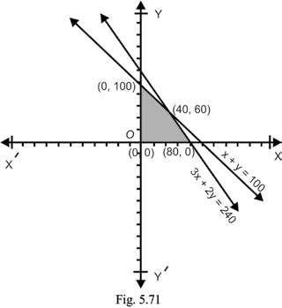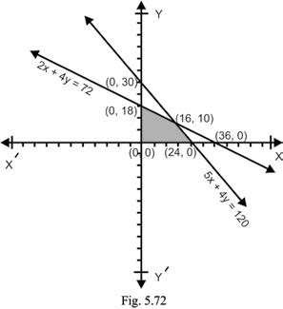

**Solution:** Let the number of bicycles to be manufactured be *x* and the number of motor cycles to be manufactured be *y*.

Then the time required to use machine *A* for *x* bicycles and *y* motorcycles is 5*x* + 4*y* (hours) and the time required to use machine *B* for *x* bicycles and *y* motorcycles in 4*x* + 8*y* (hours). Thus the problem constraints are

5*x* + 4*y* 7 120

And 4*x* + 8*y* 7 144

⇒ 2*x* + 4*y* 7 72 .

### 22 23

**1. Quadratic Equations eLearn.Punjab 1. Quadratic Equations eLearn.Punjab**

***5. Linear Inequalities and Linear Programming eLearn.Punjab 5. Linear Inequalities and Linear Programming eLearn.Punjab***

Since the numbers of articles to be produced cannot be negative, so *x* 8 0, *y* 8 0.

Let *P*(*x*, *y*) be the proit function, then *P*(*x*, *y*) = 40*x* + 50*y*.

Now the problem is to maximize *P* subject to the constraints:

5*x* + 4*y* 7 120 2*x* + 4*y* 7 72 ; *x* 8 0 , *y* 8 0

Solving 5*x* + 4*y* = 120 and 2*x* + 4*y* = 72, gives 3*x* = 48 ⇒ *x* = 16 and

4*y* = 72 - 2*x* = 72 - 32 = 40 ⇒ *y* = 10.

Thus their point of intersection is (16, 10). Graphing the linear inequality constraints, the feasible region obtained is depicted in the igure 5.72 by shading. The corner points of the feasible region are (0, 0), (0, 18), (16, 10) and (24, 0).

Now we ind the values of *P* at the comer points.

**Corner point *P*(*x*, *y*) = 40*x* + 50*y***

(0, 0) *P*(0, 0) = 40 x 0 + 50 x 0 = 0

(0, 18) *P*(0, 18) = 40 x 0 + 50 x 18 = 900

(16, 10) *P*(16, 10) = 40 x 16 + 50 x 10 = 1140

(24, 0) *P*(24, 0) = 40 x 24 + 50 x 0 = 960

From the above table, it follows, that the maximum proit is Rs. 1140 at the corner point (16, 10). Manufacturer gets the maximum proit if he manufactures 16 bicycles and 10 motorcycles.

### **EXERCISE 5.3**

1. Maximize *f*(*x*, *y*) = 2*x* + 5*y*  subject to the constraints

2*y* - *x* 7 8; *x* - *y* 7 4; *x* 0 8 0; *y* 8 0

1. Maximize *f*(*x* , *y*) = *x* + 3*y*  subject to the constraints

2*x* + 5*y* 7 30; 5*x* + 4*y* 7 20; *x* 8 0; *y* 8 0

1. Maximize *z* = 2*x* + 3*y*; subject to the constraints: 3*x* + 4*y* 7 12; 2*x* + *y* 7 4: 4*x* - *y* 7 4; *x* 8 0; *y* 8 0 **4.** Minimize *z* = 2*x* + *y*: subject to the constraints:

*x* + *y* 8 3; 7*x* + 5*y* 7 35; *x* 8 0; *y* 8 0

1. Maximize the function deined as; *f*(*x*, *y*) = 2*x* + 3*y* subject to the constraints:

2*x* + *y* 7 8; *x* + 2*y* 7 14; *x* 8 0; *y* 8 0

1. Minimize *z* = 3*x* + *y*; subject to the constraints:

3*x* + 5*y* 8 15; *x* + 6*y* 8 9; *x* 8 0; *y* 8 0

1. Each unit of food *X* costs Rs. 25 and contains 2 units of protein and 4 units of iron while each unit of food *Y* costs Rs. 30 and contains 3 units of protein and 2 unit of iron. Each animal must receive at least 12 units of protein and 16 units of iron each day. How many units of each food should be fed to each animal at the smallest possible cost?
2. A dealer wishes to purchase a number of fans and sewing machines. He has only Rs. 5760 to invest and has space atmost for 20 items. A fan costs him Rs. 360 and a sewing machine costs Rs. 240. His expectation is that the can sell a fan at a proit of Rs. 22 and a sewing machine at a proit of Rs. 18. Assuming that he can sell all the items that he can buy, how should he invest his money in order to maximize his proit?
3. A machine can produce product *A* by using 2 units of chemical and 1 unit of a compound or can produce product *B* by using 1 unit of chemical and 2 units of the compound. Only 800 units of chemical and 1000 units of the compound are available. The proits per unit of *A* and *B* are Rs. 30 and Rs. 20 respectively, maximize the proit function.

24 25

***version: 1.1***

# CHAPTER 6 Conic Sections

*Animation 6.1: Conic Section*

*Source and credit: eLearn.Punjab*

**1. Quadratic Equations eLearn.Punjab 1. Quadratic Equations eLearn.Punjab *6. Conic Sections eLearn.Punjab 6. Conic Sections eLearn.Punjab***

## 6.1 INTRODUCTION

**Conic sections** or simply **conics**, are the curves obtained by cutting a (double) right circular cone by a plane. Let *RS* be a line through the centre *C* of a given circle and perpendicular to its plane. Let *A* be a ixed point on *RS*. All lines through *A* and points on the circle generate a **right circular cone**. The lines are called rulings or generators of the cone. The surface generated consists of two parts, called **nappes**, meeting at the ixed point *A*, called the **vertex** or apex of the cone. The line ***RS*** is called **axis** of the cone. If the cone is cut by a plane perpendicular to the axis of the cone, then the section is a **circle**.

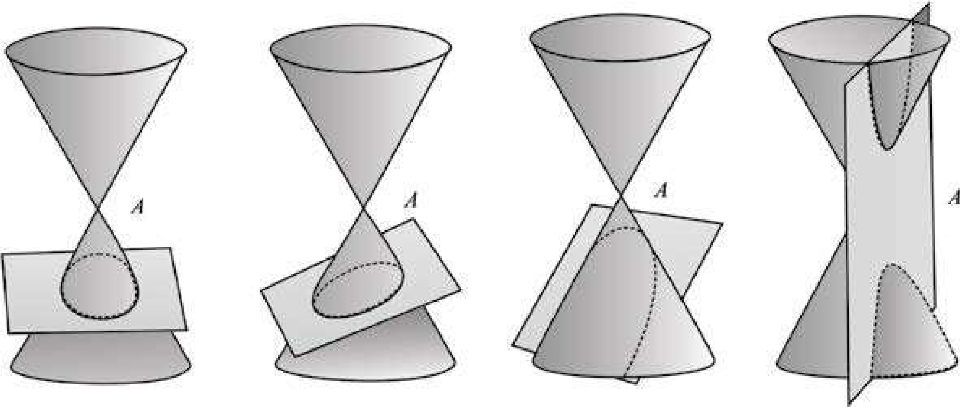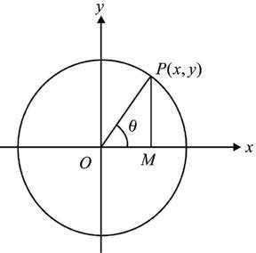

The size of the circle depends on how near the plane is to the vertex of the cone. If the plane passes through the vertex *A*, the intersection is just a single point or a **point circle**. If the cutting plane is slightly tilted and cuts only one nappe of the cone, the resulting section is an **ellipse**. If the intersecting plane is parallel to a generator of the cone, but intersects its one nappe only , the curve of intersection is a parabola. If the cutting plane is parallel to the axis of the cone and intersects both of its nappes, then the curve of intersection is a **hyperbola**.

The Greek mathematicians Apollonius’ (260-200 B.C.) and Pappus (early fourth century) discovered many intersecting properties of the conic sections. They used the methods of Euclidean geometry to study conics. We shall not study conics from the point of view stated above, but rather approach them with the more powerful tools of analytic geometry.

The theory of conics plays an important role in modern space mechanics, occeangraphy and many other branches of science and technology.

We irst study the properties of a Circle. Other conics will be taken up later.

### **6.1.1 Equation of a Circle**

The set of all points in the plane that are equally distant from a ixed point is called a circle. The ixed point is called the centre of the circle and the distance from the **center** of the circle to any point on the circle is called the **radius** of the circle.

If *C*(*h*,*k*) is centre of a circle, *r* its radius and *P*(*x*, *y*) any point on the circle, then the circle, denoted *S*(*C* ; *r*) in set notation is

*S C r*( ; ) =={*P x,y*( ):*CP r*}

By the distance formula, we get

*CP* = (*x* - *h*)2 +( *y* - *k*)2 = *r*  or (*x* - *h*)2 + ( *y* - *k*)2 = *r*2 (1) is an equation of the circle **in standard form**.

If the centre of the circle is the origin, then (1) reduces to

*x*2 + *y*2 = *r*2 (2)

If *r* = 0, the circle is called a **point circle** which consists of the centre only.

Let *P*(*x*, *y*) be any point on the circle (2) and let the inclination of *OP* be q as shown in the igure. It is clear that

1. = *rcos*q
2. = *r sin*q (3)

The point *P*(*r* cosq, *r* sin q) lies on (2) for all values of q. Equations (3) are called **parametric equations** of the circle (2).

**Example 1:** Write an equation of the circle with centre (-3, 5) and radius 7. **Solution:** Required equation is

### 2 3

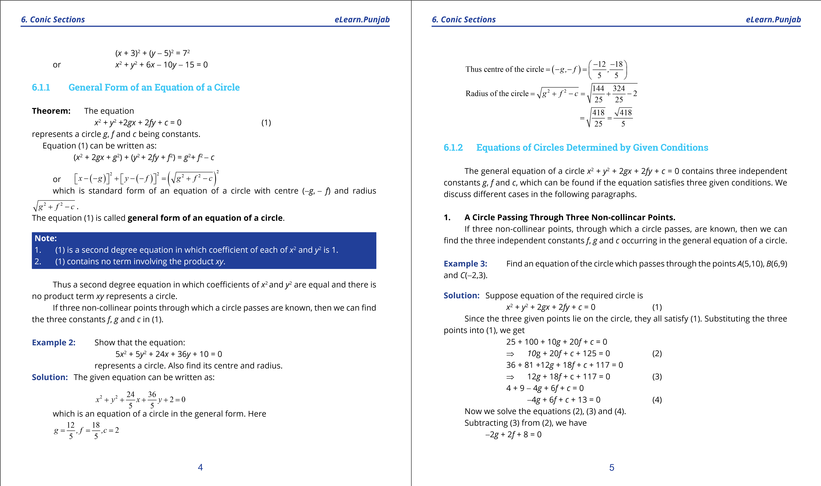

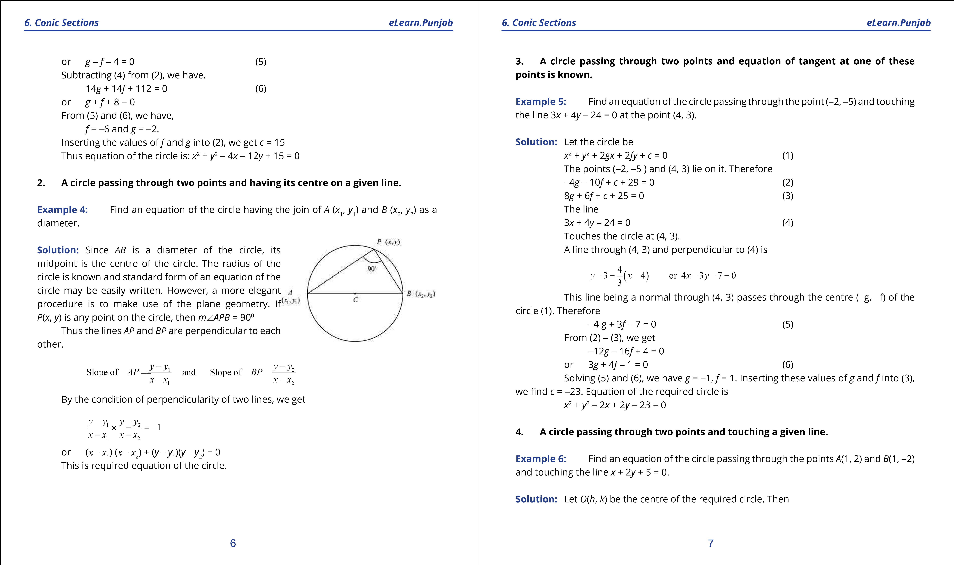

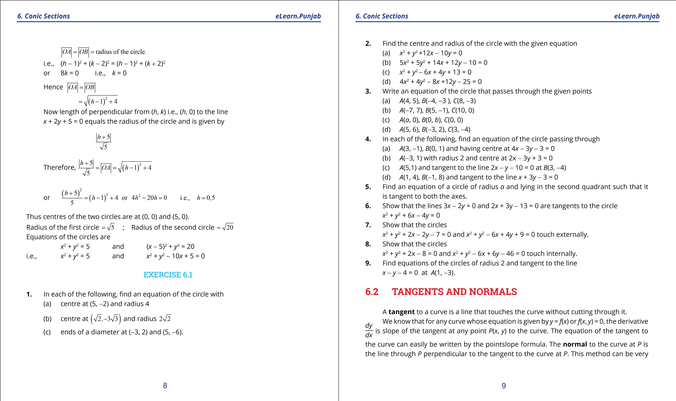

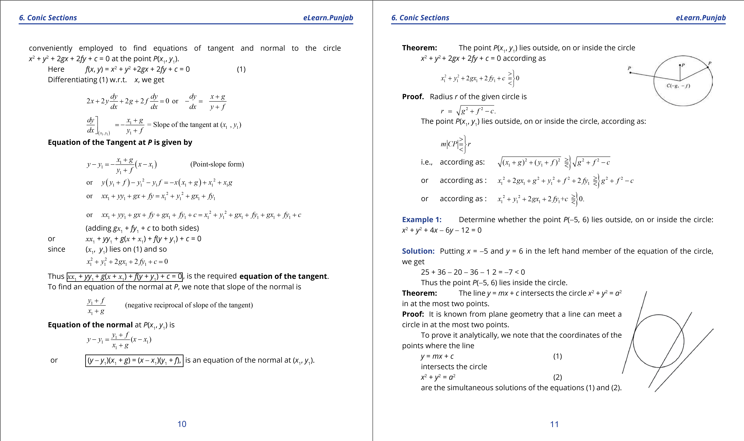

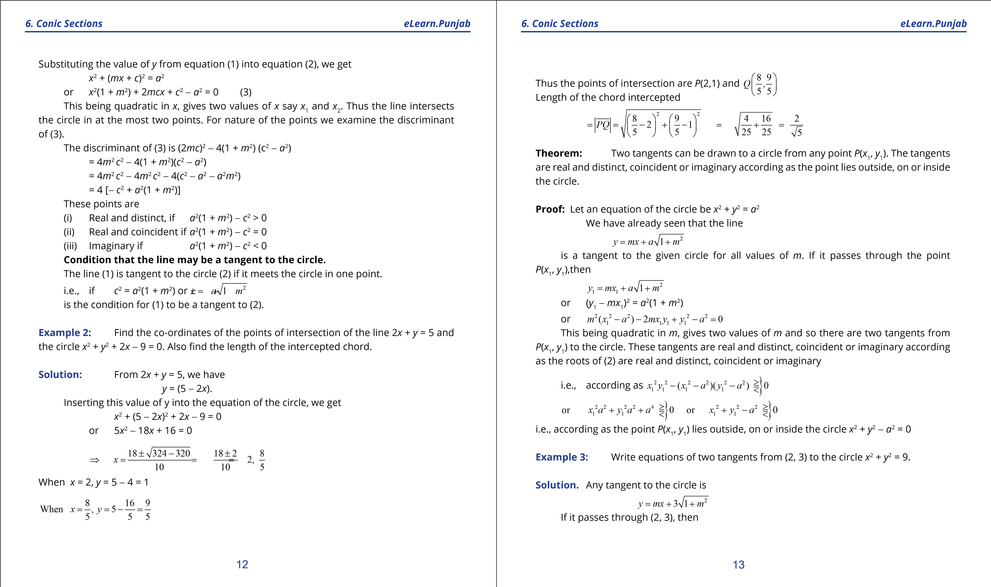

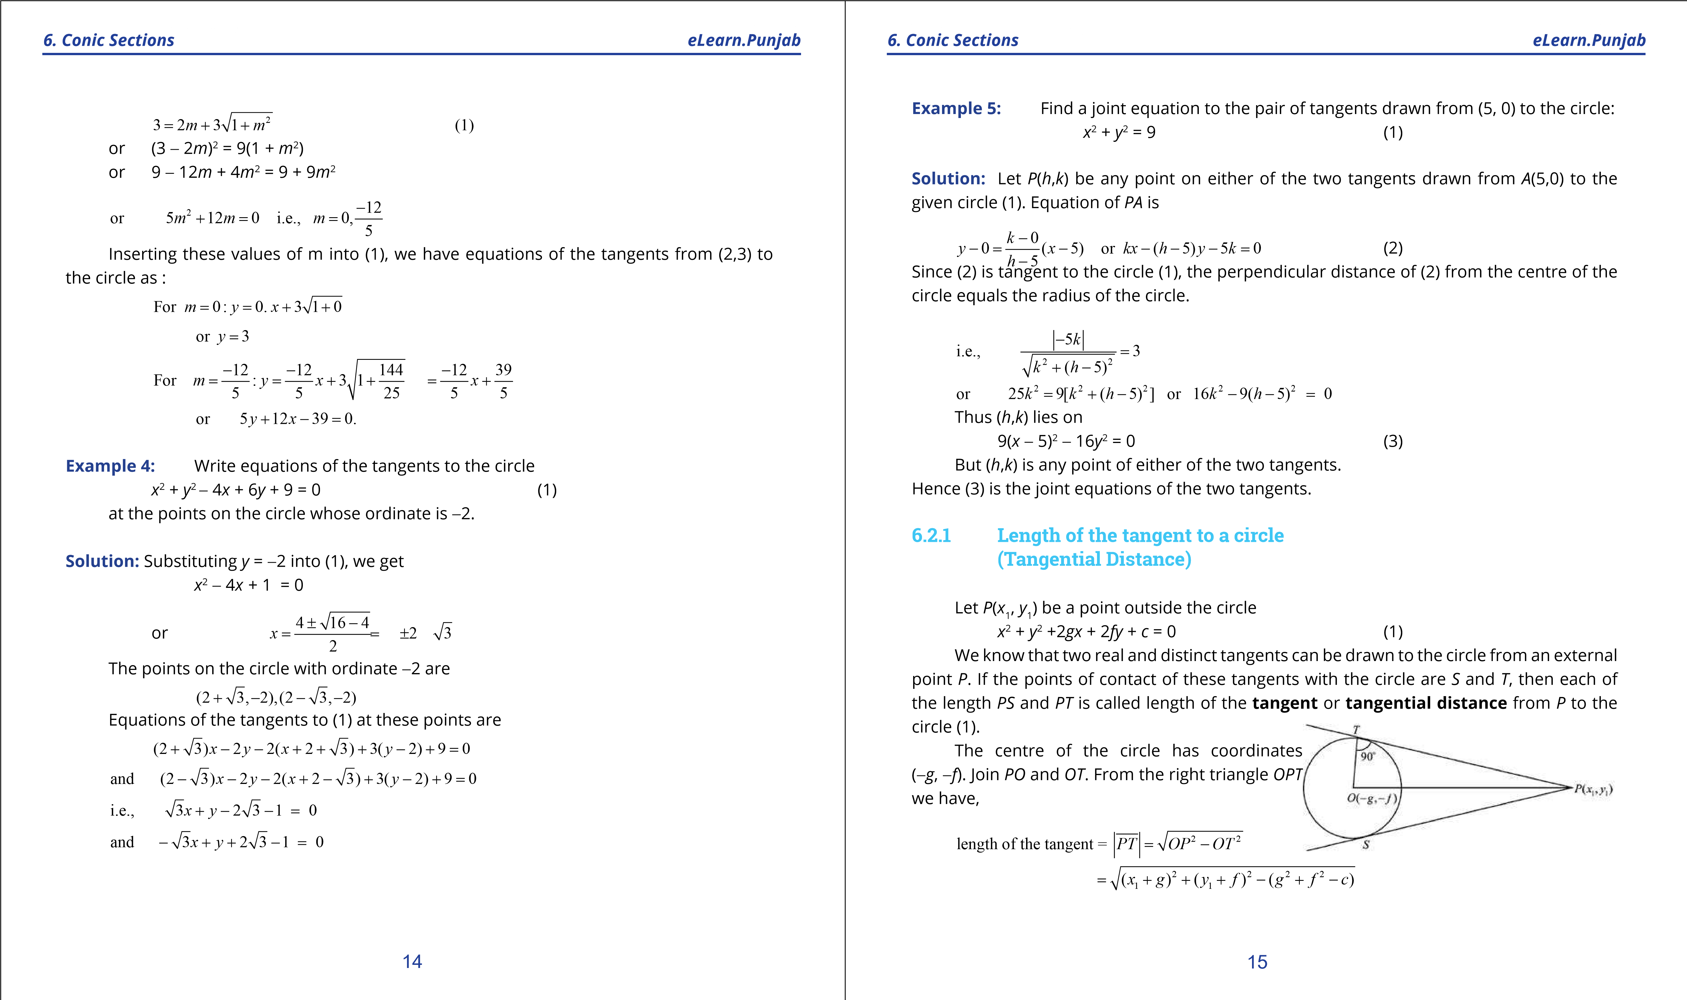

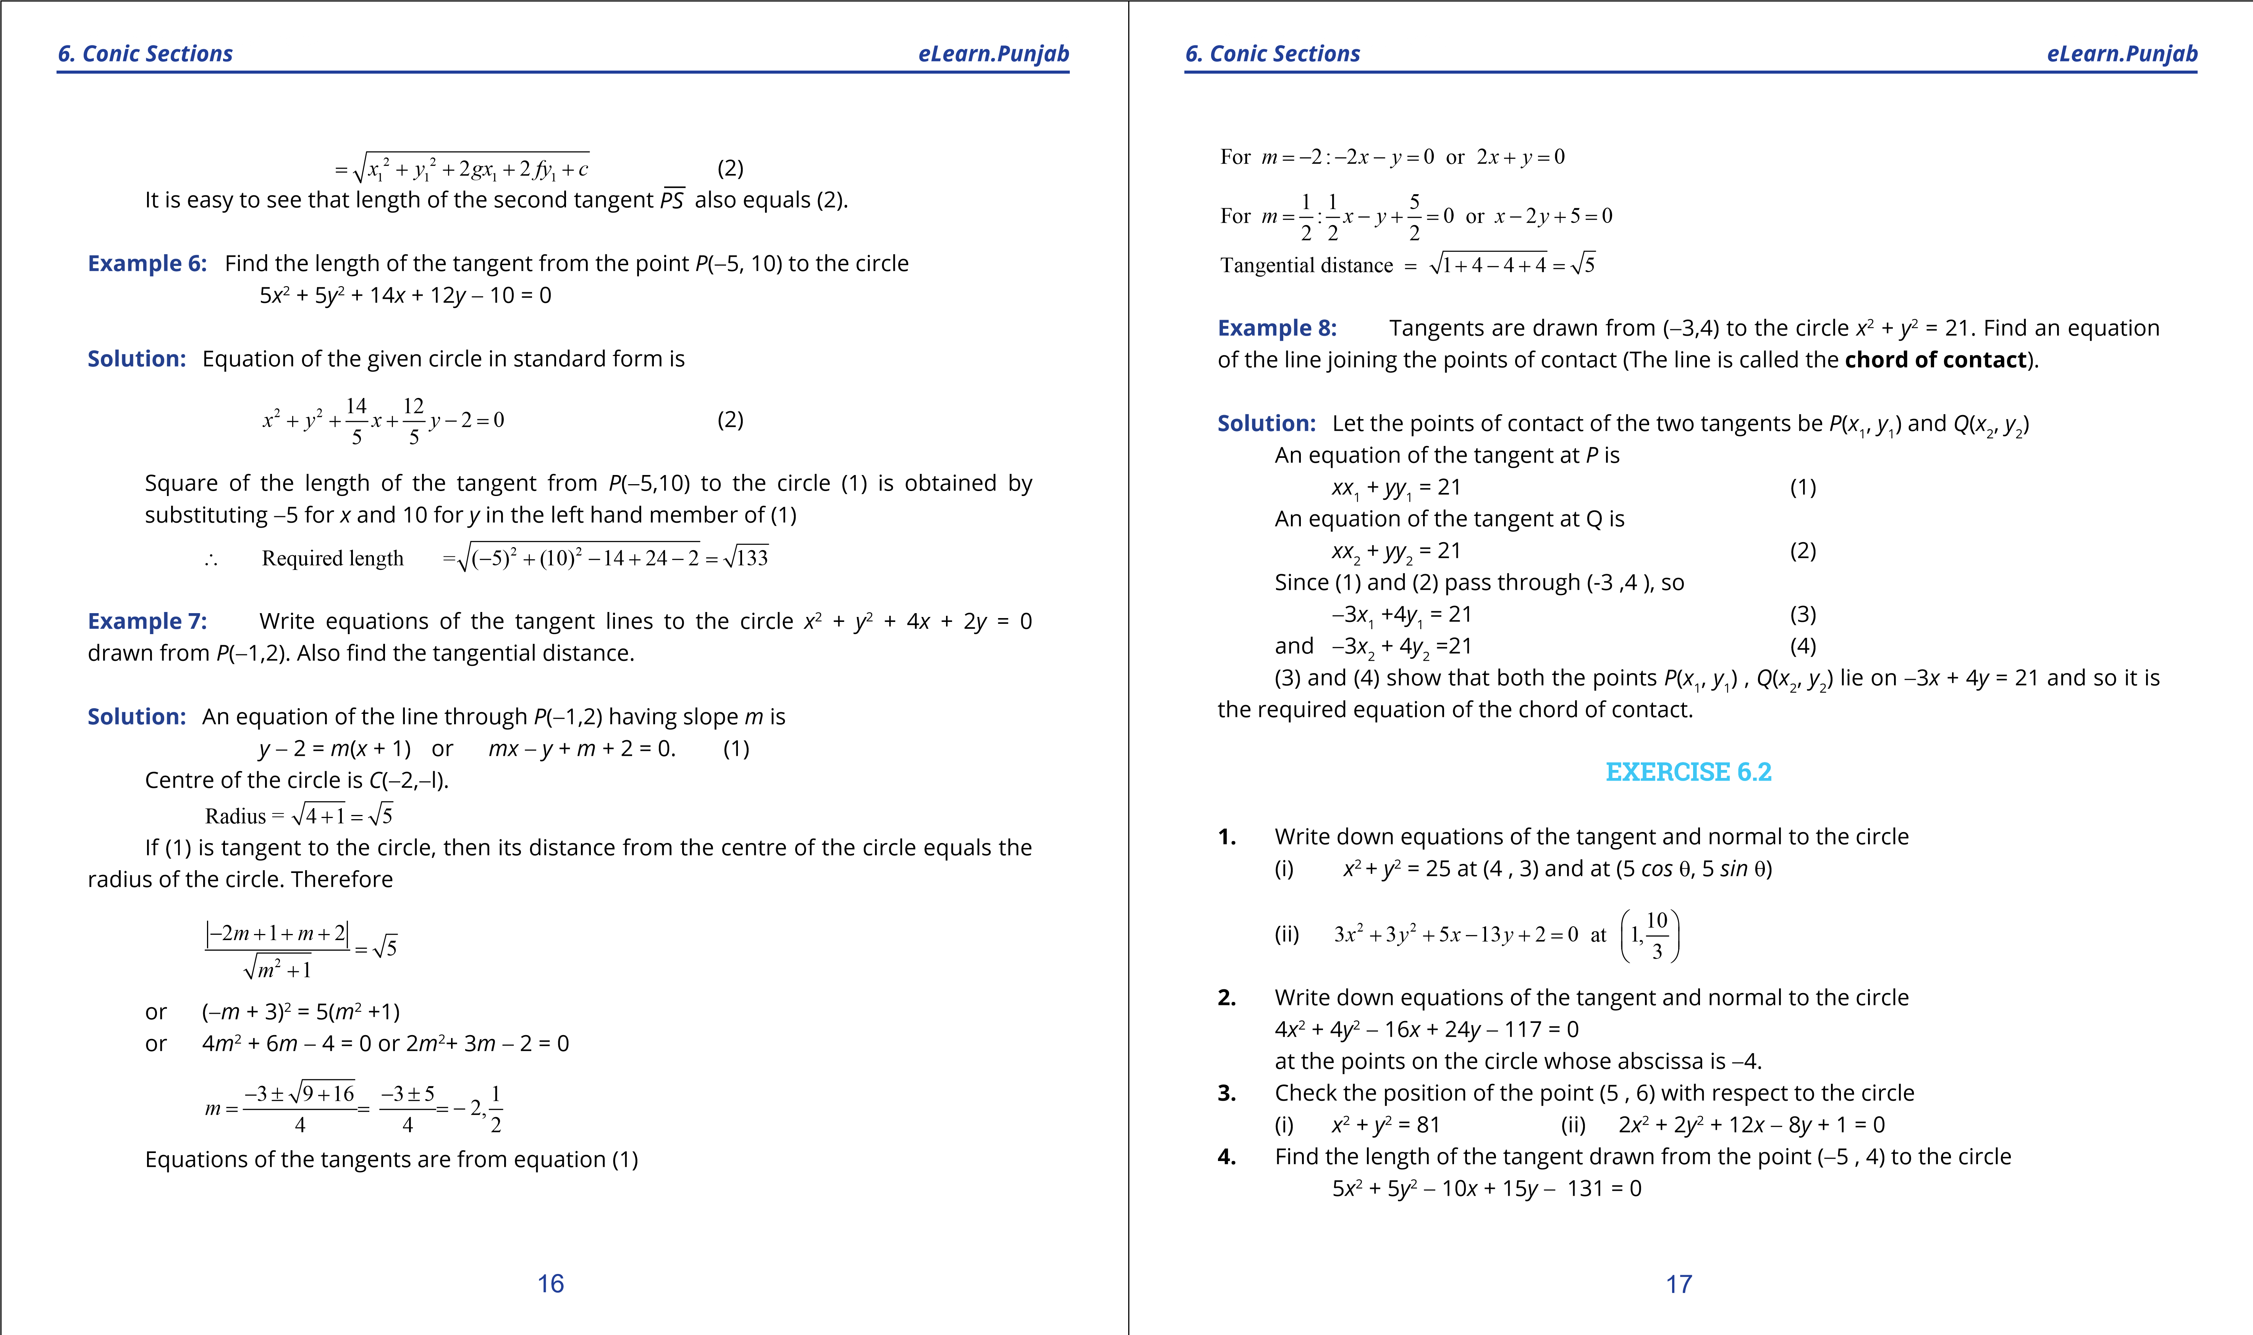

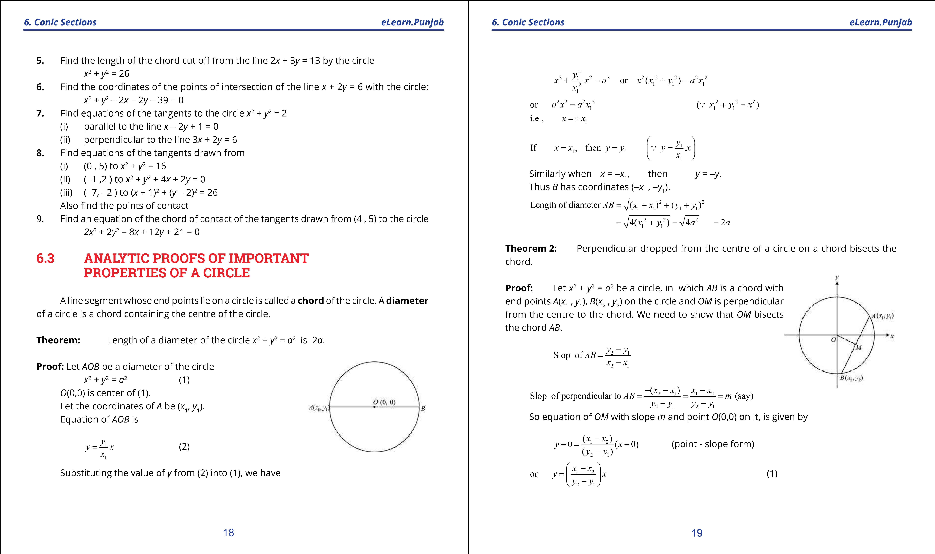

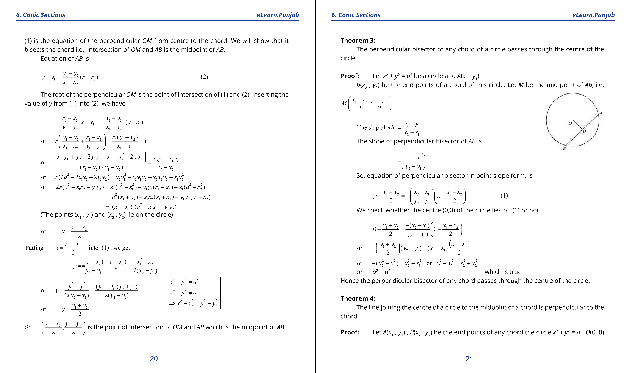

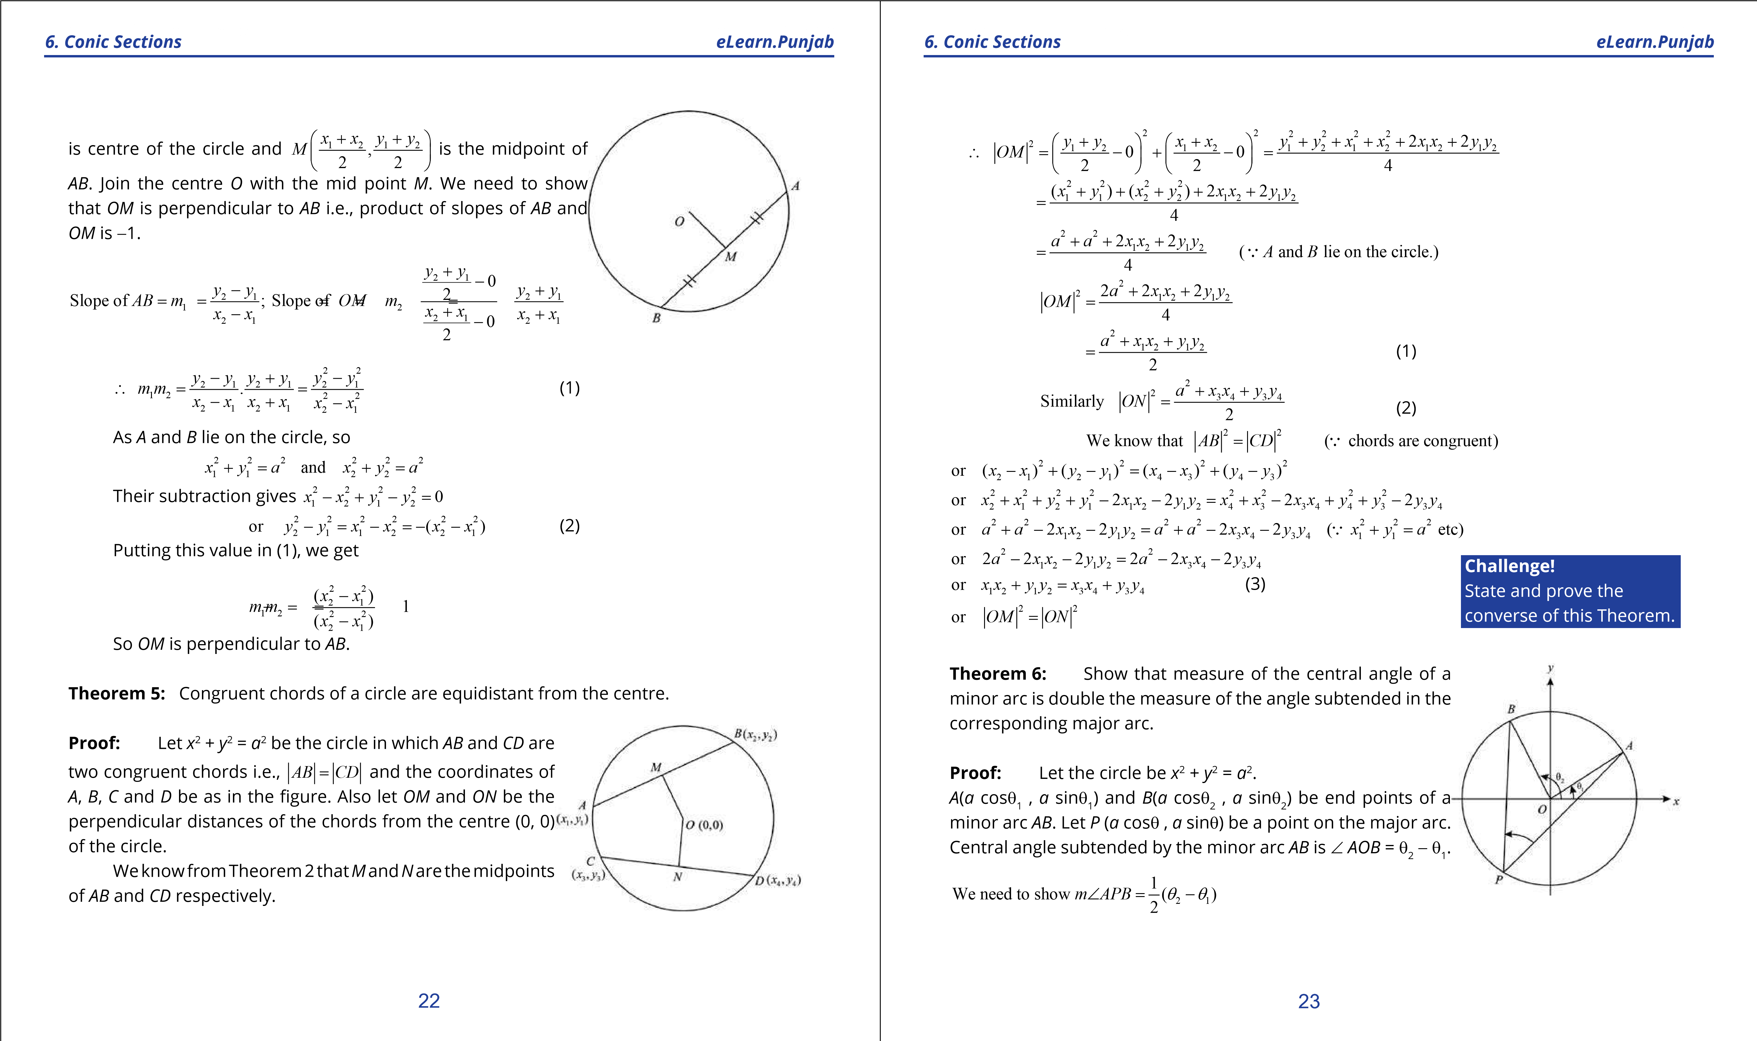

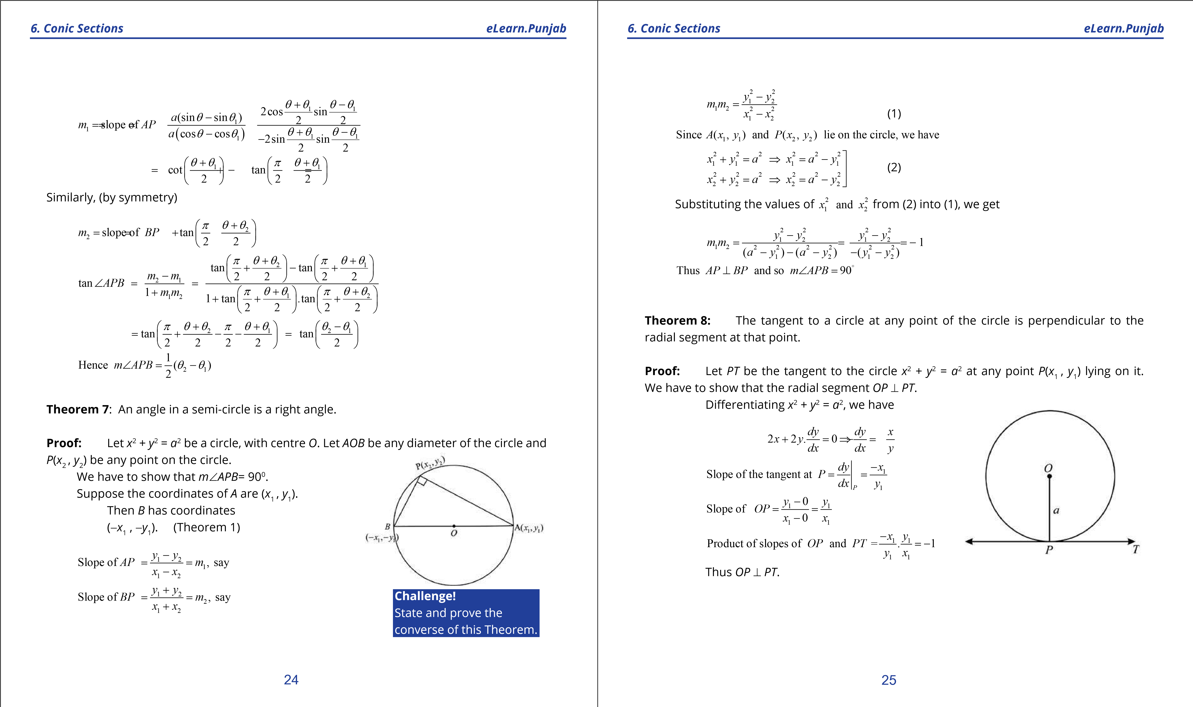

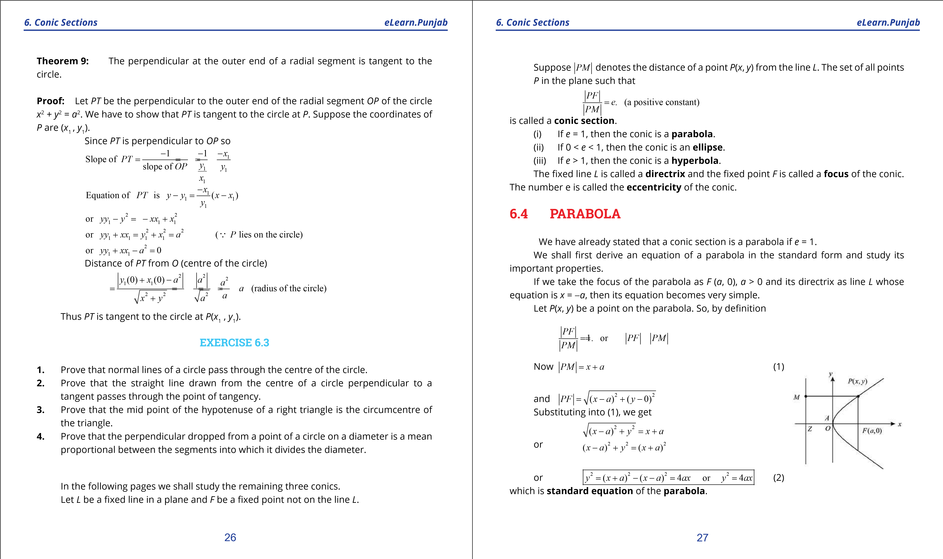

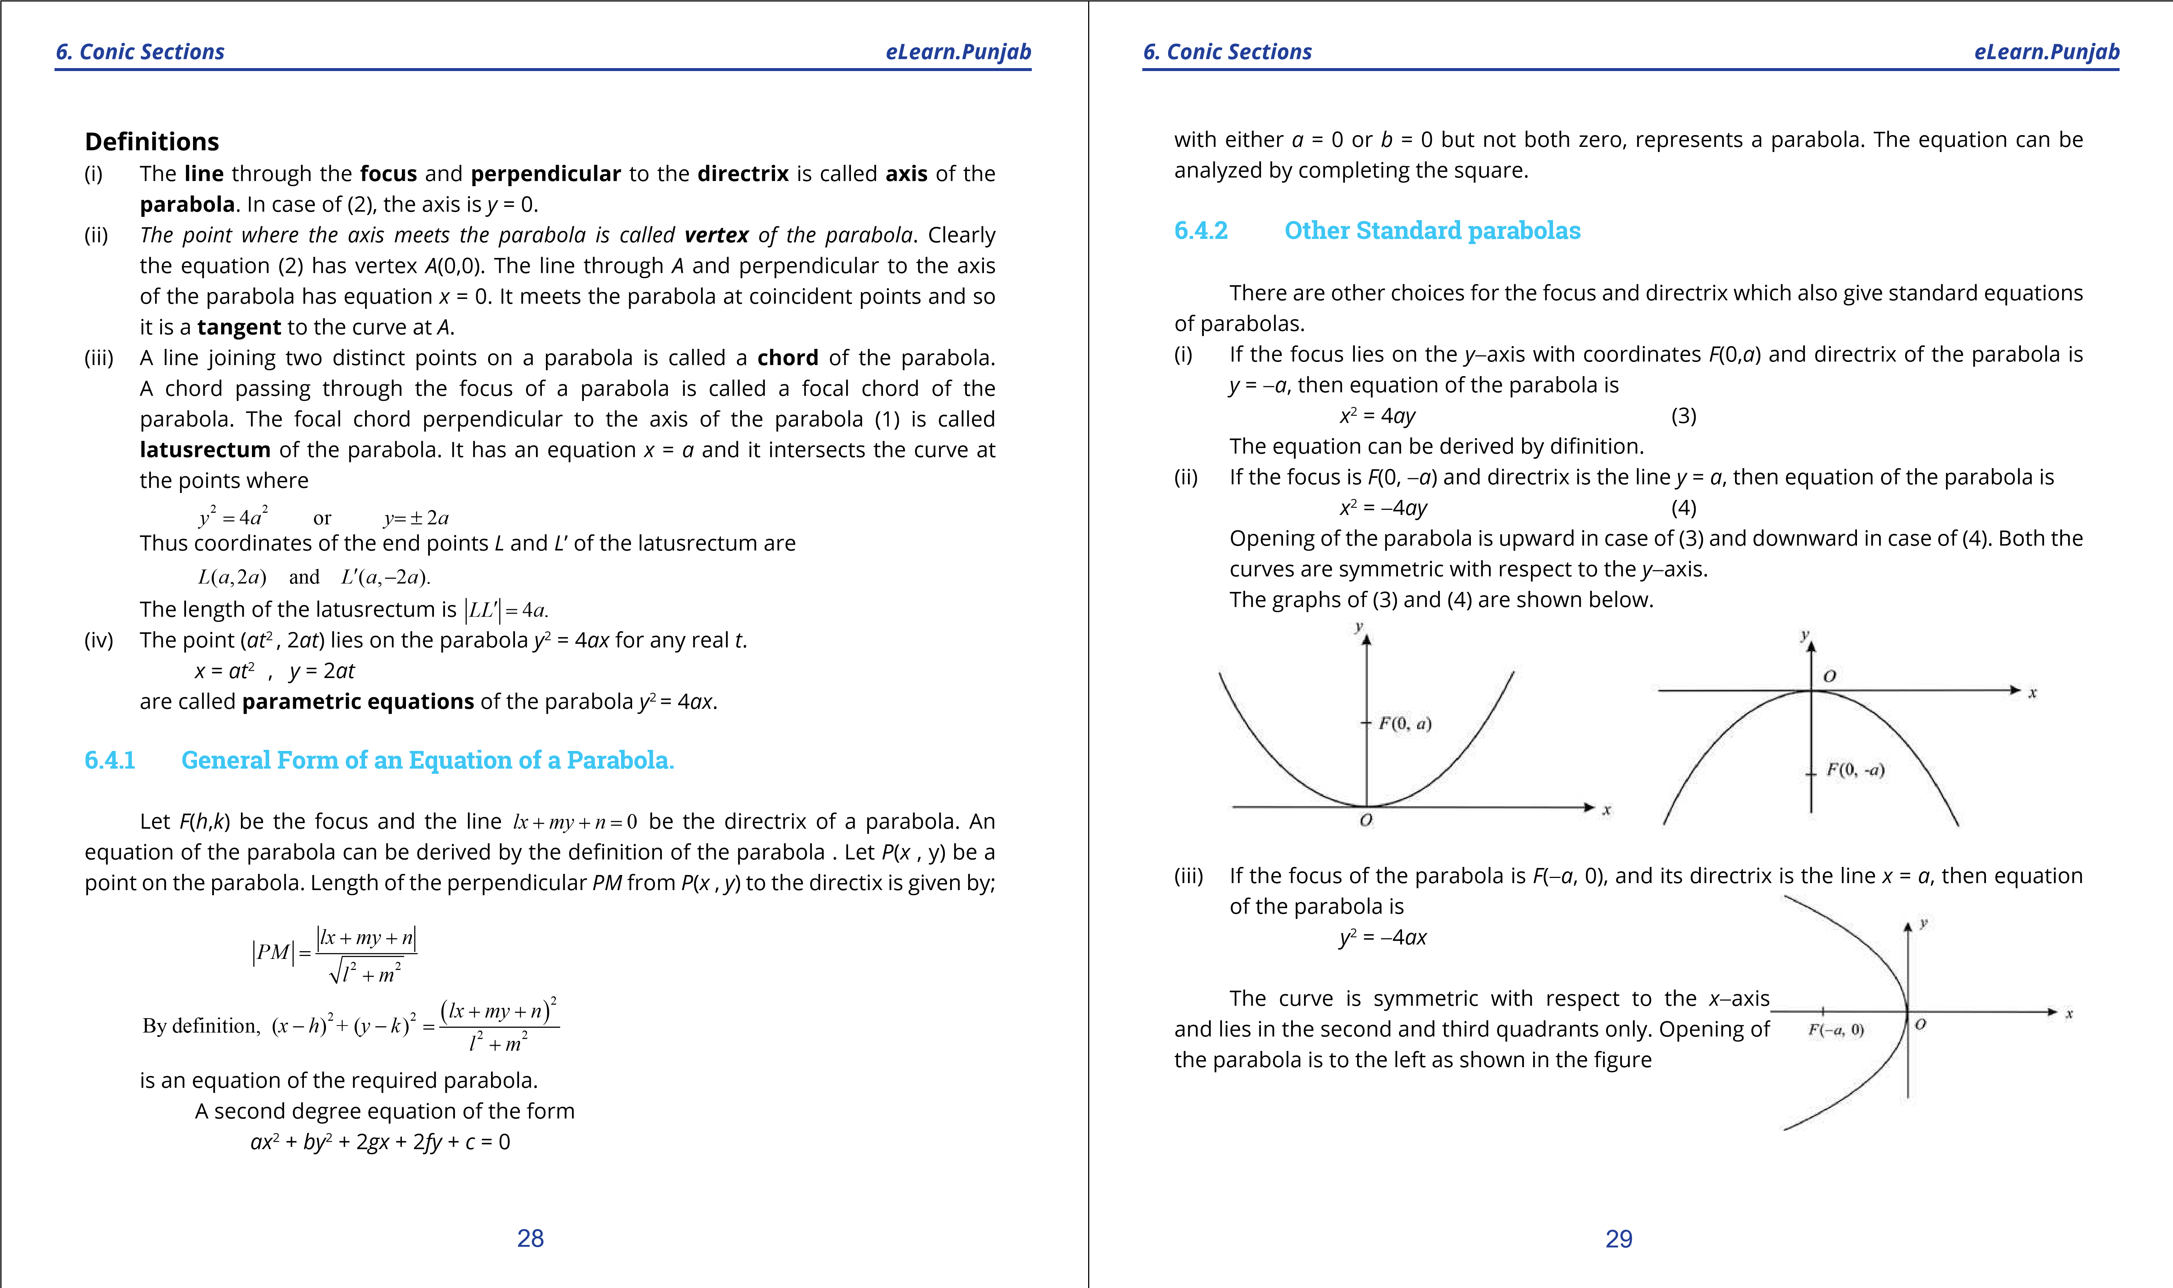

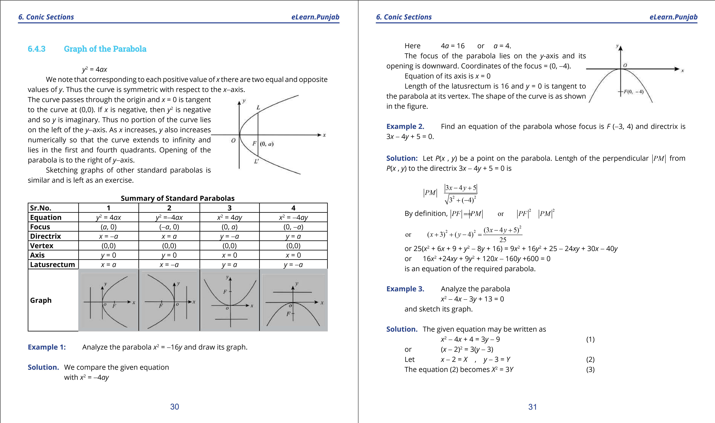

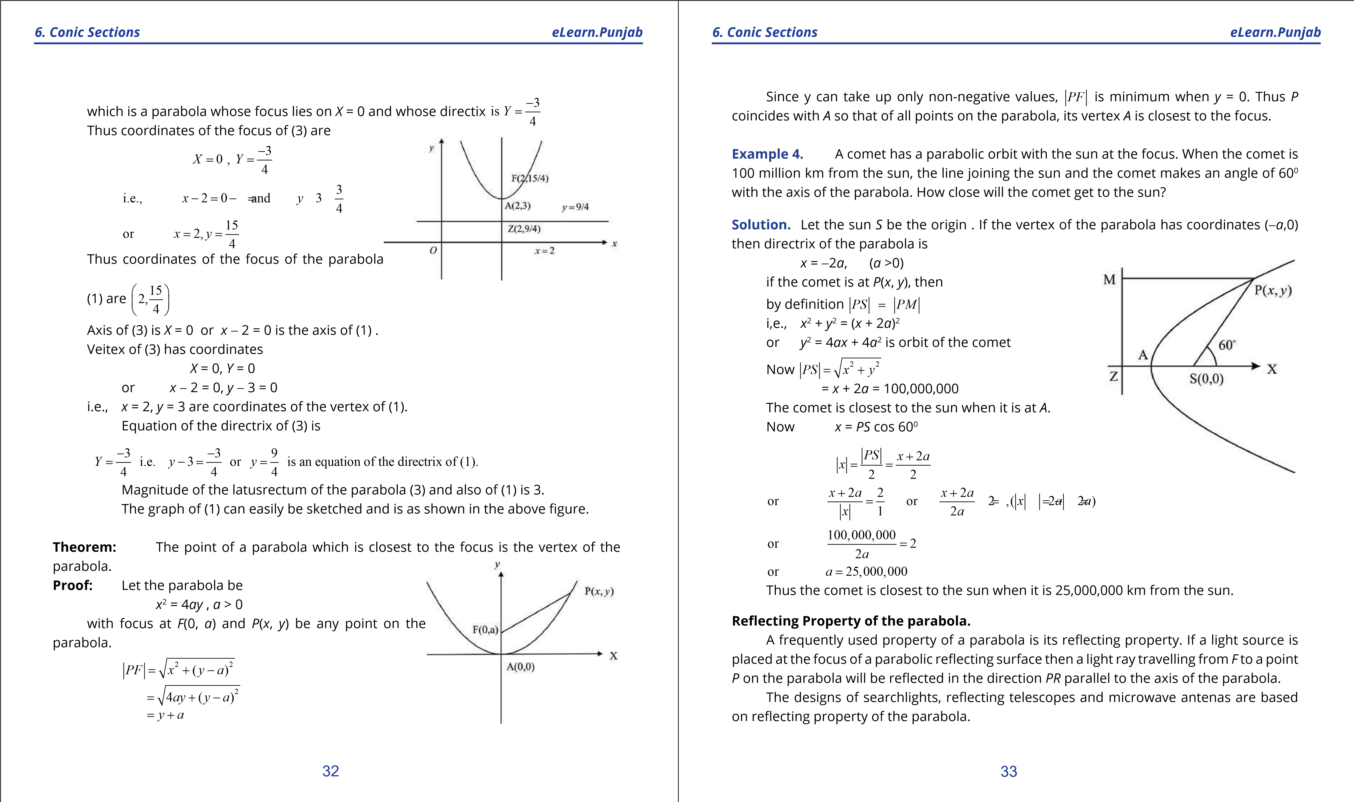

**1. Quadratic Equations eLearn.Punjab 1. Quadratic Equations eLearn.Punjab *6. Conic Sections eLearn.Punjab 6. Conic Sections eLearn.Punjab***

Another application of the parabola is in a

Suspension bridge. The main cables are of parabolic shape. The total weight of the bridge is uniformly distributed along its length if the shape of the cables is parabolic. Cables in any other shape will not carry the weight evenly.

**Example 6.** A suspension bridge with weight uniformly distributed along the length has two towers of 100 m height above the road surface and are 400 m apart. The cables are parabolic in shape and are tangent to road surface at the centre of the bridge. Find the height of the cables at a point 100 m from the centre.

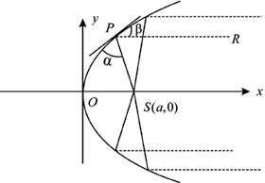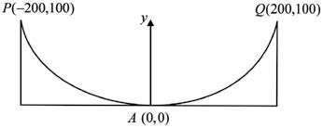

**Solution.** The parabola formed by the *P* cables has *A*(0, 0) as vertex and focus on the *y*-axis. An equation of this parabola is *x*2 = 4*ay*.

The point *Q*(200,100) lies on the parabola and so

(200)2 = 4*a* x 100 or *a* = 100 Thus an equation of the parabola is

*x*2 = 400y. (1) To ind the height of the cables when *x* = 100, we have from (1)

(100)2 = 400*y*  or *y* = 25 Thus required height = 25 m

### **EXERCISE 6.4**

1. Find the focus, vertex and directrix of the parabola. Sketch its graph.
   1. *y*2 = 8*x* (ii) *x*2 = -16*y* (iii) *x*2 = 5*y*

(iv) *y*2 = -12*x* (v) *x*2 = 4 (*y* - 1) (vi) *y*2 = -8(*x* - 3)

(vii) (*x* - 1)2 = 8(*y* + 2) (viii) *y* = 6*x*2 - 1

(ix) *x* + 8 - *y*2 + 2*y* = 0 (x) *x*2 - 4*x* - 8*y* + 4 = 0

1. Write an equation of the parabola with given elements.
   1. Focus (-3, 1) ; directrix *x* = 3
   2. Focus (2, 5) ; directrix *y* = 1
   3. Focus (-3, 1) ; directrix *x* - 2*y* - 3 = 0
   4. Focus (1, 2) ; vertex (3, 2)
   5. Focus (-1, 0) ; vertex (-1, 2)
   6. Directrix *x* = -2 ; Focus (2, 2)
   7. Directrix *y* = 3 ; vertex (2, 2)
   8. Directrix *y* = 1, length of latusrectum is 8. Opens downward.
   9. Axis *y* = 0, through (2, 1) and (11, -2)
   10. Axis parallal to *y*-axis, the points (0, 3), (3, 4) and (4, 11) lie on the graph.
2. Find an equation of the parabola having its focus at the origon and directrix, parallel to the (i) *x*-axis (ii) *y*-axis.
3. Show that an equation of the parabola with focus at (*a*cosa, *a*sina) and directrix *x* cos a + *y*sina + *a* = 0 is (*x*sina - *y*cosa)2 = 4*a*(*x*cosa + *y*sina)
4. Show that the ordinate at any point *P* of the parabola is a mean proportional between the length of the latus rectum and the abscissa of *P*.
5. A comet has a parabolic orbit with the earth at the focus. When the comet is 150,000 km from the earth, the line joining the comet and the earth makes an angle of 300 with the axis of the parabola. How close will the comet come to the earth?
6. Find an equation of the parabola formed by the cables of a suspension bridge whose span is *a* m and the vertical height of the supporting towers is *b* m.
7. A parabolic arch has a 100 m base and height 25 m. Find the height of the arch at the point 30 m from the centre of the base.
8. Show that tangent at any point *P* of a parabola makes equal angles with the line *PF* and the line through *P* parallel to the axis of the parabola, *F* being focus.

(These angles are called respectively angle of **incidence** and angle of **relection**).

#### 34 35

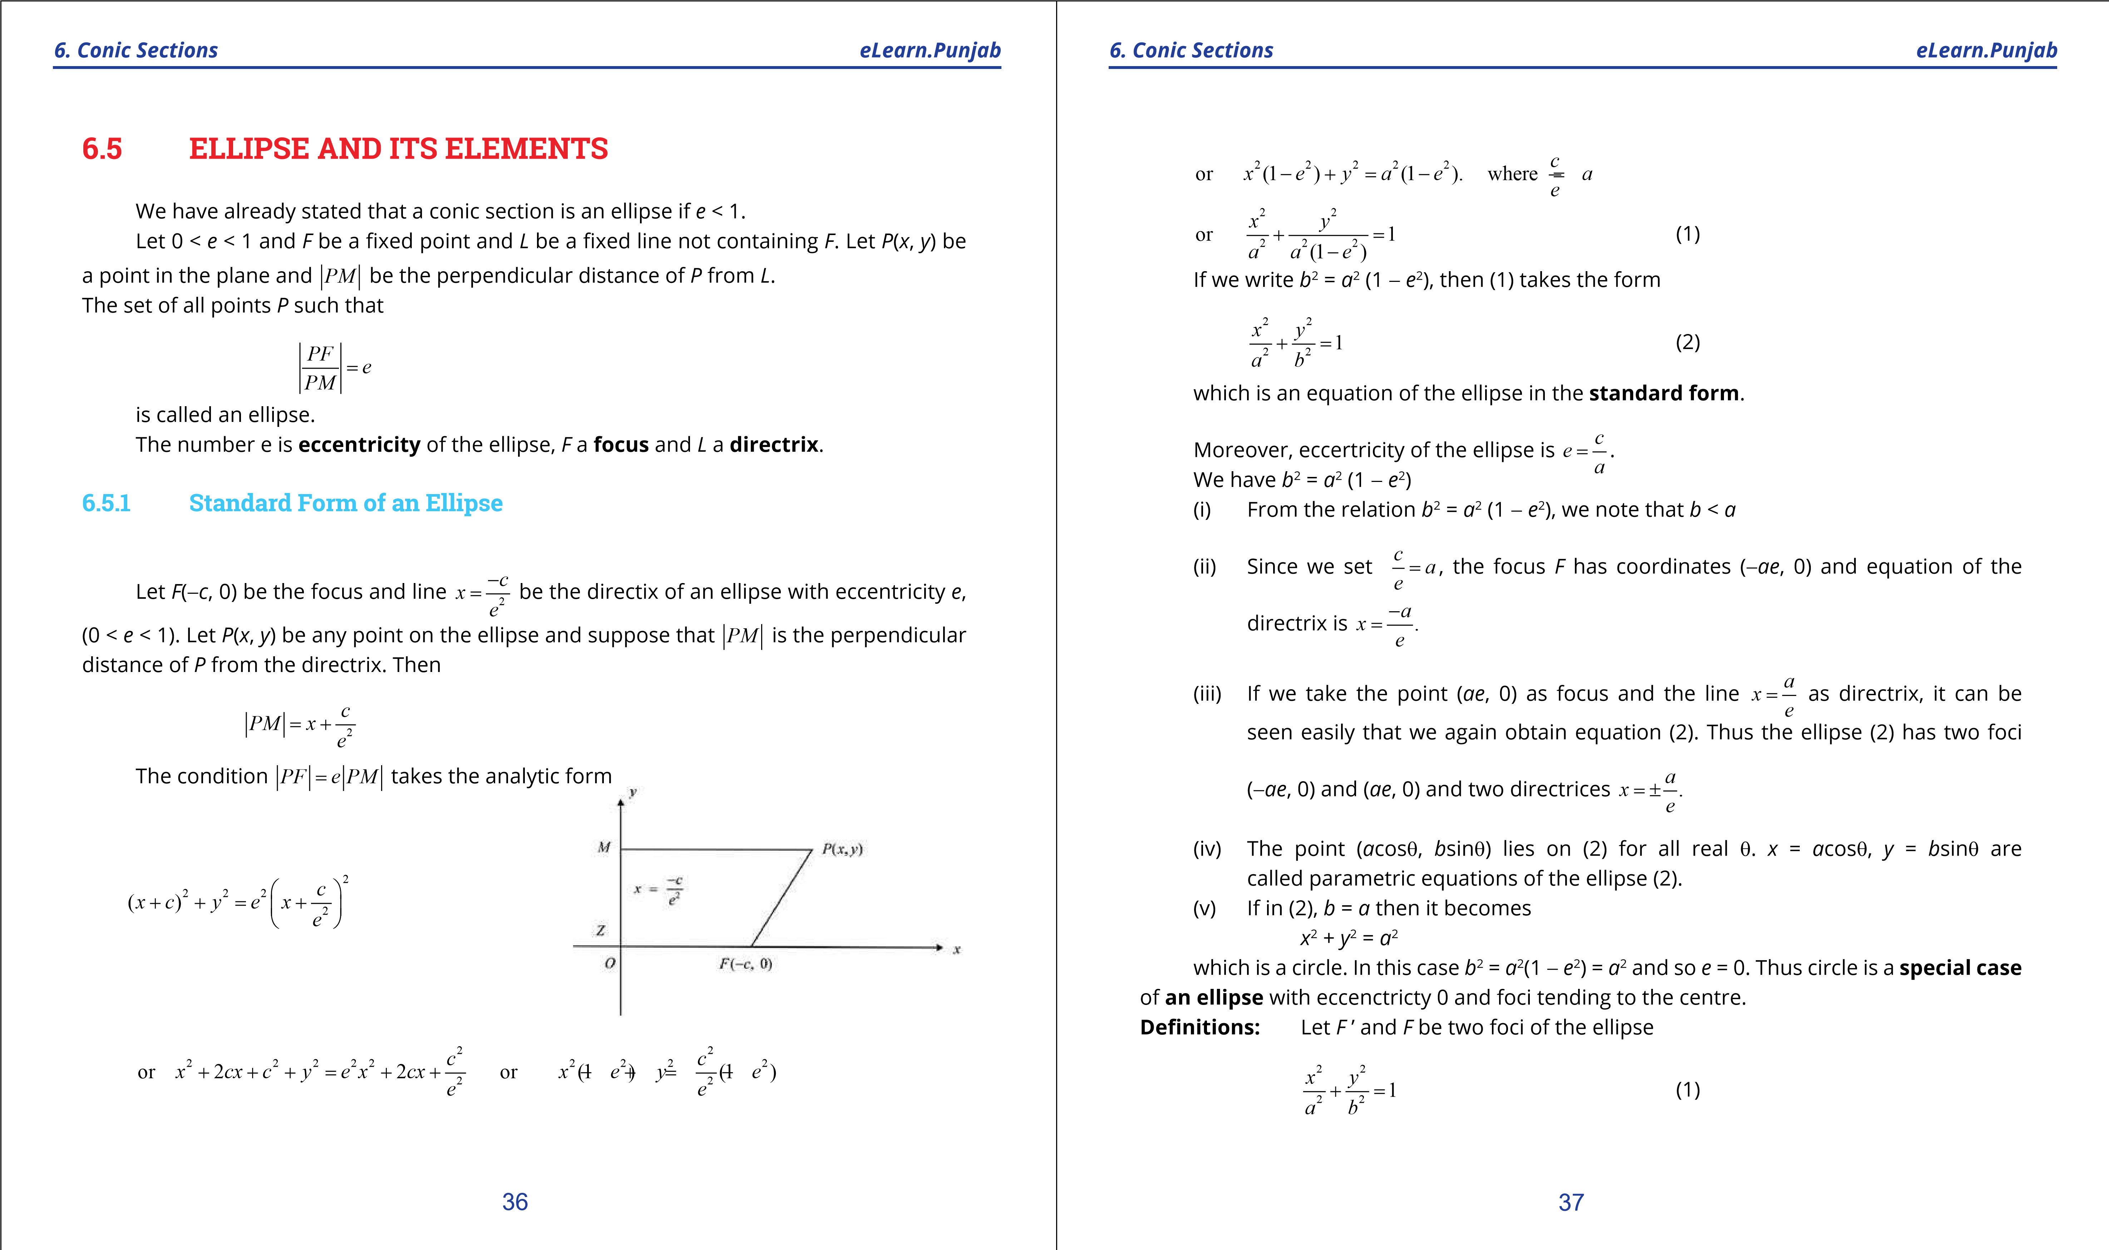

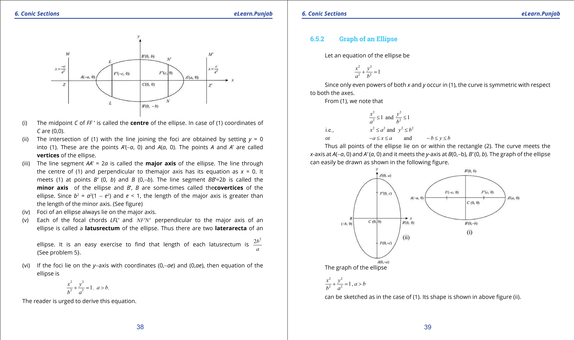

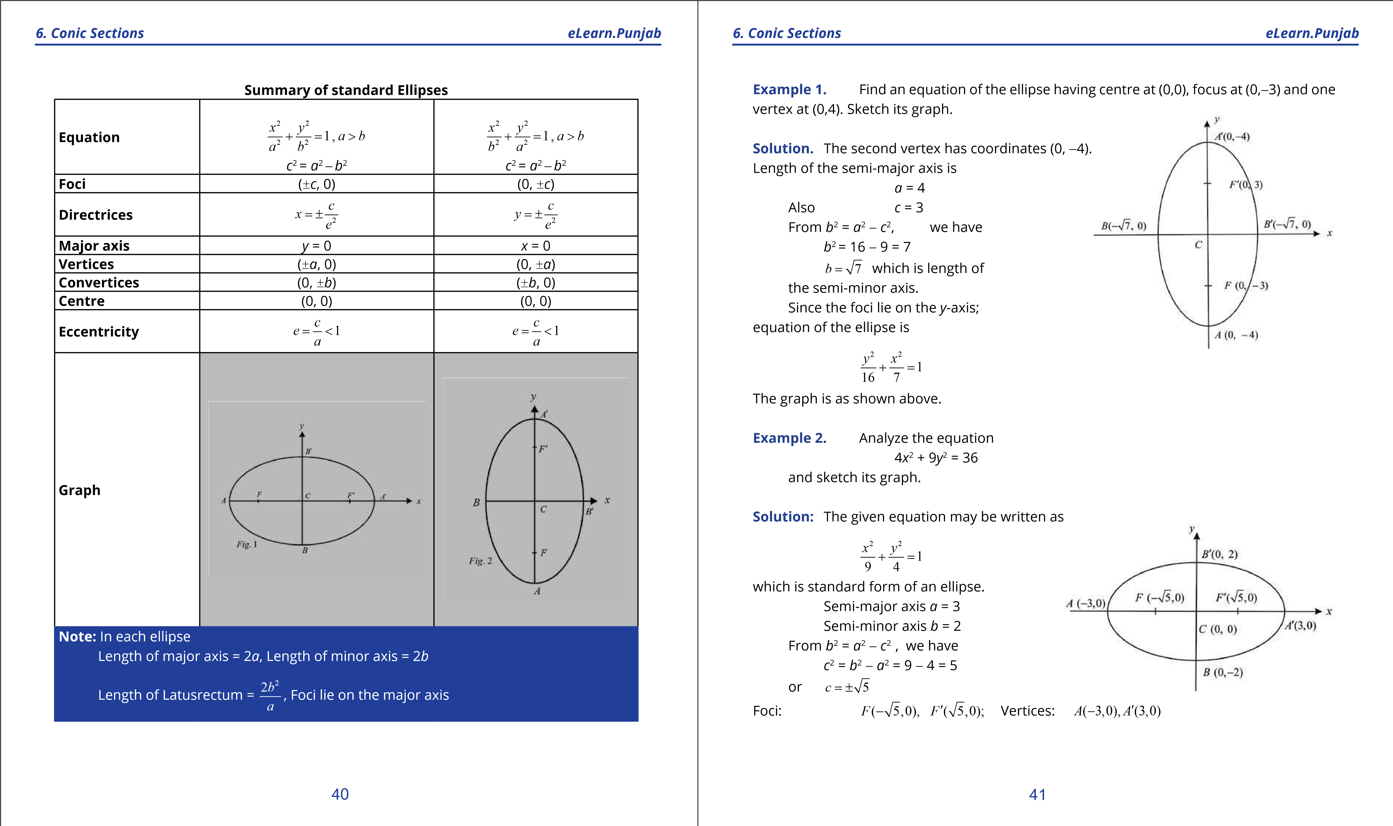

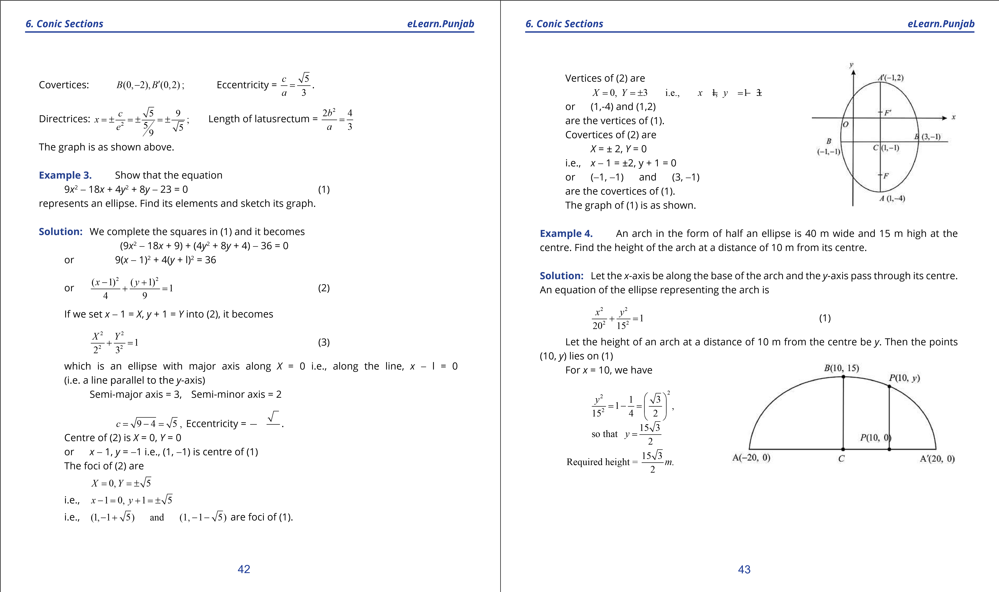

**1. Quadratic Equations eLearn.Punjab 1. Quadratic Equations eLearn.Punjab *6. Conic Sections eLearn.Punjab 6. Conic Sections eLearn.Punjab***

### **EXERCISE 6.5**

1. Find an equation of the ellipse with given data and sketch its graph:
   1. Foci (±3,0) and minor axis of length 10 (ii) Foci (0,-1) and (0,-5) and major axis of length 6.
   2. Foci ( 3 3,0)- and vertices (±6,0)
   3. Vertices (-1,1), (5,1); foci (4,1) and (0,1)
   4. Foci (± 5,0)and passing through the point  32, 3
   5. Vertices (0, ±5), eccentricity .
   6. Centre (0,0), focus (0, -3), vertex (0,4)
   7. Centre (2, 2), major axis parallel to *y*-axis and of length 8 units, minor axis parallel to *x*-axis and of length 6 units.
   8. Centre (0, 0), symmetric with respect to both the axes and passing through the points (2, 3) and (6, 1).
   9. Centre (0, 0), major axis horizontal, the points (3, 1), (4, 0) lie on the graph.
2. Find the centre, foci, eccentricity, vertices and directrices of the ellipse, whose equation is given:
   1. *x*2 + 4*y*2 = 16 (ii) 9*x*2 + *y*2 = 18

(iii) 25*x*2 + 9*y*2 = 225 (iv) (2*x* -1)2 + (*y* + 2)2 =1

4 16

* 1. *x*2 + 16*x* + 4*y*2 - 16*y* + 76 = 0
  2. 25*x*2 + 4*y*2 - 250*x* - 16*y* + 541 = 0

1. Let *a* be a positive number and 0 < *c* < *a*. Let *F*(-*c*, 0) and *F* ’(*c*, 0) be two given points. Prove that the locus of points *P*(*x*, *y*) such that

*PF* + *PF*′ = 2*a*, is an ellipse.

1. Use problem 3 to ind equation of the ellipse as locus of points *P*(*x*, *y*) such that the sum of the distances from *P* to the points (0, 0) and (1, 1) is 2.
2. Prove that the lactusrectum of the ellipse.

*x*2 *y*2 2*b*2 *a*2 + *b*2 =1 is *a*

1. The major axis of an ellipse in standard form lies along the *x*-axis and has length

4 2 . The distance between the foci equals the length of the minor axis. Write an equation of the ellipse.

1. An astroid has elliptic orbit with the sun at one focus. Its distance from the sun ranges from 17 million miles to 183 million miles. Write an equation of the orbit of the astroid.
2. An arch in the shape of a semi-ellipse is 90m wide at the base and 30m high at the centre. At what distance from **the centre** is the arch 20 2 m high?
3. The moon orbits the earth in an elliptic path with earth at one focus. The major and minor axes of the orbit are 768,806 km and 767,746 km respectively. Find the greatest and least distances (in Astronomy called the **apogee** and **perigee** respectively) of the moon from the earth.

3

5

## 6.6 HYPERBOLA AND ITS ELEMENTS

We have already stated that a conic section is a hyperbola if *e* > 1. Let *e* > 1 and *F* be a ixed point and *L* be a line not containing *F*. Also let *P*(*x*, *y*) be a point in the plane and

*PM* be the perpendicular distance of *P* from *L*.

The set of all points *P*(*x*, *y*) such that

*PF*

= *e* >1 (1)

*PM*

is called a hyperbola.

*F* and *L* are respectively **focus** and **directrix** of the hyperbola *e* is the eccentricity.

### **6.6.1 Standard Equation of Hyperbola**

Let *F*(*c*, 0) be the focus with *c* > 0 and *x* = *c*2 be the directrix of the hyperbola. *e*

Also let *P*(*x*, *y*) be a point on the hyperbola, then by deinition

*PF*

= *e PM*

### 44 45

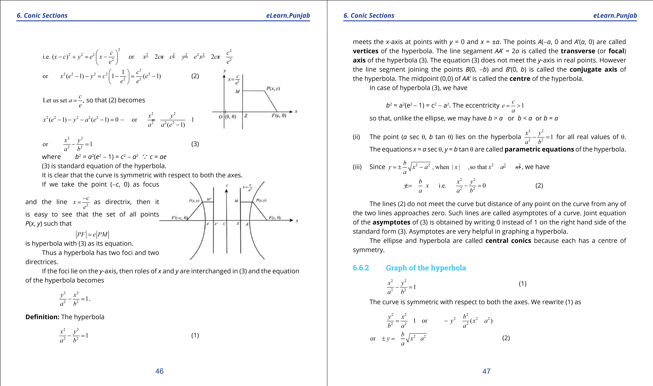

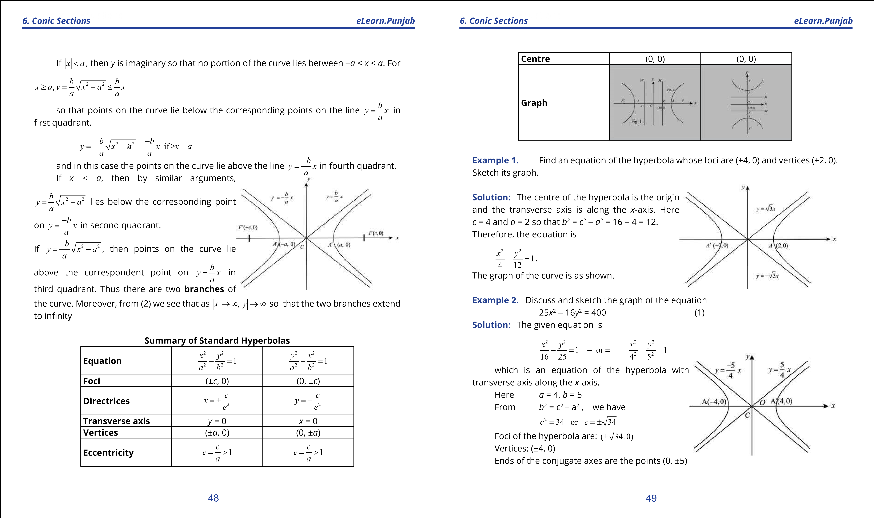

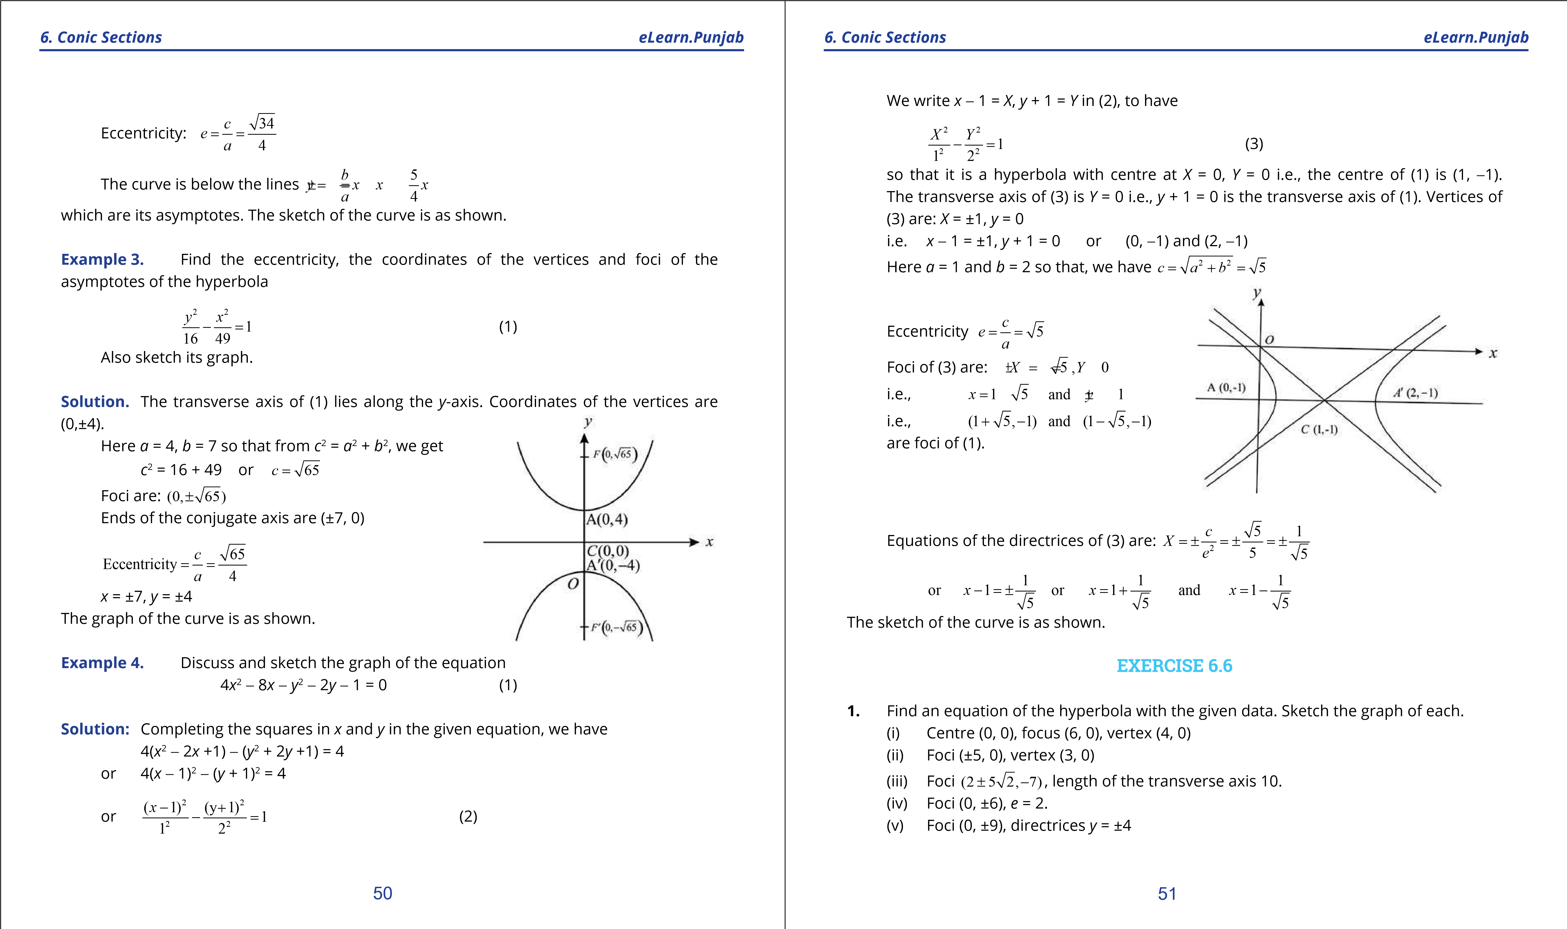

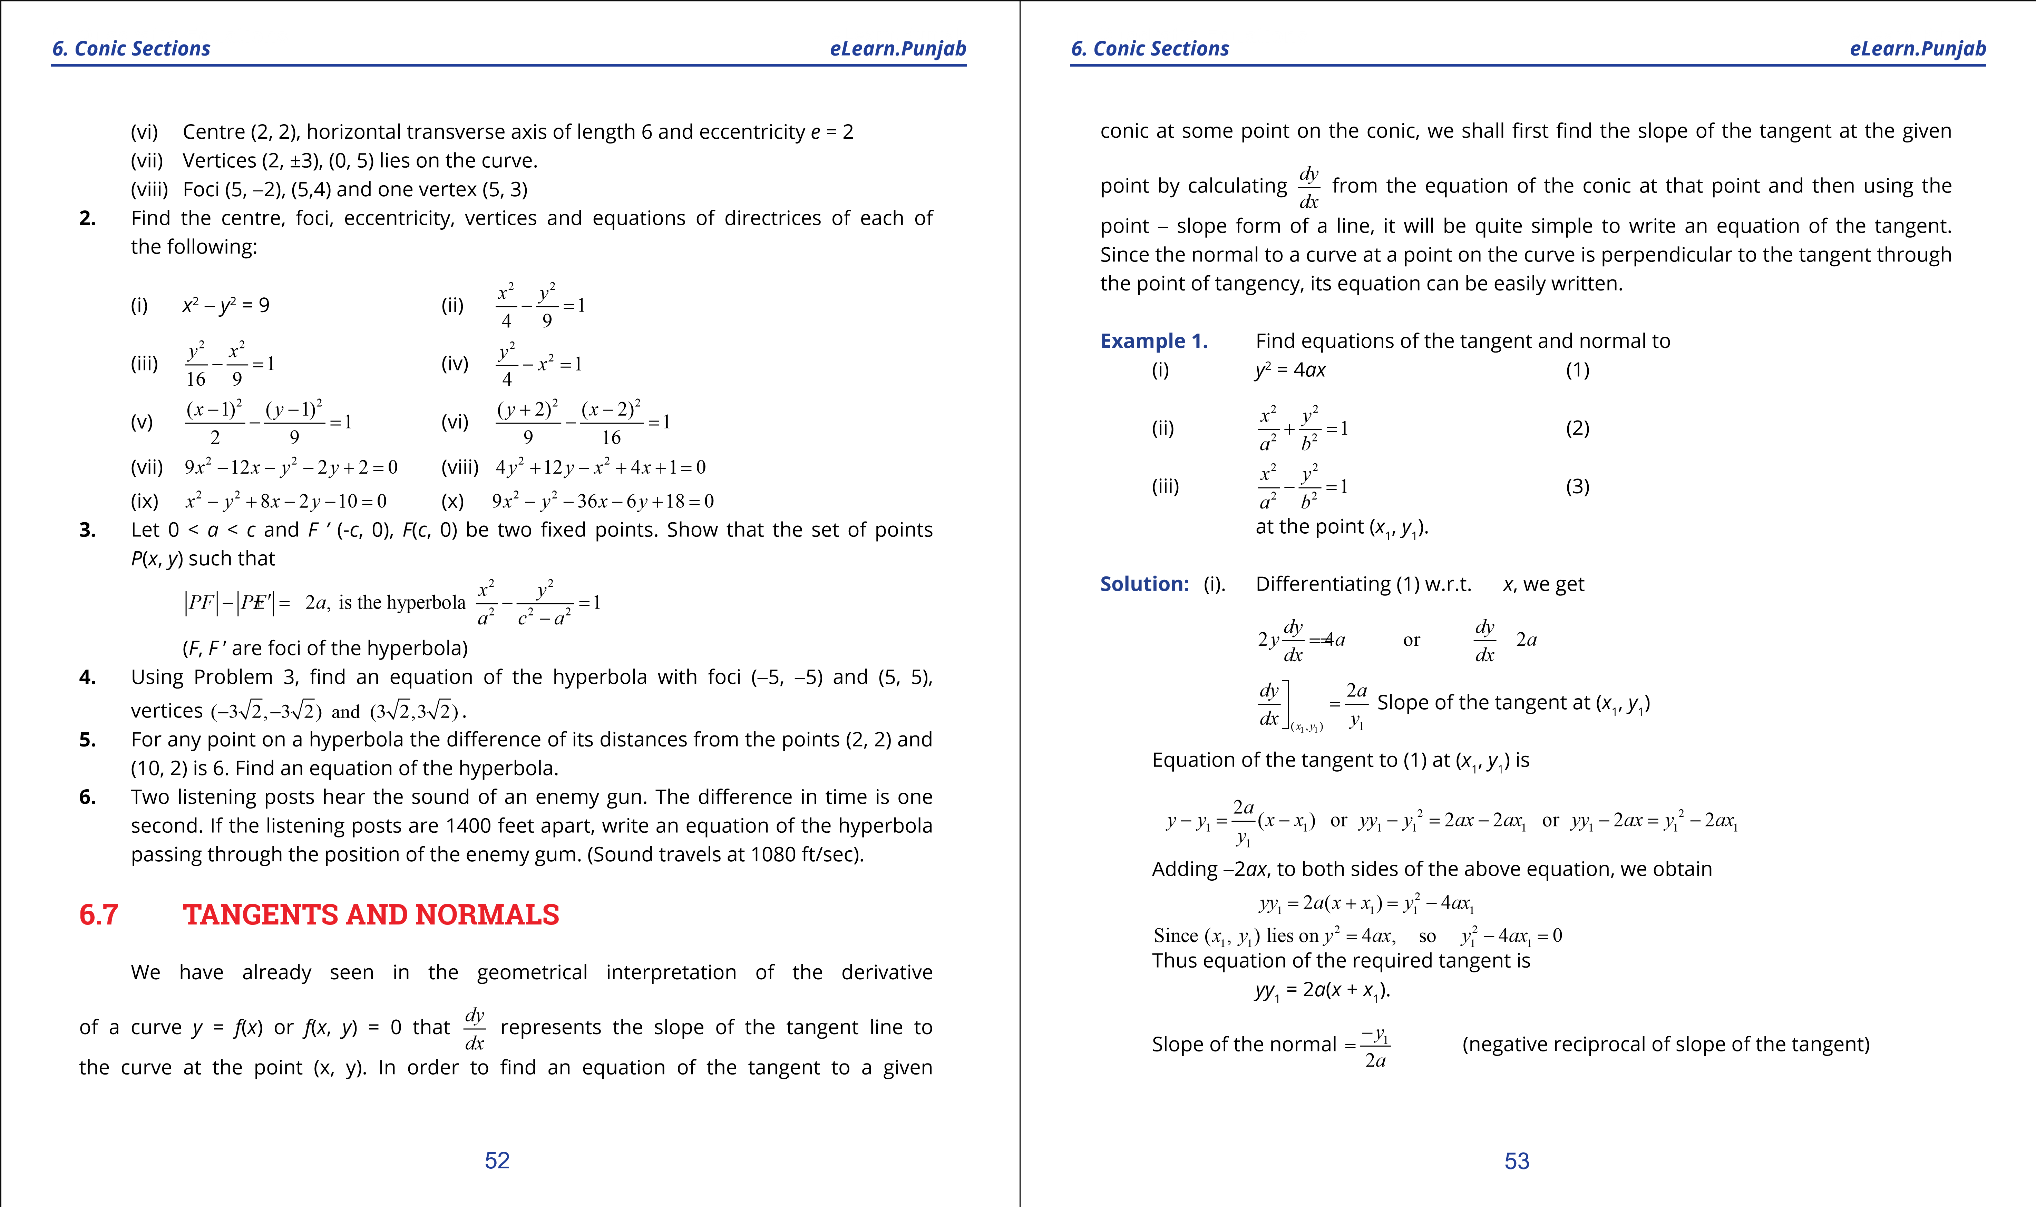

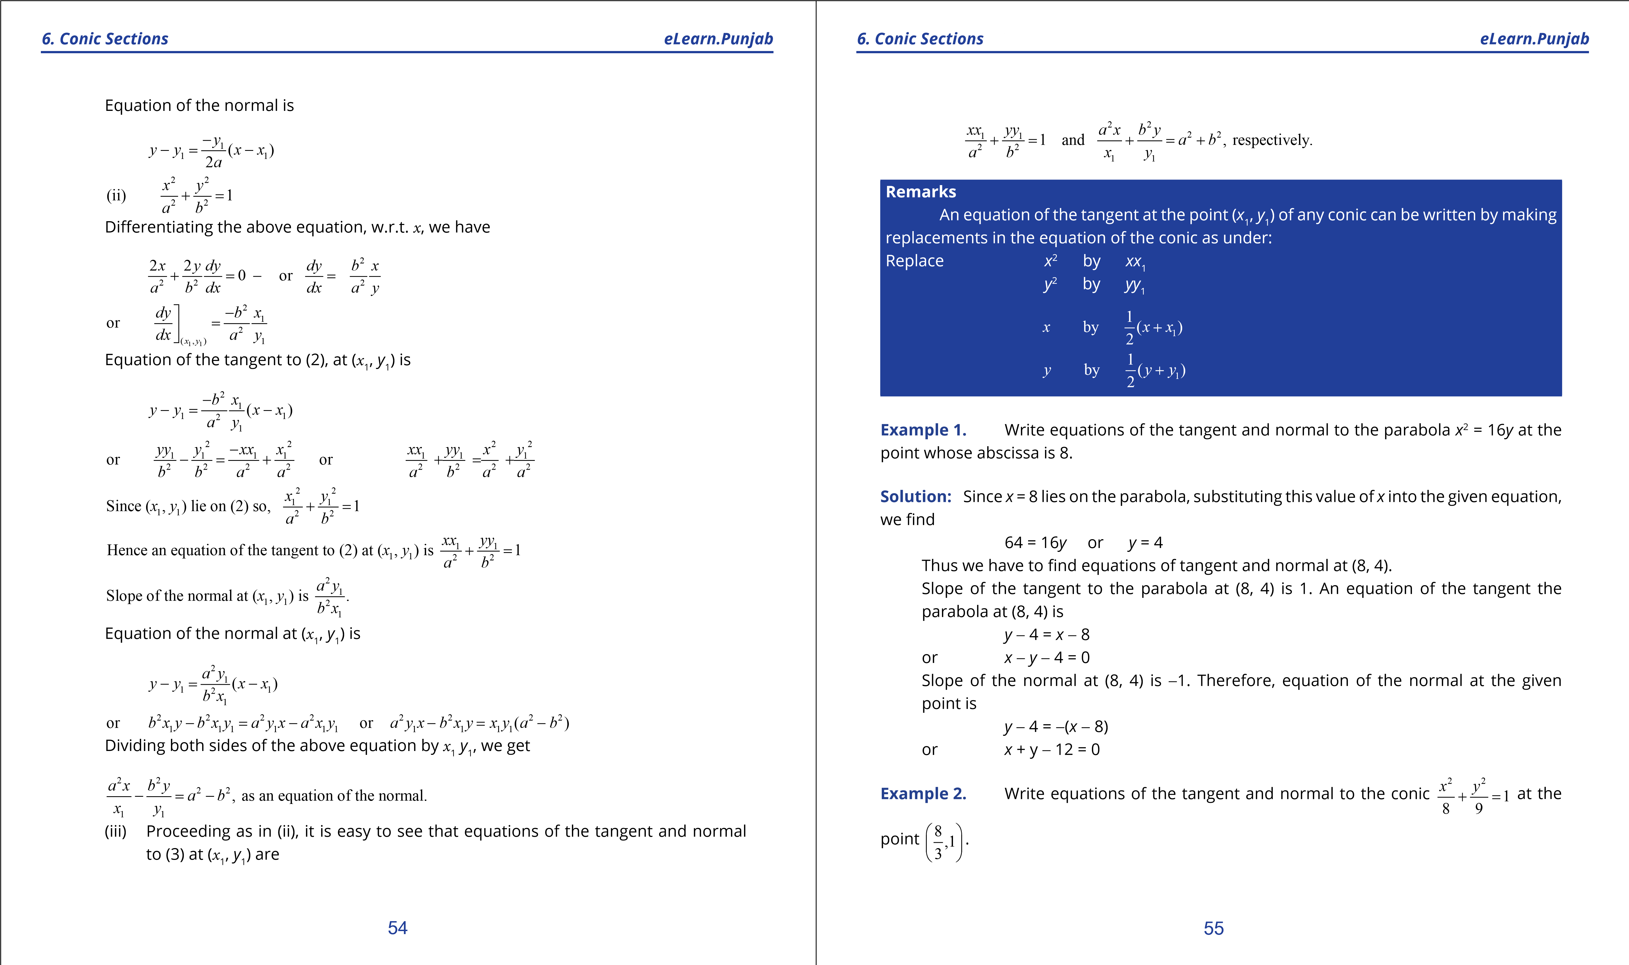

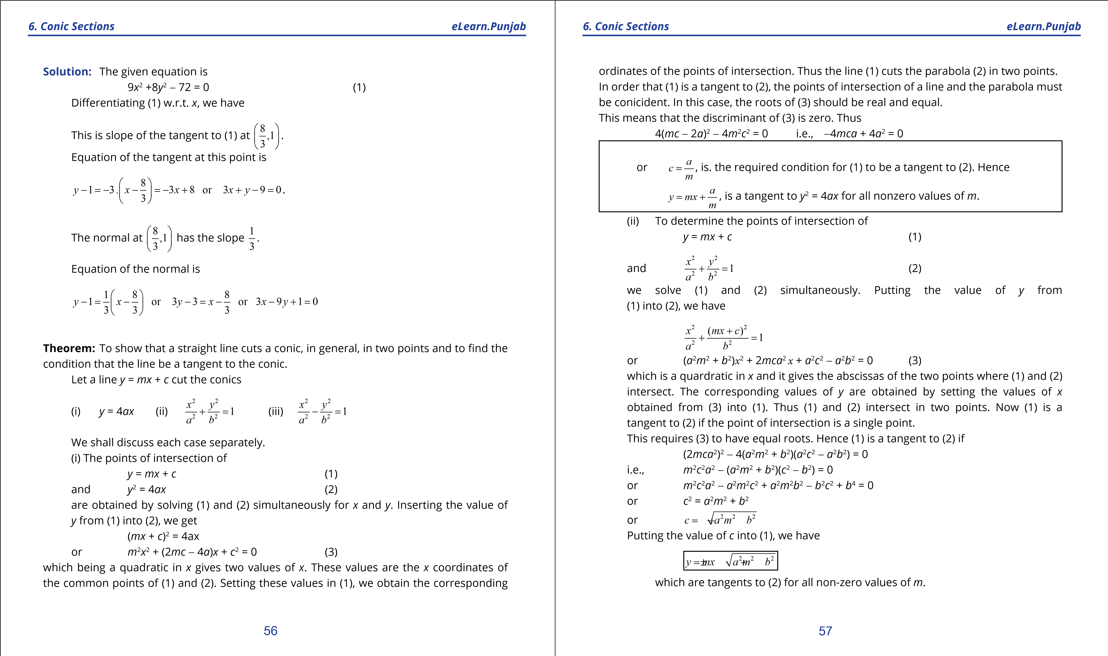

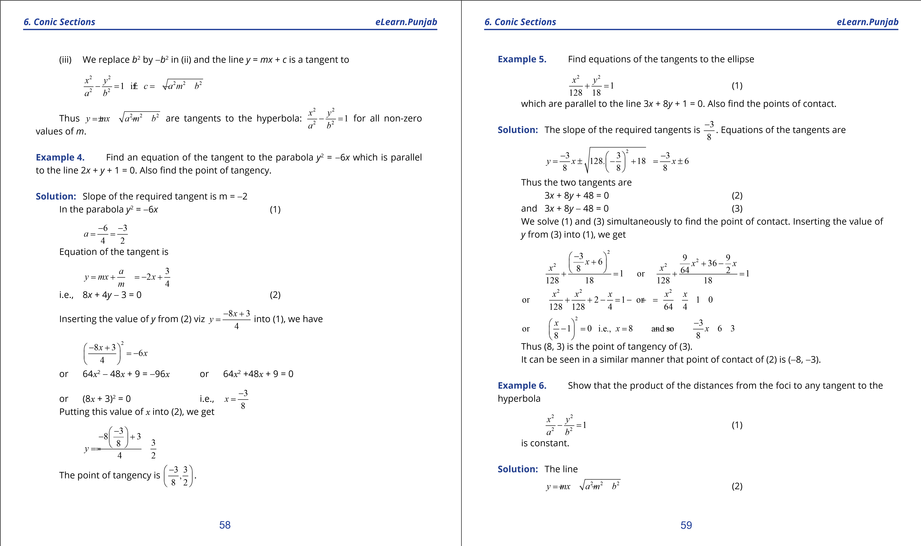

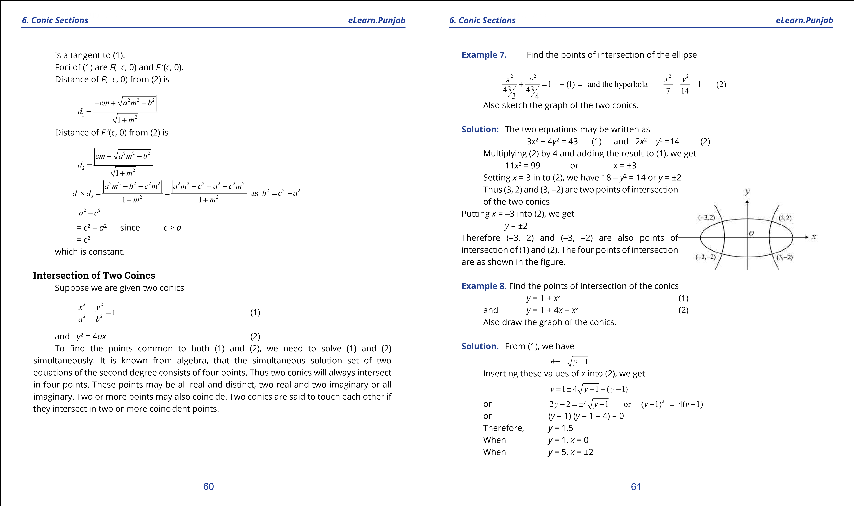

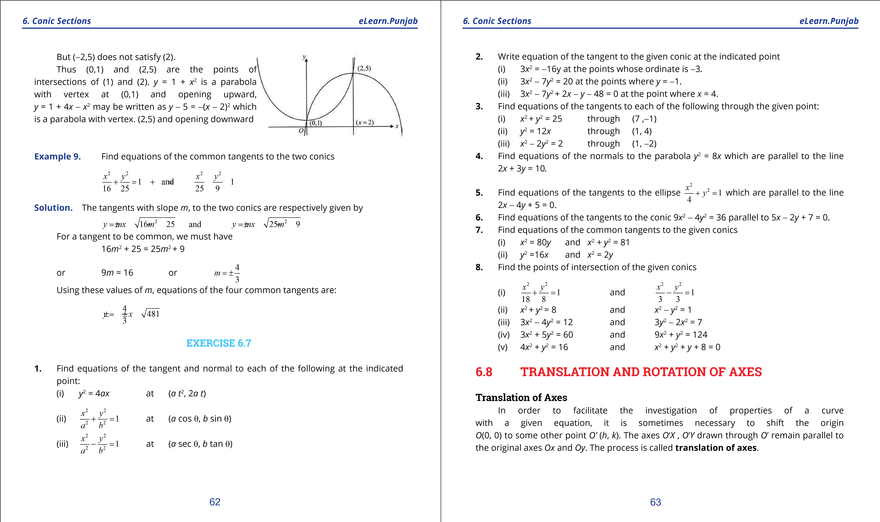

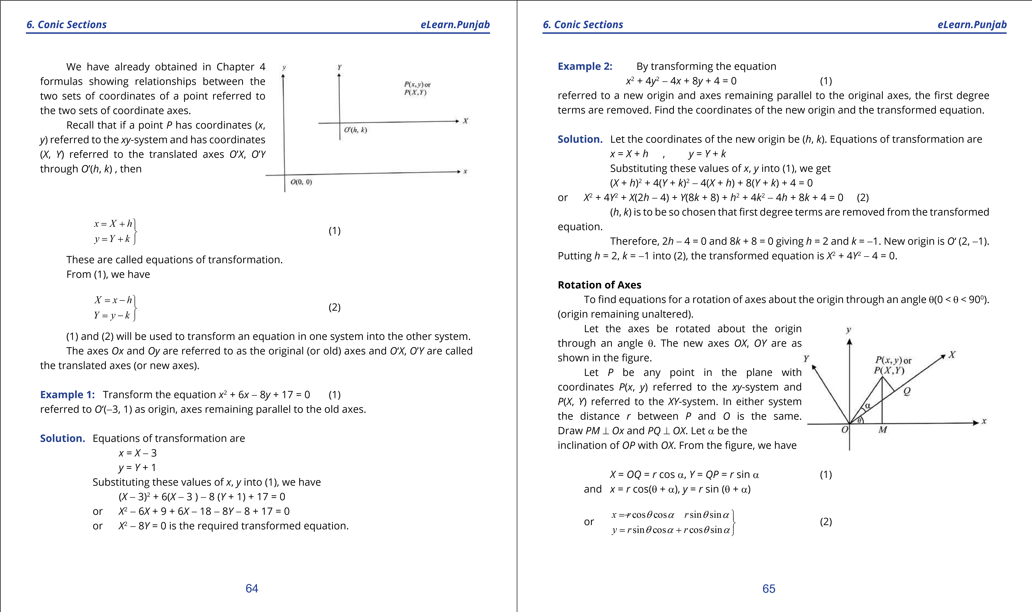

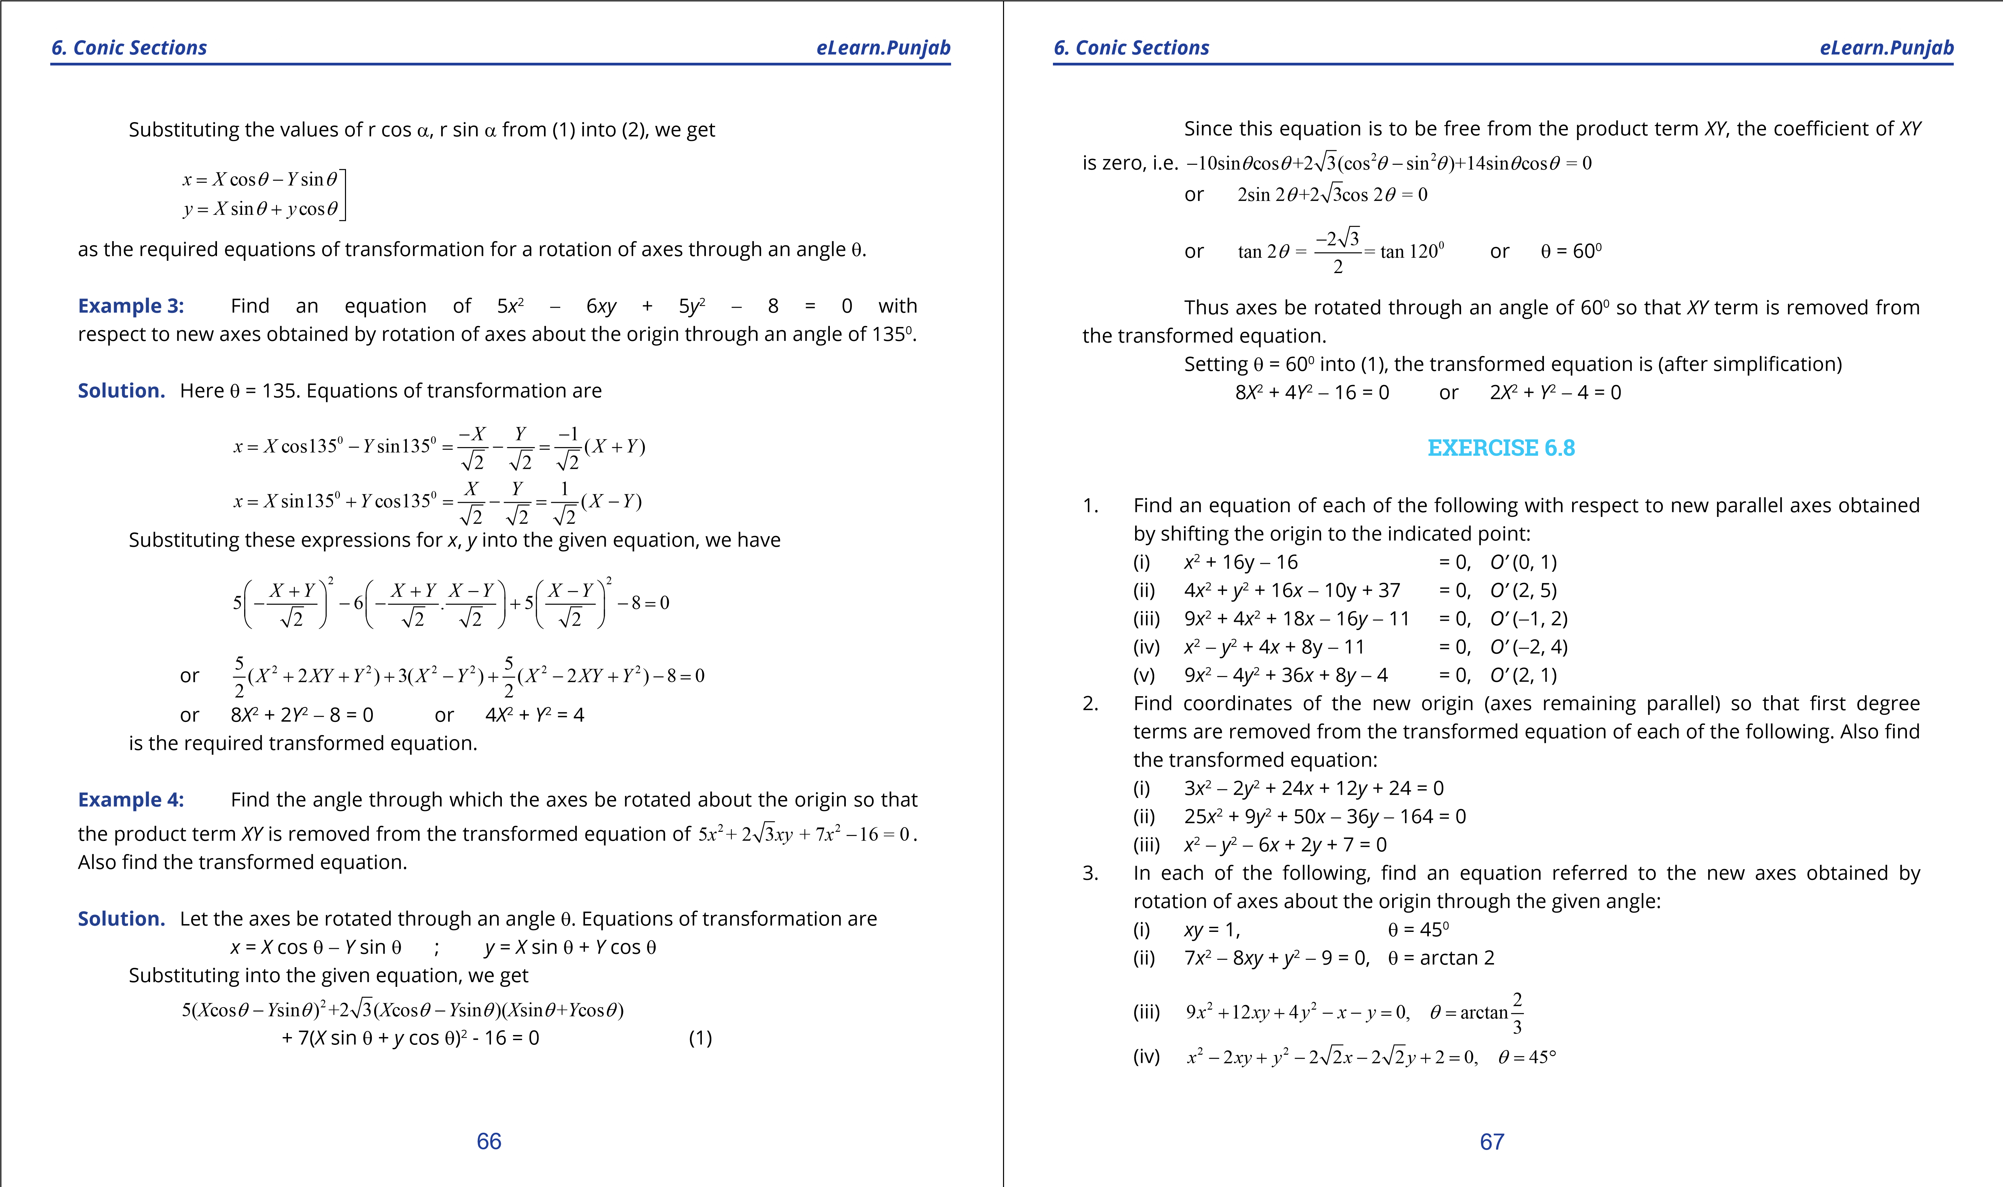

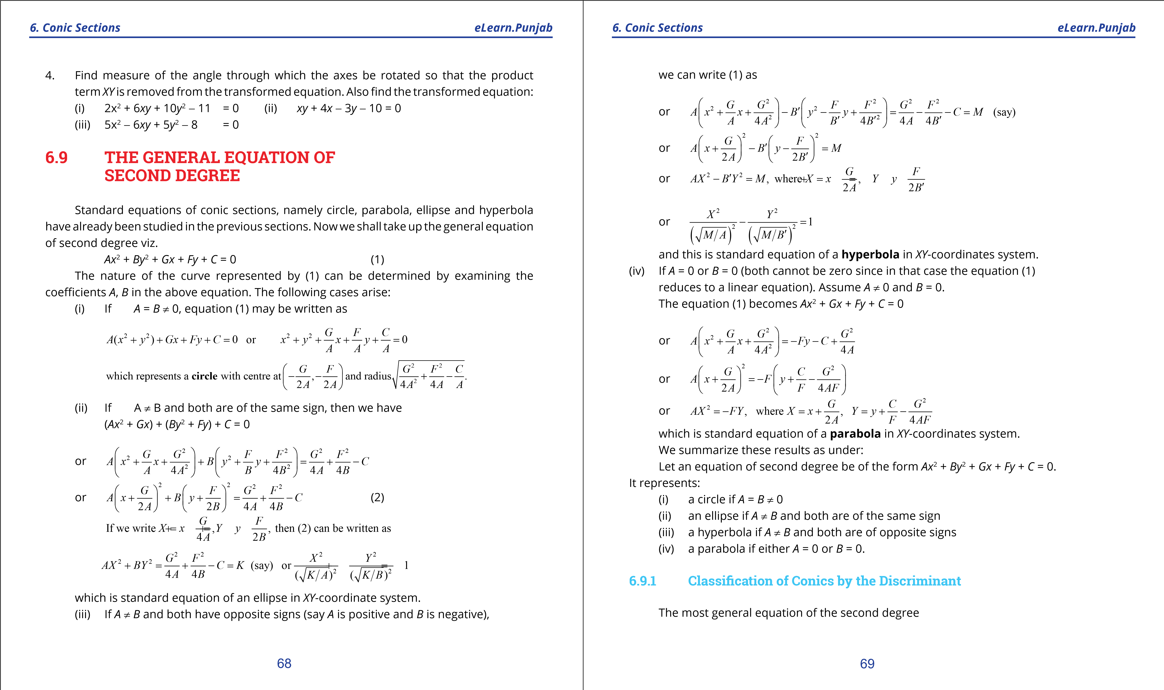

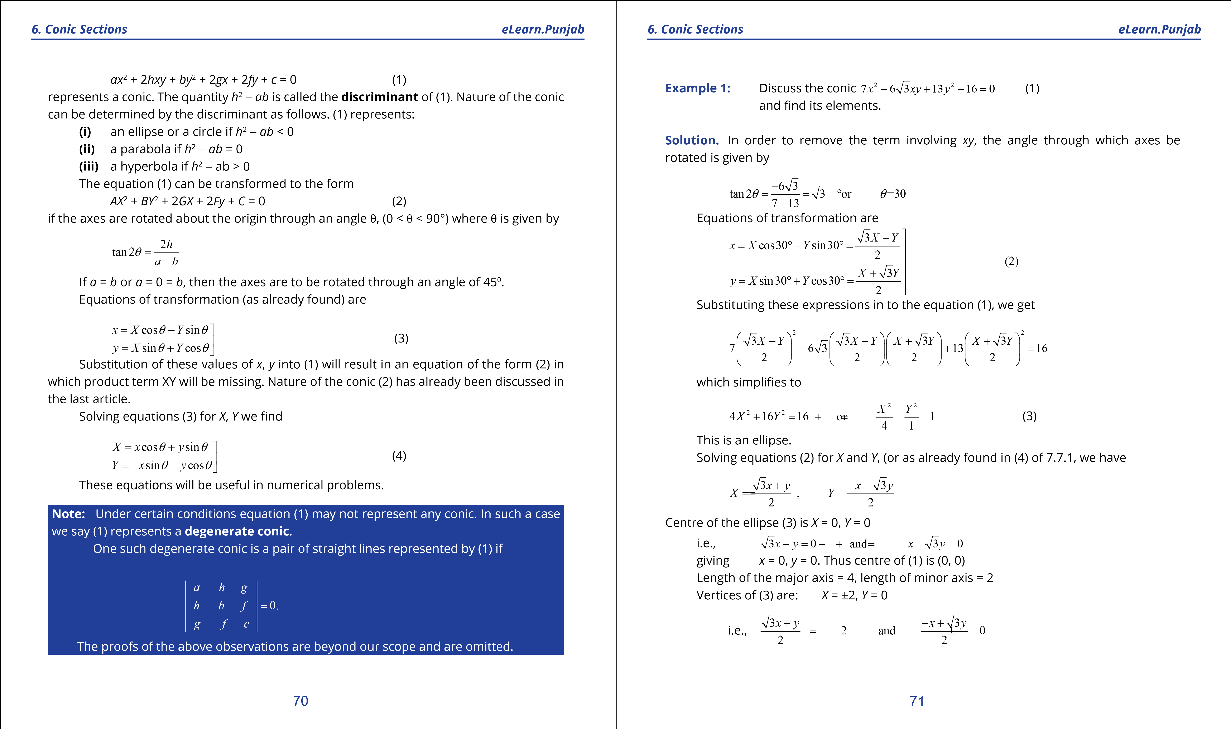

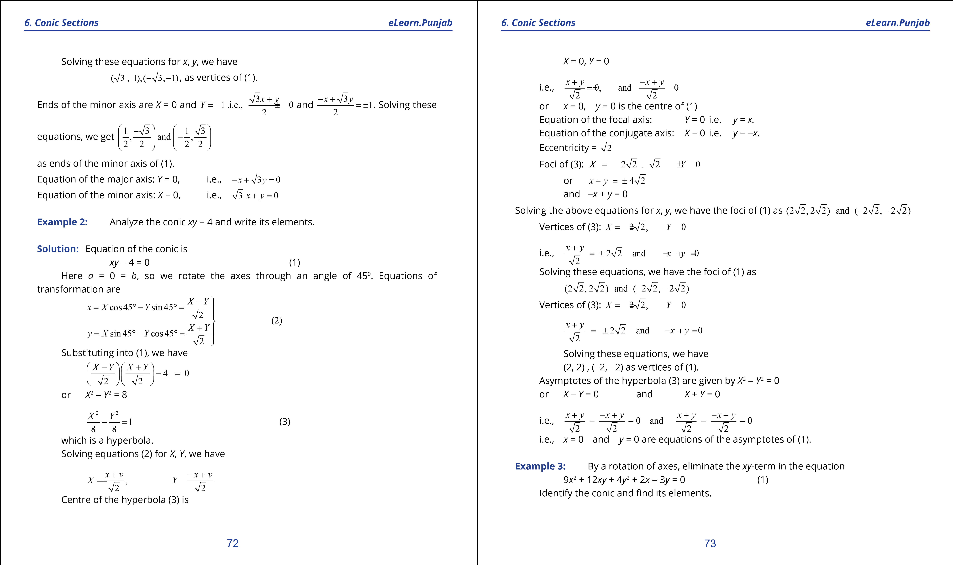

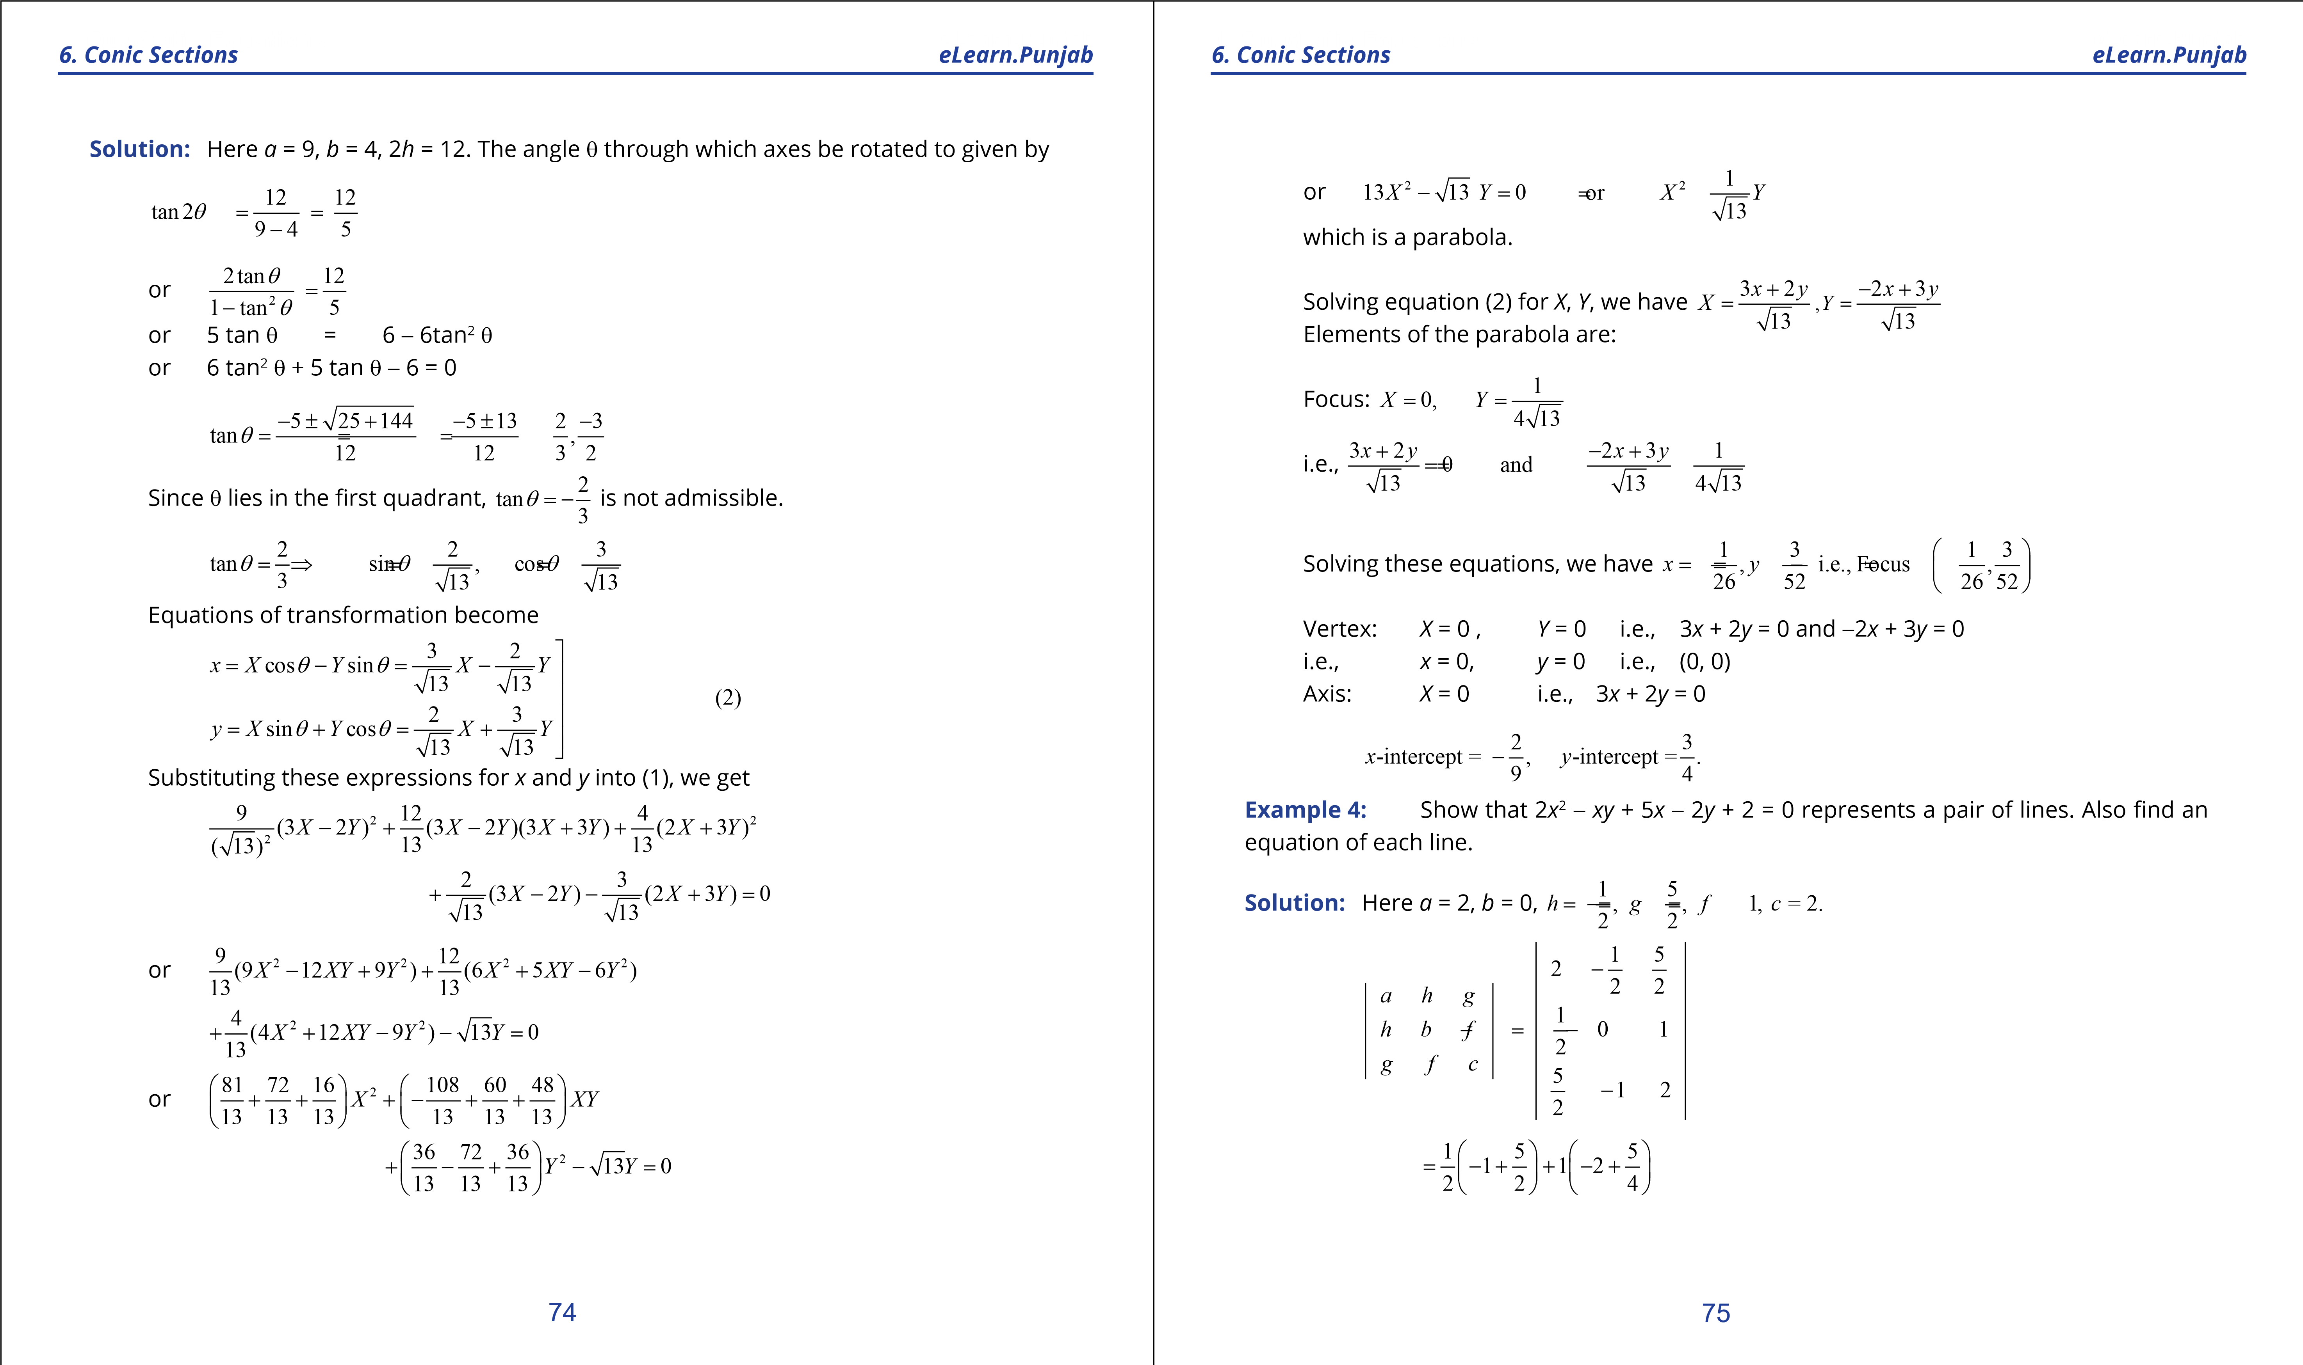

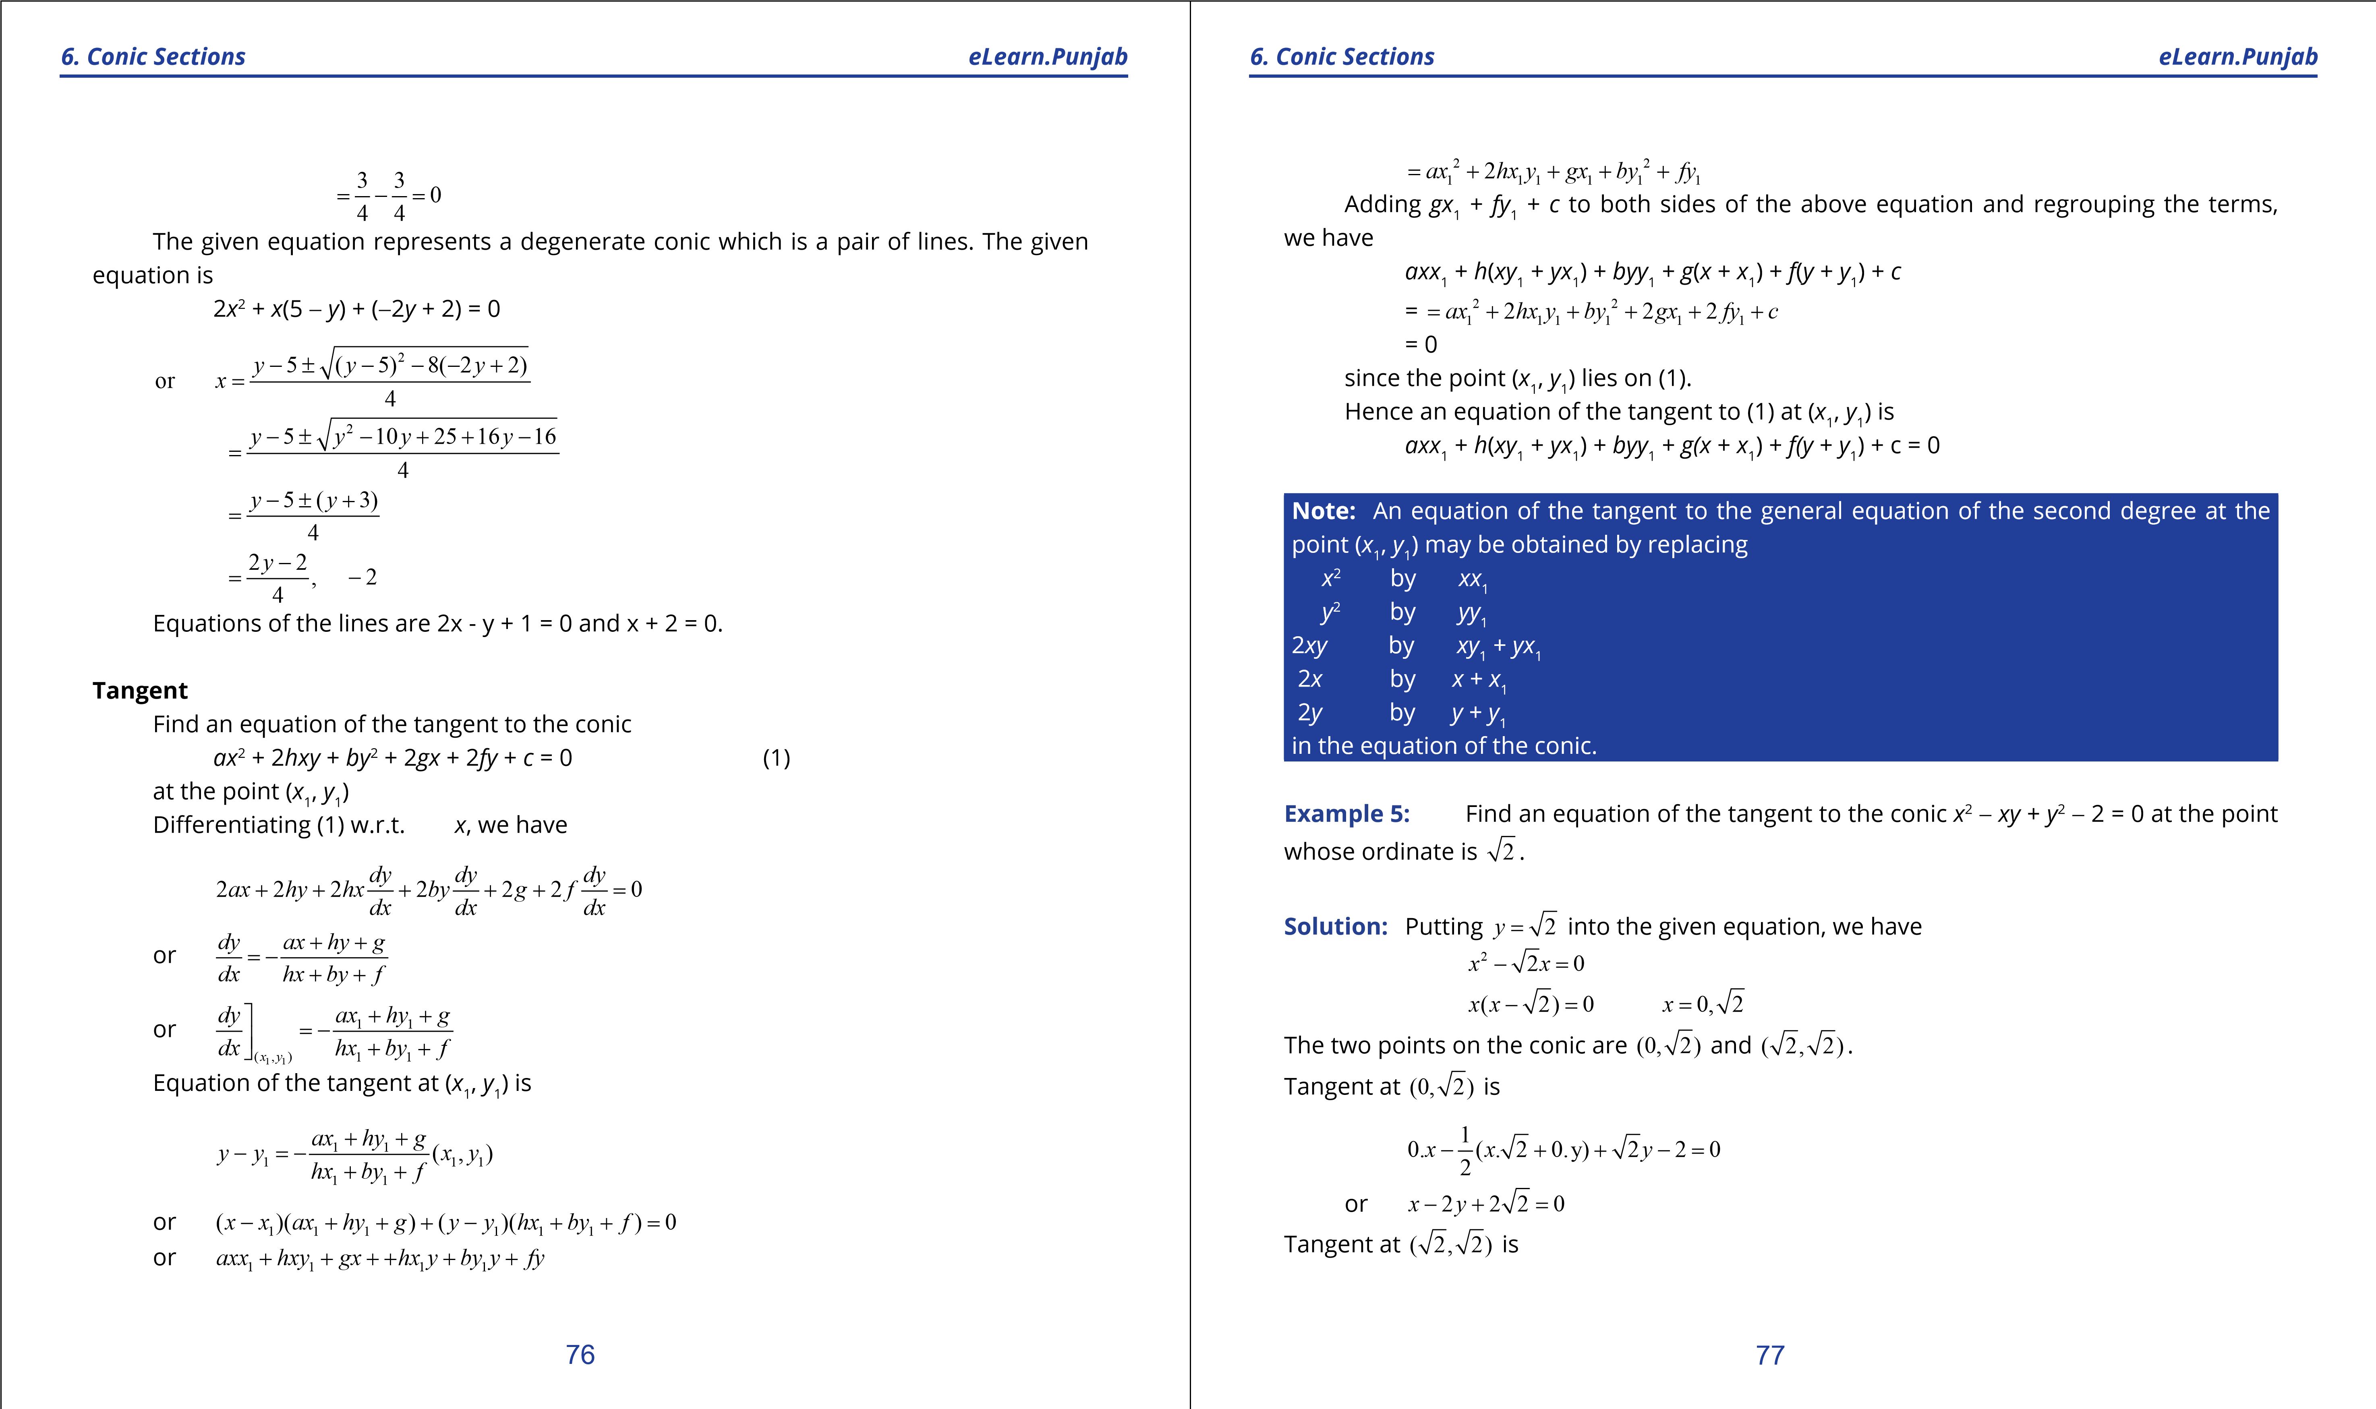

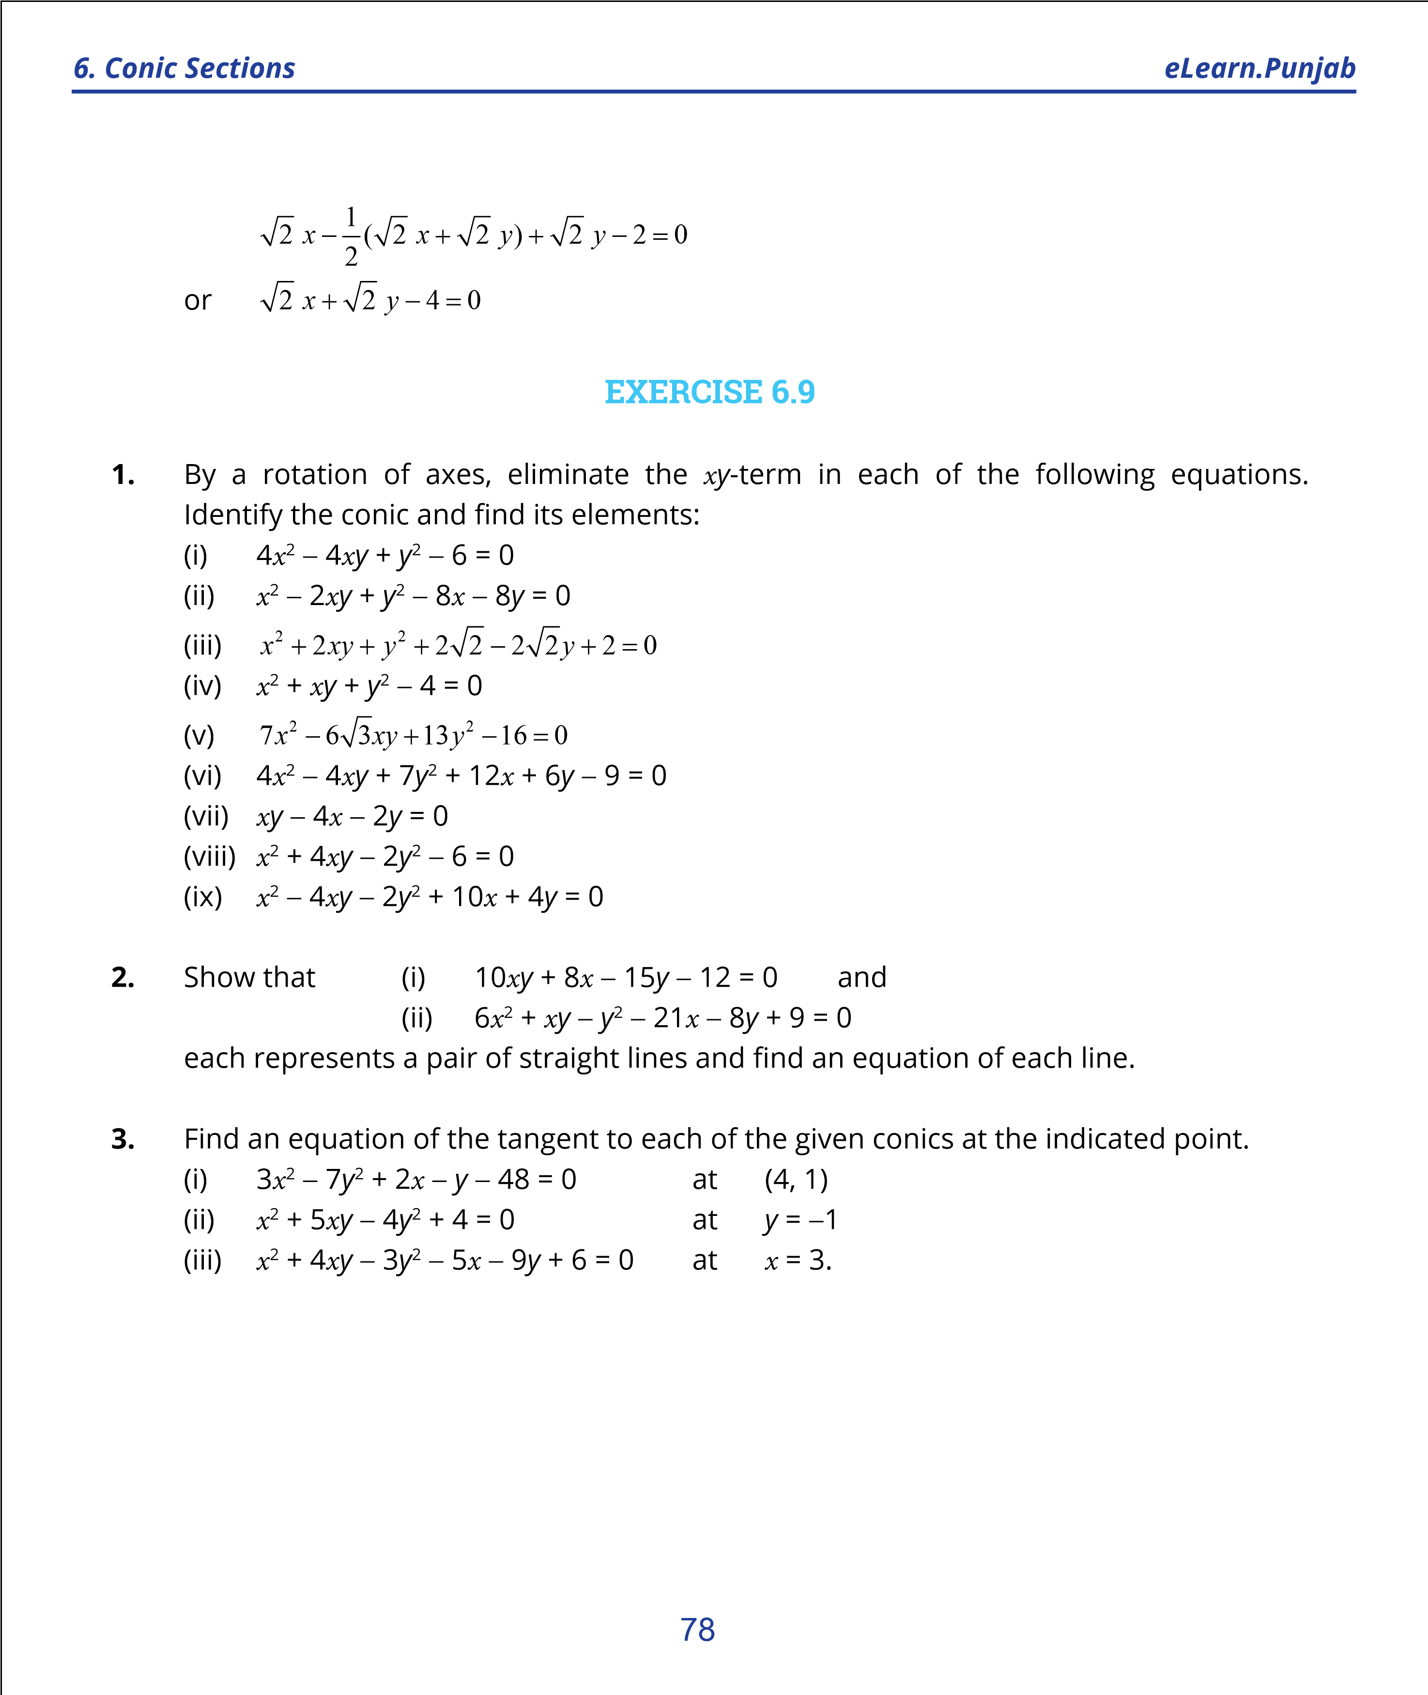

***version: 1.1***

CHAPTER 7 Vectors

*Animation 7.1: Cross Product of Vectors*

*Source and credit: eLearn.Punjab*

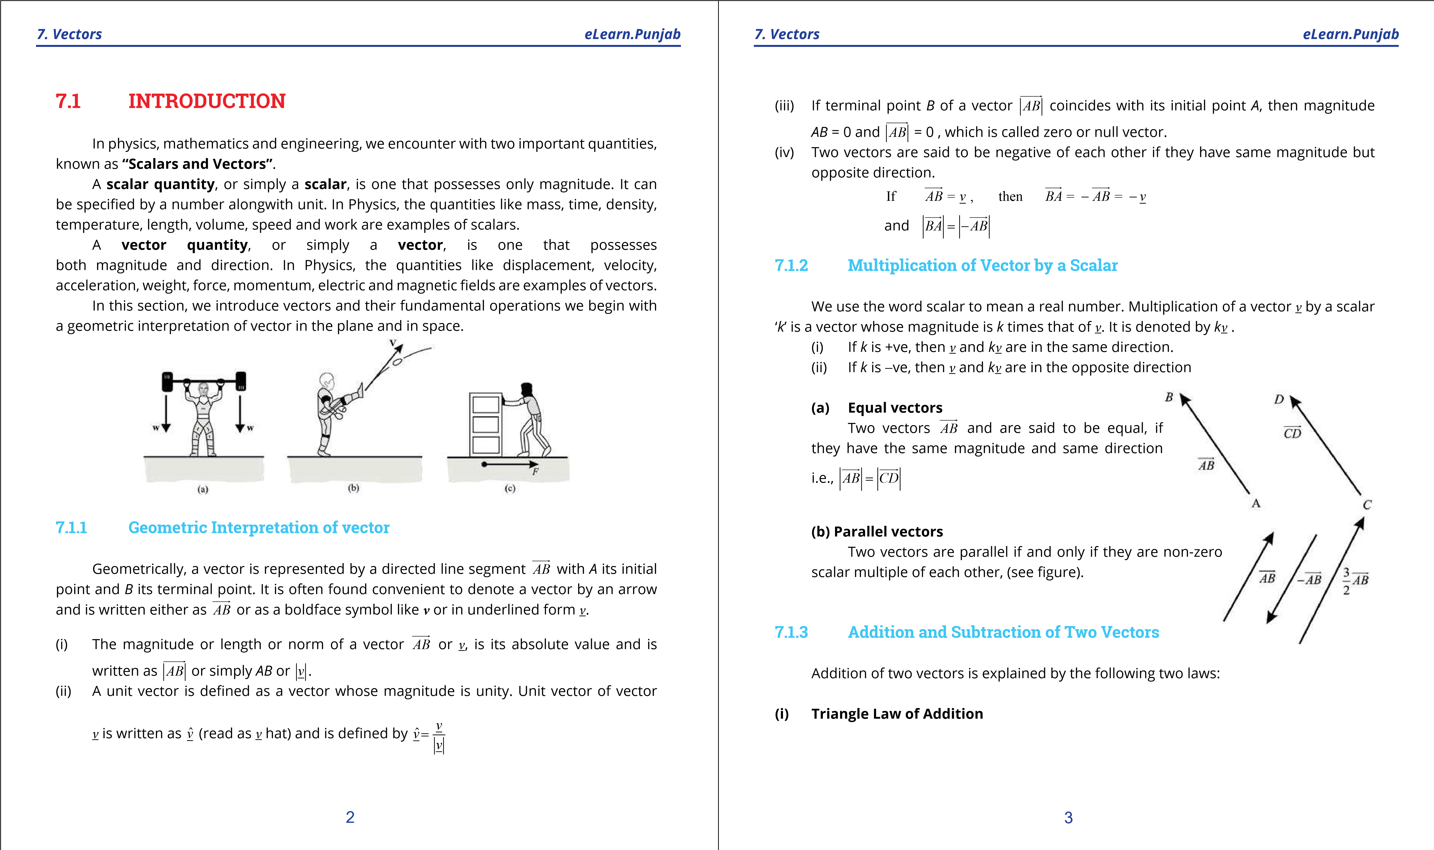

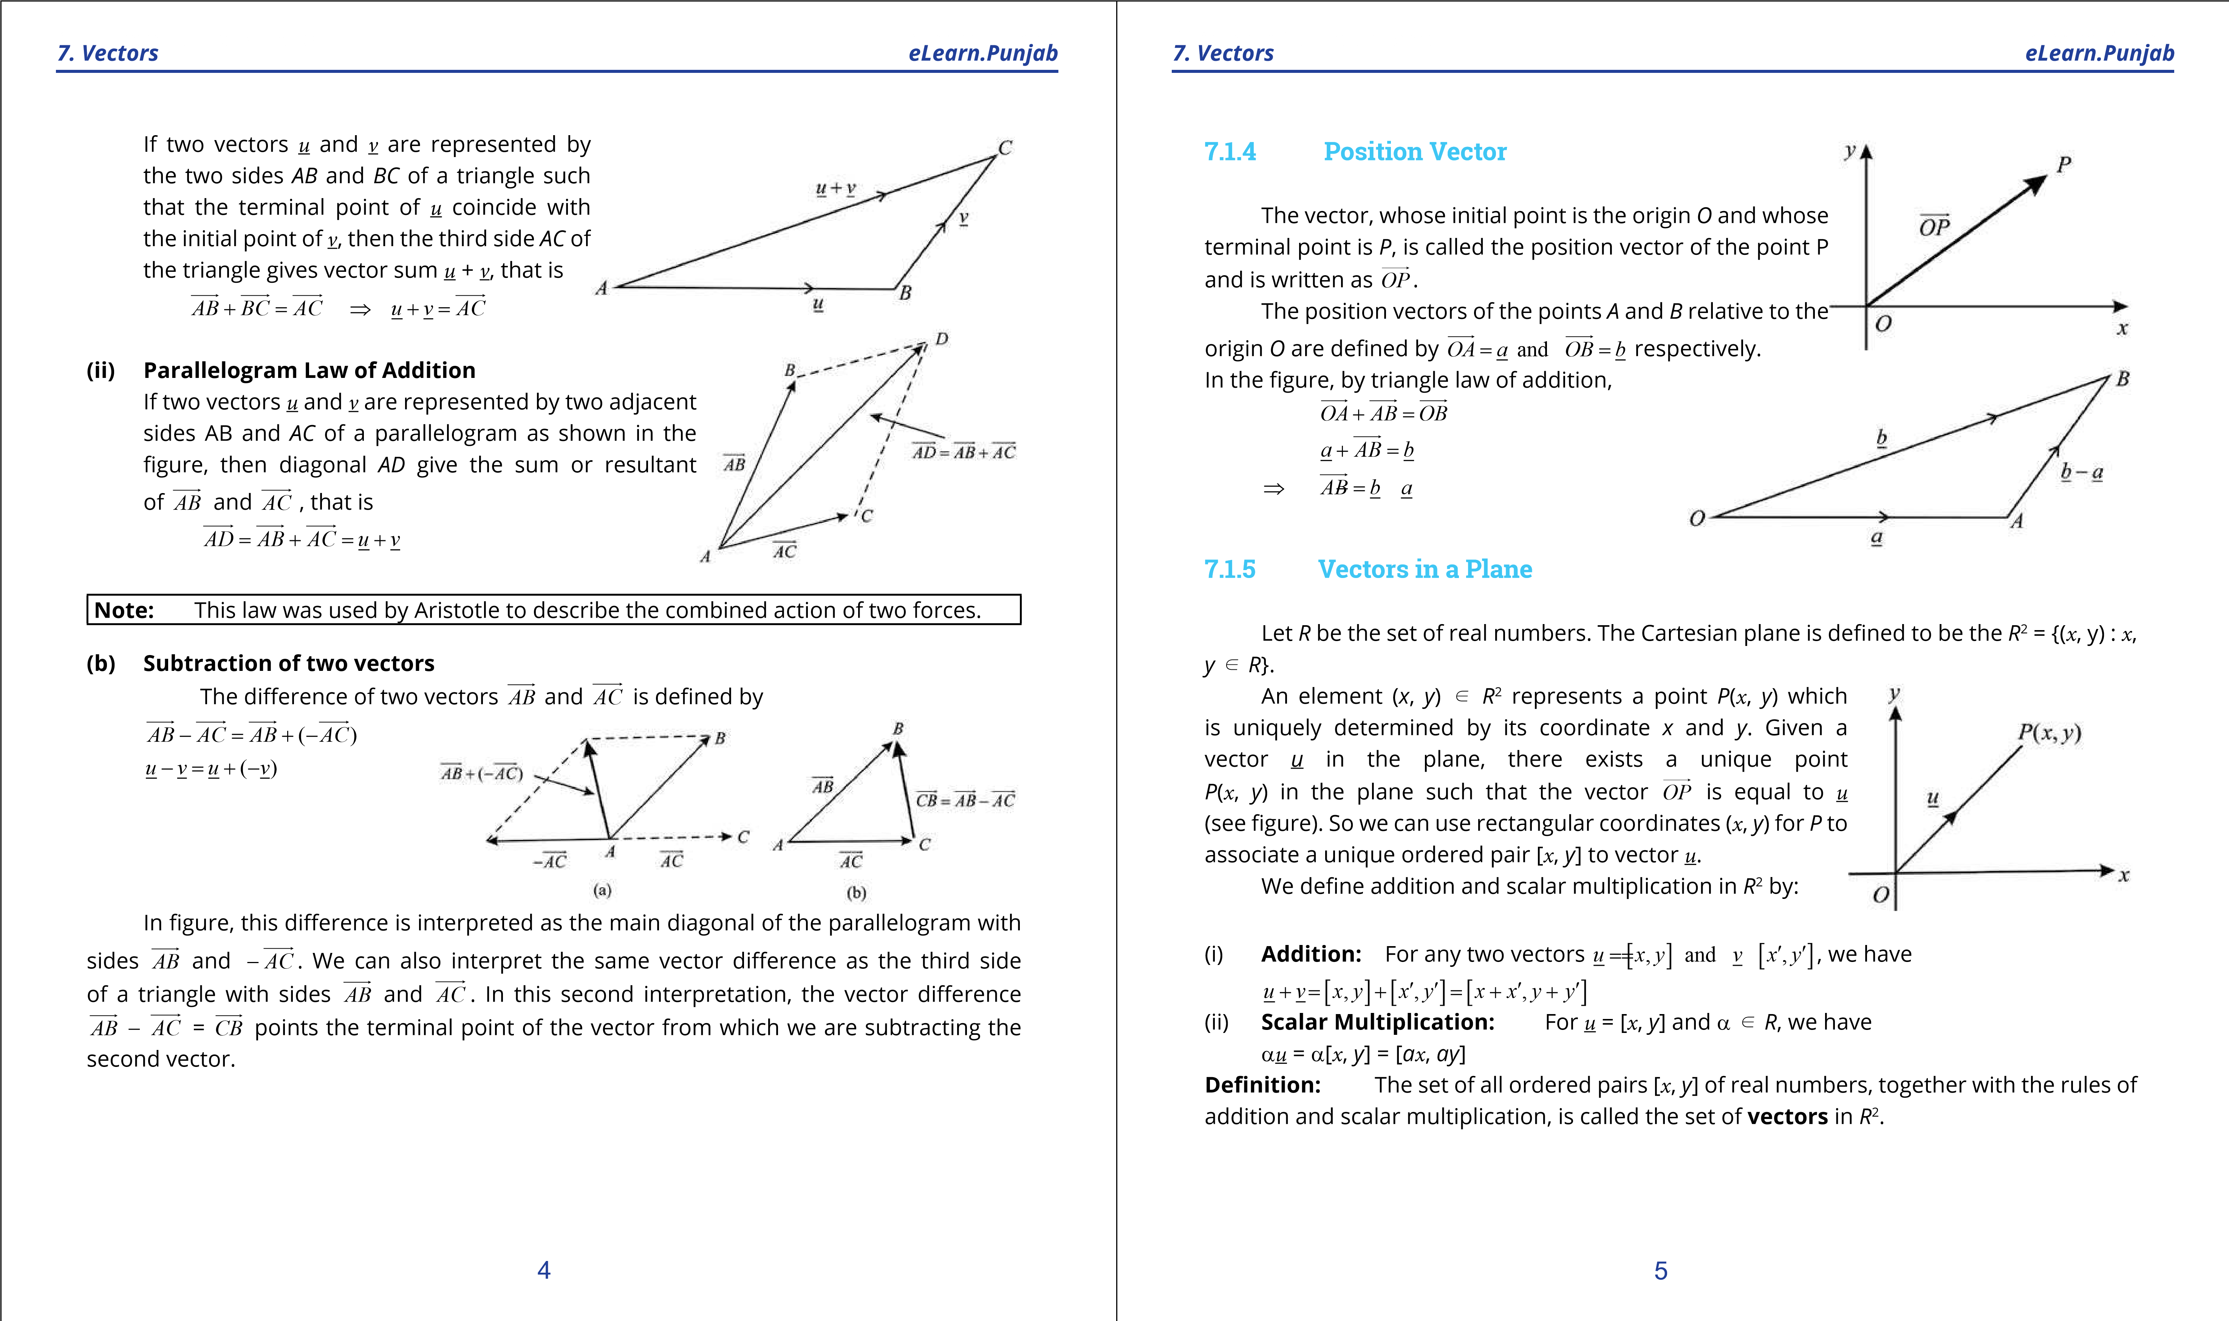

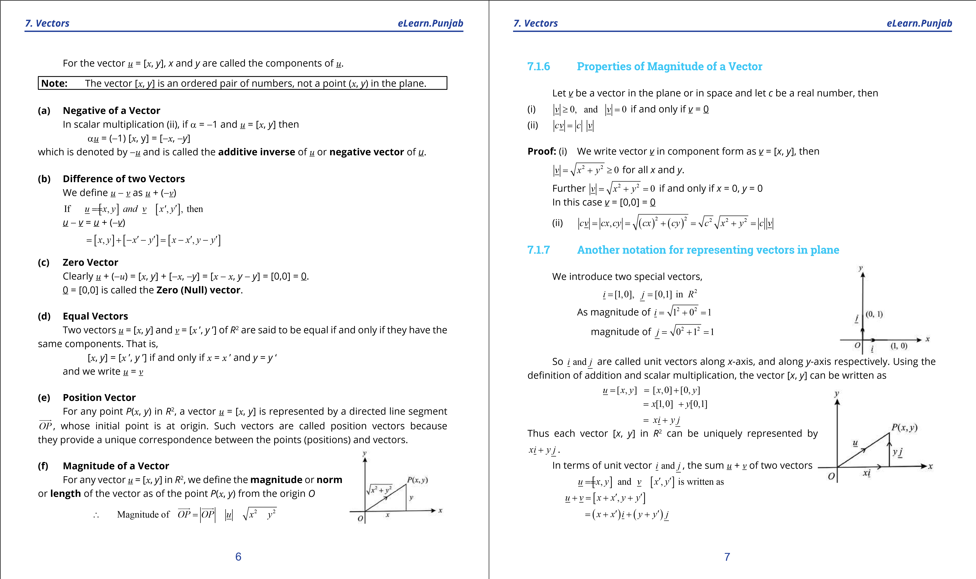

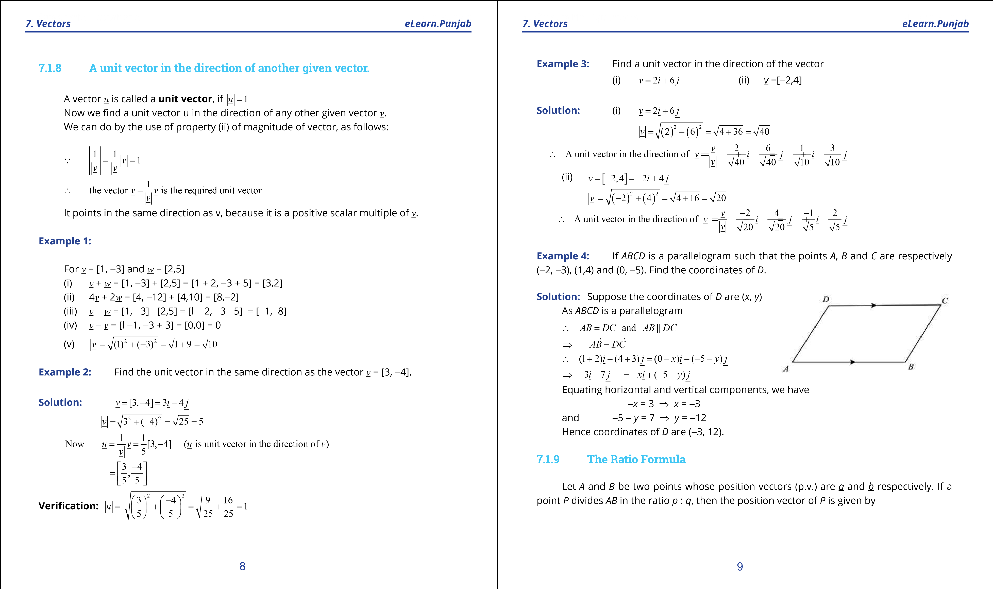

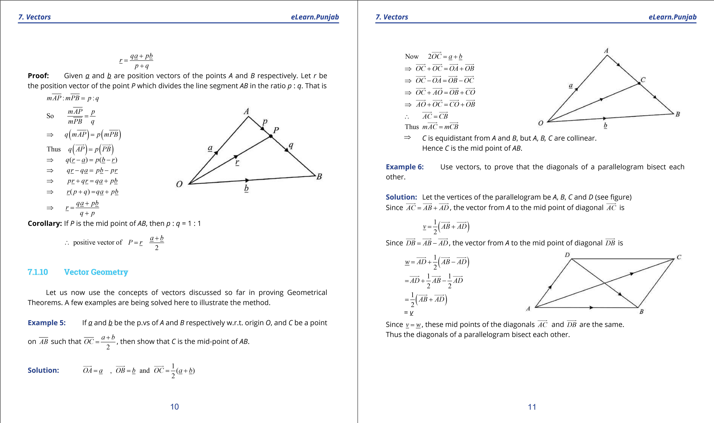

**1. Quadratic Equations eLearn.Punjab 1. Quadratic Equations eLearn.Punjab**

***7. Vectors eLearn.Punjab 7. Vectors eLearn.Punjab***

### **EXERCISE 7.1**



**1.**  Write the vector *PQ* in the form *xi* + *y j* . (i) *P*(2,3), *Q*(6, -2) (ii) *P*(0,5), *Q*(-1, -6) **2.** Find the magnitude of the vector *u*:

(i) *u* = 2*i* - 7 *j* (ii) *u* = +*i j* (iii) *u* = [3, - 4]

1. If *u* = 2*i* - 7 *j* , *v* = -*i* 6 *j* and *w* = - +*i j* . Find the following vectors:
   1. *u* + *v* - *w* (ii) 2*u* - 3*v* + 4*w* (iii) 1*u* + 1 *v* + 1 *w*

2 2 2

 

1. Find the sum of the vectors *AB* and *CD*, given the four points *A*(1, -1), *B*(2 ,0 ), *C*(-1, 3) and *D*(-2, 2).



1. Find the vector from the point *A* to the origin where *AB* = 4*i* - 2 *j* and *B* is the point (-2, 5).
2. Find a unit vector in the direction of the vector given below:
   1. *v* = 2*i* - *j* (ii) *v* = 1*i* + 3 *j* (iii) -*v* = ~~-~~3 *i* 1 *j*

2 2 2 2

1. If *A*, *B* and *C* are respectively the points (2, -4), (4, 0) and (1, 6). Use vector method to ind the coordinates of the point D if:
   1. *ABCD* is a parallelogram (ii) *ADBC* is a parallelogram
2. If *B*, *C* and *D* are respectively (4, 1), (-2, 3) and (-8, 0). Use vector method to ind the coordinates of the point: (i) *A* if *ABCD* is a parallelogram. (ii) *E* if *AEBD* is a parallelogram.

 

1. If *O* is the origin and *OP* = *AB* , ind the point *P* when *A* and *B* are (-3, 7) and (1, 0) respectively.
2. Use vectors, to show that *ABCD* is a parallelogram, when the points *A*, *B*, *C* and *D* are respectively (0, 0), (  *a*, 0), (*b*, c) and (*b* - *a*, *c*).
3. If *AB* = *CD*, ind the coordinates of the point *A* when points *B*, *C*, *D* are (1, 2), (-2, 5), (4, 11) respectively.
4. Find the position vectors of the point of division of the line segments joining the following pair of points, in the given ratio:
   1. Point *C* with position vector 2*i* -3*j* and point *D* with position vector 3*i* + 2 *j* in the ratio 4 : 3
   2. Point *E* with position vector 5 *j* and point *F* with position vector 4*i* + *j* in ratio 2 : 5 **13.** Prove that the line segment joining the mid points of two sides of a triangle is parallel to the third side and half as long.

**14.** Prove that the line segments joining the mid points of the sides of a quadrilateral taken in order form a parallelogram.

## 7.2 INTRODUCTION OF VECTOR IN SPACE

In space, a rectangular coordinate system is constructed using three mutually orthogonal (perpendicular) axes, which have orgin as their common point of intersection. When sketching igures, we follow the convention that the positive *x*-axis points towards the reader, the positive *y*-axis to the right and the positive *z*-axis points upwards.

These axis are also labeled in accordance with the right hand rule. If ingers of the right hand, pointing in the direction of positive x-axis, are curled toward the positive y-axis, then the thumb will point in the direction of positive z-axis, perpendicular to the xy-plane. The broken lines in the igure represent the negative axes.

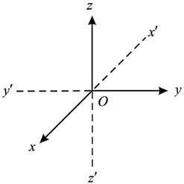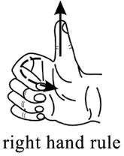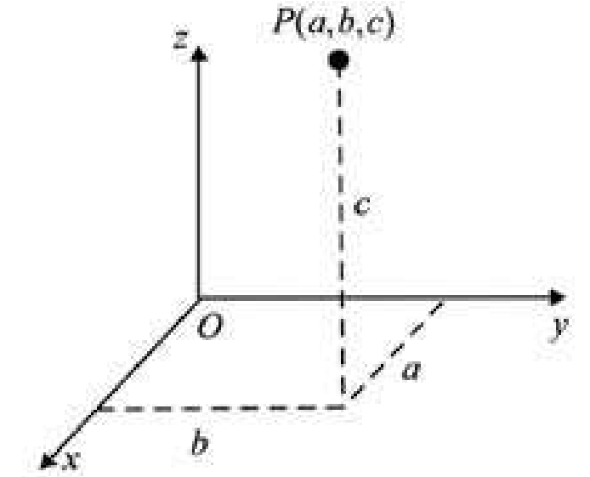

A point *P* in space has three coordinates, one along *x*-axis, the second along *y*-axis and the third along *z*-axis. If the distances along *x*-axis, *y*-axis and *z*-axis respectively are *a*, *b*, and *c*, then the point *P* is written with a unique triple of real numbers as *P* = (*a*, *b*, *c*) (see igure).

### 12 13

**1. Quadratic Equations eLearn.Punjab 1. Quadratic Equations eLearn.Punjab**

***7. Vectors eLearn.Punjab 7. Vectors eLearn.Punjab***

#### 7.2.1 Concept of a vector in space

The set *R*3 = {(*x*, *y*, z) : *x*, *y*, *z* *d* *R*} is called the 3-dimensional space. An element (*x*, *y*, *z*) of *R*3 represents a point *P*(*x*, *y*, *z*), which is uniquely determined by its coordinates *x*, *y* and *z*. Given a vector *u* in space, there exists a unique point  *P*(*x*, *y*, *z*) in space such that the vector *OP* is equal to *u* (see igure).

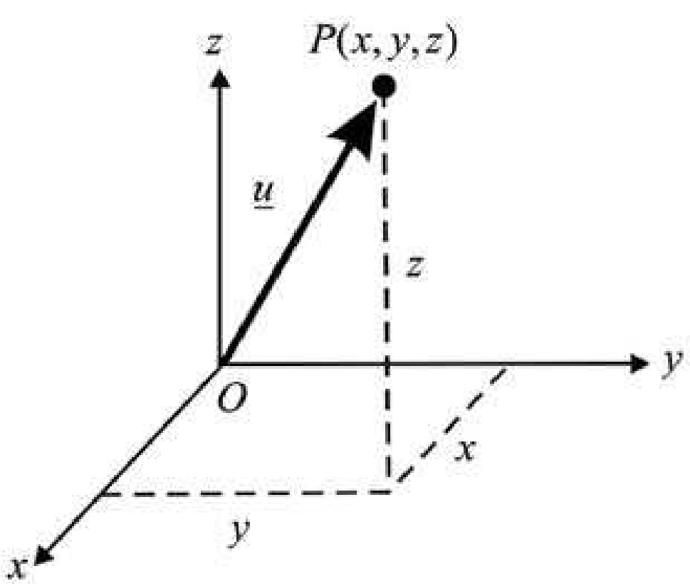

Now each element (*x*, *y*, *z* ) *d* *P*3 is associated to a unique ordered triple [ *x*, *y*, *z*], which represents the vector *u* = *OP* = [*x*, *y*, *z*].

We deine addition and scalar multiplication in *R*3 by:

1. **Addition:** For any two vectors *u* = [*x*, *y*, *z*] and *v* = [*x y z*′, ′, ′], we have *u* + *v* = [*x y z*, , ] [+ *x y z*′, ′, ′] [= *x* + *x y*′, + *y z*′, + *z*′]
2. **Scalar Multiplication:** For *u* = [*x*, *y*, *z*] and a *d* *R*, we have a*u* =a[*x*, *y*, *z*] = [a*x*, a*y*, a*z*]

**Deinition:** The set of all ordered triples [*x*, *y*, *z*] of real numbers, together with the rules of addition and scalar multiplication, is called the set of **vectors** in *R*3. For the vector *u* = [*x*, *y*, z], *x*, *y* and *z* are called the components of *u*.

The deinition of vectors in *R*3 states that vector addition and scalar multiplication are to be carried out for vectors in space just as for vectors in the plane. So we deine in *R*3: a) The **negative** of the vector *u* = [*x y z*; , ] as -*u* = -( 1)*u* = -[ *x*,-*y*,-*z*]

b) The **diference** of two vectors *v* ==[*x y z*′, ′, ′] and *w* [*x*′′, *y*′′,*z*′′]as *v* - *w* = *v* + -( *w*) =[*x*′- *x*′′, *y*′- *y*′′,*z*′- *z*′′] c) The **zero vector** as 0 = [0,0,0]

d) **Equality** of two vectors *v* = ==[*x y z*′, ′, ′] and *w* [*x*′′, *y*′′,*z*′′] by *v w*if and only *x*′ = *x*′′, *y*′ = *y*′′ and *z*′ = *z*′′. e) **Position Vector**

For any point  *P*(*x*, *y*, *z*) in *R*3, a vector *u* = [*x*, *y*, *z*] is represented by a directed line segment *OP*, whose initial point is at origin. Such vectors are called position vectors in *R*3.

f) **Magnitude** of a vector: We deine the **magnitude** or **norm** or **length** of a vector *u* in space by the distance of the point *P*(*x*, *y*, z) from the origin *O*.



∴ *OP* = *u* = *x*2 + *y*2 + *z*2

**Example 1:** For the vectors, *v* = [2,1,3] and *w* = [-1,4,0], we have the following

1. *v* + *w* = [2 - 1, 1 + 4, 3 + 0]= [l,5,3]
2. *v* - *w* = [2 + 1,1 - 4, 3 - 0]= [3, -3, 3]
3. 2*w* =2[-1, 4, 0] = [-2, 8, 0]
4. *v*- 2*w* = + - - = -[2 2,1 8,3 0] [4, 7,3] = ( )4 2 + - +( 7)2 ( )3 2 = 16 + + =49 9 74

#### 7.2.2 Properties of Vectors

Vectors, both in the plane and in space, have the following properties: Let *u*, *v* and *w* be vectors in the plane or in space and let *a*, *b* *d* *R*, then they have the following properties

1. *u* + *v* = *v* + *u* (Commutative Property)
2. (*u* + *v*) + *w* = *u* + (*v* + *w*) (Associative Property)
3. *u* + (-1)*u* = *u* - *u* = 0 (Inverse for vector addition)
4. *a*(*v* + *w*)=*av* + *aw* (Distributive Property)
5. *a*(*bu*) = (*ab*)*u* (Scalar Multiplication)

**Proof:** Each statement is proved by writing the vector/vectors in component form in

*R*2 / *R*3 and using the properties of real numbers. We give the proofs of properties (i) and (ii) as follows.

(i) Since for any two real numbers *a* and *b*

*a* + *b* = *b* + *a*, it follows, that

for any two vectors *u* = [*x*, *y*] and *v*=[*x y*′, ′] in *R*2, we have *u* + *v* =[*x y*, ]+[*x*′+ *y*′]

=[*x* + *x y*′, + *y*′]

=[*x*′+ *x y*, ′+ *y*]

=[*x y*′, ′]+[*x y*, ]

= *v* + *u*

So addition of vectors in *R*2 is commutative

### 14 15

